ROUND TABLE REVIEW - Section 6-1
1) The rate of change in the table is constant.
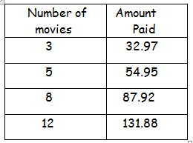
a) Find the rate of change.

b) What does the rate of change represent?
2) Find the slope of the line. ($\frac{\text{rise}}{\text{run}}=\frac{y_{2}−y_{1}}{x_{2}−x_{1}}$ Count up and over).

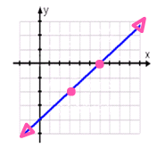
3) Find the slope of the line containing (4, -1) and (-3, 7).

Use the slope formula:
$\frac{y_{2}−y_{1}}{x_{2}−x_{1}}$

ROUND TABLE REVIEW - Section 6-2

(Remember slope-intercept form: y = mx + b; m = slope and b = y-intercept.)
Identify the slope and y-intercept for each equation.
1) y = 2x + 3 2) y = 3 – ¼ x

3) Write the equation of the line with slope 2 and y-intercept -1.

4) Write an equation for the line shown below.

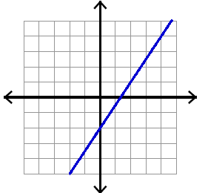

ROUND TABLE REVIEW - Section 6-2

(Remember slope-intercept form: y = mx + b; m = slope and b = y-intercept.)
Identify the slope and y-intercept for each equation.
1) y = 2x + 3 2) y = 3 – ¼ x

3) Write the equation of the line with slope 2 and y-intercept -1.

4) Write an equation for the line shown below.

ROUND TABLE REVIEW - Section 6-2 – Part 2

Graph each equation and tell what the slope of the line is.

1) y = -3x – 4 2) Graph y = -2 3) Graph x = 4

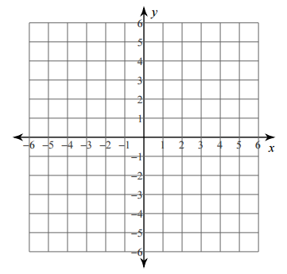

ROUND TABLE REVIEW - Section 6-2 – Part 2

Graph each equation and tell what the slope of the line is.

1) y = -3x – 4 2) Graph y = -2 3) Graph x = 4

