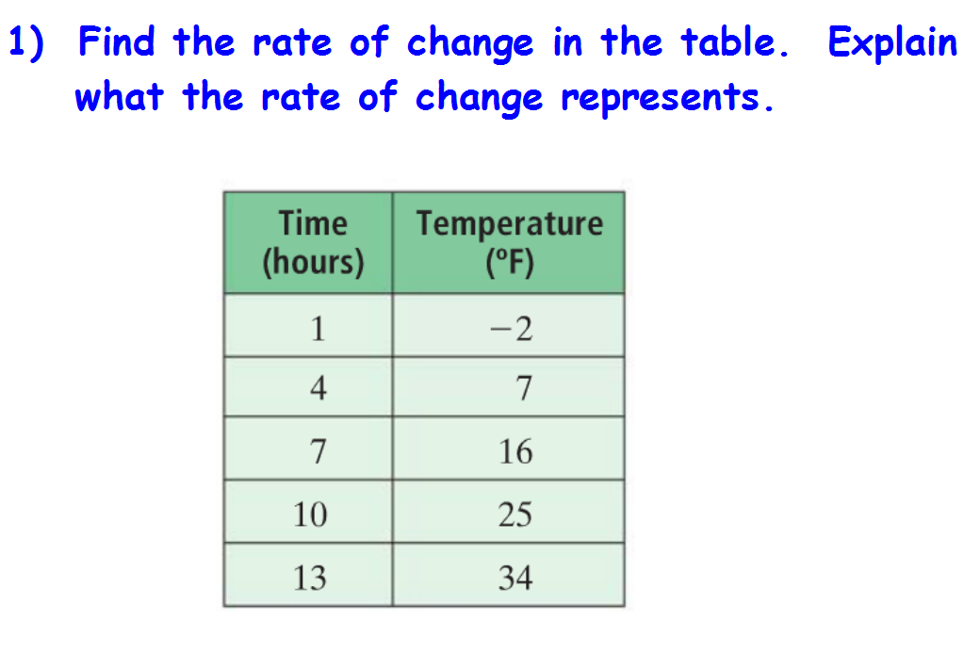 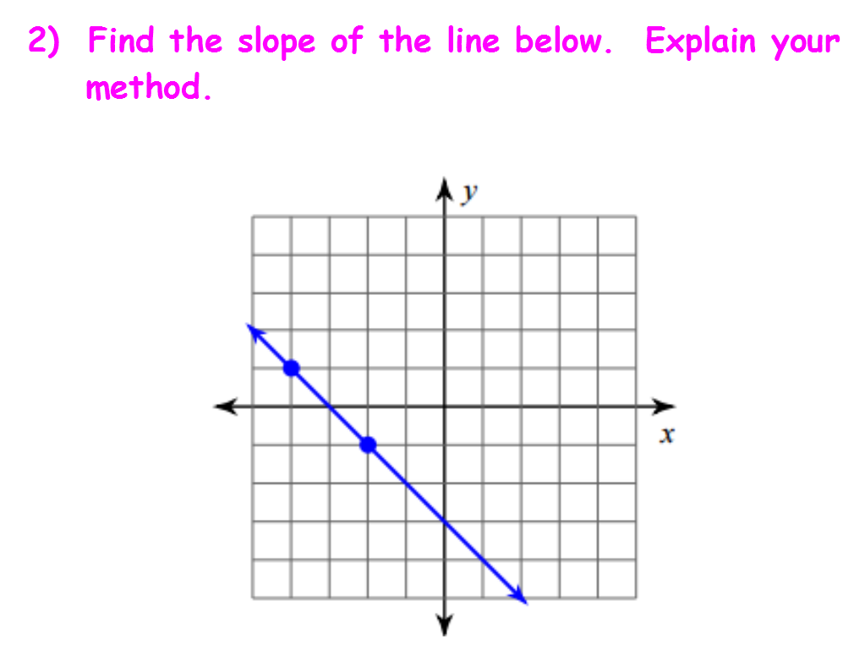

**3) Find the slope of the line containing** **(-5, 3) and (-2, -7).**

**4. Identify the slope and y-intercept for the equation. Explain how you know which**

**is the slope and which is the y-intercept.**  **y = -3x + 5**

**5. Identify the slope and y-intercept for the equation. Explain how you**  **know which**

**is the slope and which is the y-intercept. y = -1 + 2/3 x**

**6. Write the equation of the line with slope 1/2 and y-intercept -7.**

**7. Graph the equation y = -2x + 4.**  **Explain your steps.** 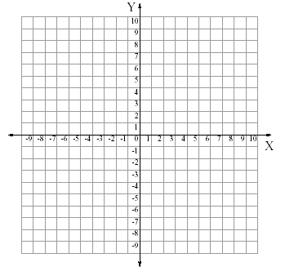

**8. Graph y = 4. What is the slope? Explain.**



**9. Graph x = -3. What is the slope? Explain.**



10. Identify the slope and a point on the line for the equation. Explain how you know the

coordinates of the point and the slope.

**y + 5 = 3/4(x - 4)**

**11. Graph the equation: y - 3 = -1/2(x + 1). Explain your steps.**



12. Write an equation in point-slope form for the line going through (-4, -2) with slope

3/4. Explain.