**Final Exam Review – Part 1 Name ______________________________**

**Exponential Functions – y = ab x**

**Remember: a = the initial amount (the y-intercept) b = the growth factor - if 0 < b < 1 this shows decay**

**- if b > 1 this shows growth**

1. Sketch a graph that shows exponential:   
 a) Growth b) Decay

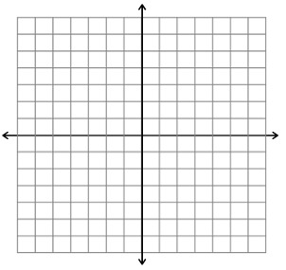 

**For #2-6, tell if:**

**a) the equation represents growth or decay (circle one) d) the initial value (what is the value of a?)**

**b) the growth or decay factor (what is the value of b?) e) graph the function**

**c) the percent of growth or decay (what is the difference f) tell the domain and range**

**between b and 1? (1 + r) or (1 – r)**

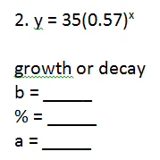 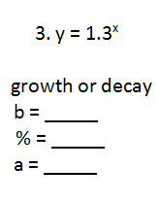 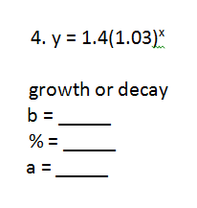

  

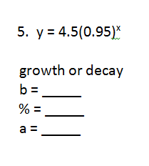  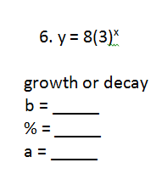

7. Of #2 – 6, which shows the greatest growth? Explain.

8. The population in 2012, of a small Upper Peninsula town was approximately 2,500. The   
 following equation can be used to model the change, *g*(*t*), over time, *t*, in years: *g*(*t*) = 2500(1.15)*t*

a) What is the percent of growth or decay per year in this town?   
 b) Is the population increasing or decreasing? Explain how you know.   
 c) Where will the graph of the function cross the vertical axis? Explain how you know.   
 d) What does the vertical intercept indicate in the context of the problem?   
 e) How would an increase in the percentage rate of growth affect the graph of the function?   
 f) What will be the predicted population in 2020?

9. A certain stock is worth $42 at the beginning of the day. Every hour the stock goes down by 5%.

a) Can this information be represented by exponential growth or decay? Explain.   
 b) What is the growth or decay factor for this information? Explain how you found it.   
 c) Write an equation to model this information. Explain what each part means.   
 d) How much will the stock be worth in 8 hours? Show work.

10. A dust bunny gathers dust at a rate of 11% per week. The dust bunny originally weighs 0.7 oz.   
 a) Write a function that represents the weight of the dust bunny at a given time. Use x for weeks   
 and y for the weight of the dust bunny.   
 b) Find the weight of the dust bunny after 7 weeks.

**Final Exam Review –Part 2 - Quadratic Functions Name ______________________________**

**For 1 – 4,**

**a) find and label the y-intercept**

**b) find and label the x-intercept(s)/zero(s)/root(s)/solution(s) c) identify and label the vertex**

**d) is the vertex a maximum or a minimum**

**e) draw in the axis of symmetry and write the equation for it**

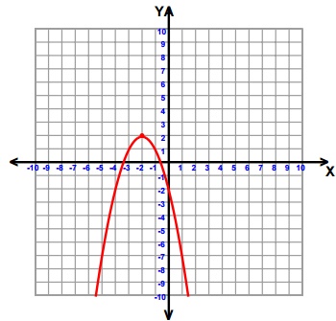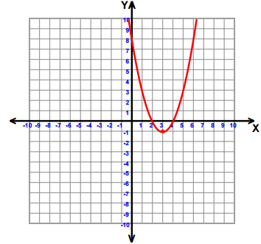 1. 2.

3. 4.

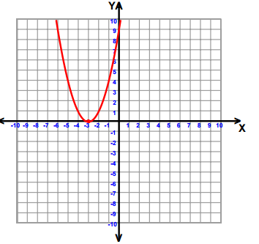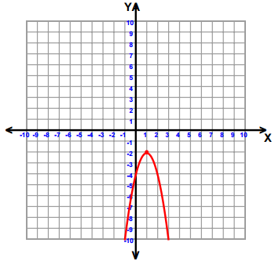

**Factor each expression for 5 – 8.**

5.  6.  7.  8. 

**The following is a graph of the path of a rocket after it is launched.**

[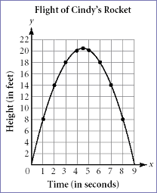](http://www.learner.org/workshops/algebra/workshop8/lessonplan1c.html)

9. Identify and explain the real world meaning of the following points. Height is in feet and time is in   
 seconds.

a) Vertex b) x-intercept(s) c) y-intercept(s)

10. How long does it take for the rocket to reach the **ground**?

**For 11 - 17, graph each quadratic function.**

11.  12.  13.  14. 

   

15.  16.  17. 

  

14. Explain what can be determined by looking at each form of a quadratic function.

a) Standard  b) Factored  c) Vertex 

13. Tell the x-intercept(s)/zero(s)/factor(s)/solution(s) of:   
 a)  b)    
 c)  d)    
 e)  f) 

14. Tell the vertex of each, then tell if the vertex is a maximum or a minimum:   
 a)  b)    
 c)  d)    
 e)  f) 

15. Tell the x- and y-intercepts of each:   
 a)    
 b)    
 c) 

16. a) What is the vertex of g(x) = (x – 3)2 + 2 ?

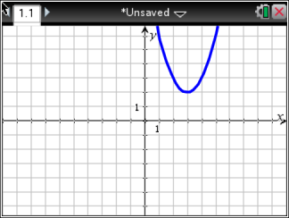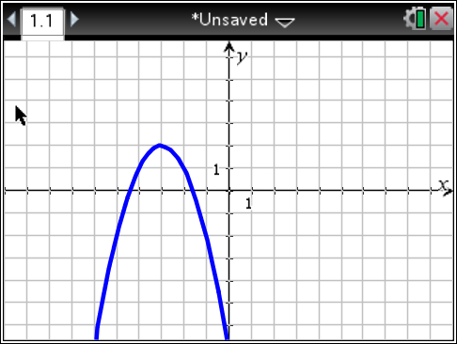 Which of the following has the **same vertex** as g(x)? Defend each answer.   
 b) h(x) = -2(x – 3)2 – 2   
 c) f(x) = (x + 3)2 + 2   
 d) p(x) = x2 – 6x + 11   
 e) q(x) = (x – 3)(x + 2)   
 f) g)

Determine the number of solutions for the following quadratic functions in questions 17 and 18.

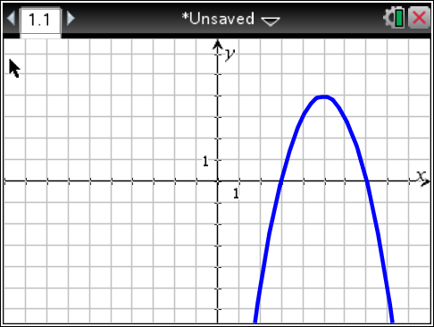17. 18.

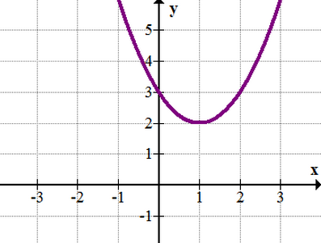

**For 19 - 27, round answers to the nearest hundredth if necessary.**

19. Find the roots of .

20. Find the zeros of .

21. Solve the equation .

22. Solve .

23. Find all of the zeros of .

24. Find the roots of .

25. Solve .

26. Find the solutions to .

27. Solve .

**Final Exam Review – Part 3 Name _______________________________________**

**Find the sum, difference or product of each for 1 – 12.**

1.  2.  3.  4. 

5.  6.  7.  8. 

9.  10.  11.  12. 

13. a) Write an expression for the perimeter of the figure below.

b) Write an expression for the area of the figure below.

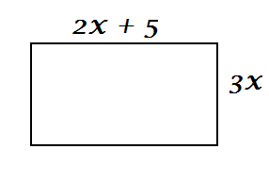

14. A 65” television is named by the length of the diagonal of the television.

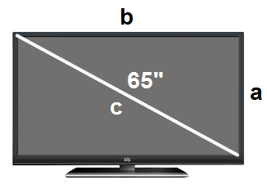

The Pythagorean Theorem, **a² + b² = c²,** can be used to compare the dimensions to the diagonal.   
 You want to know if your new TV will fit in your existing cabinet. Rearrange the formula to solve for   
 height (a).

15. In accounting, a company's gross profit rate measures how well the company controls cost of goods   
 sold to maximize gross profit. The gross profit rate, , is calculated using the formula ,   
 where  is the net sales and  is the cost of goods sold. Rearrange the formula to solve for the   
 cost of goods sold .

16. The surface area, , of a right circular cylinder is calculated using the formula ,   
 where *r* is the radius of the cylinder and *h* is the height of the cylinder. Rearrange the formula to   
 solve for height (*h*).

17. If denotes a temperature in degrees Fahrenheit and  is the same temperature measured in   
 degrees Celsius, then  and  are related by the equation . Rewrite this equation to   
 solve for  in terms of .