Name ________________________

Date ______________ Hour ______

**Review – Quadratic Graphs and Vertex Form of the Quadratic Equation**

Fill in the information for each graph.

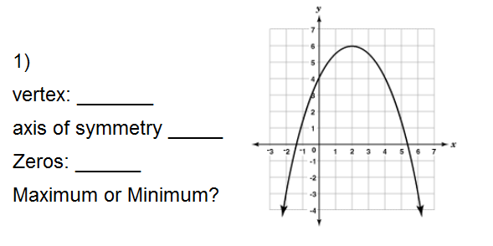 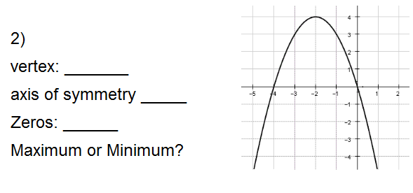

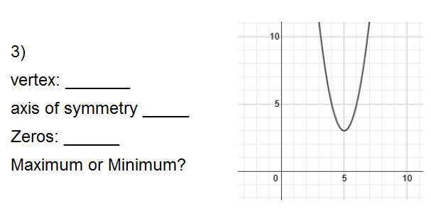 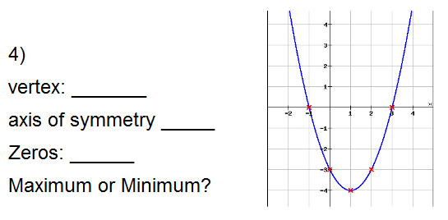

**Vertex Form of the Quadratic Equation: y = a(x – h)² + k**

For each quadratic equation in vertex form, fill in the following information. Circle Minimum or Maximum.

