Vertex form of a Quadratic Function__________________________________

a: h: k:

Vertex: Axis of Symmetry:

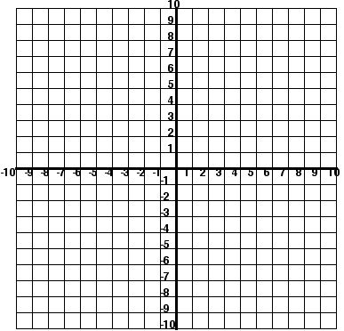

|  |
| --- |
| Vertex Form: f(x) = 2(x – 1)2 + 5  a:________________________  h: ________________________  k: ________________________  Vertex (h, k):_______________  Axis of Symmetry (x = h): __________  Minimum or Maximum |

|  |
| --- |
| Steps for Graphing in Vertex Form |