Quadratic Graphs

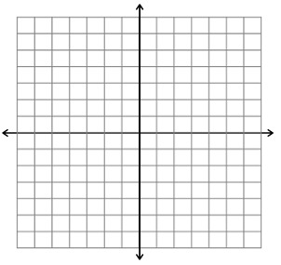

When a is _______________ the

parabola opens ______________.

The ___________ is a

______________because it is the

____________ point on the

parabola.

The ______________ or ____________ or ______________ are the x-coordinates where the parabola crosses the x-axis.



When a is _______________ the

parabola opens ______________.

The ___________ is a

______________because it is the

____________ point on the

parabola.