Practice 4 Name ___________________

Solve Quadratic Equations by Graphing

Sketch each graph below. **Use the TRACE key to accurately identify and graph the**

**x-intercepts (the zeros). Use the TRACE key or  to identify the vertex.**

1) **x² - 9x + 3 = 0** 2) **x² - 2x + 1 = 0** 3) **½x² + 2x = -1**

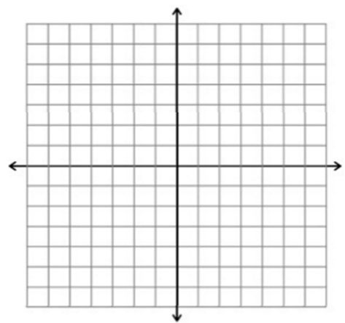  

4) **2x² + x - 3 = 0** 5) **1/4 x² + 2x + 1 = 0** 6) **-x² - 4x = 6**

  

7) **x² = 16**  8) -**1/4 x² + 2x - 3 = 0** 9) **-x² - 8x – 5 = 0**

  