Name ________________________

**Notes 4 - Solving Quadratic Equations by Graphing**

Learning Target - __________________________________________________

**Remember - we define the solutions to a quadratic equation as the zeros or

x-intercepts.**

Example 1 - Solve **x2 - 8x + 15 = 0** by graphing.

Step 1 - Use the ____ key to _______________________.

Step 2 - Use the ______ key to ______________________.

Step 3 - Use the ______ key to ____________________________________.

Sketch your graph below. **Use the TRACE key to accurately graph the x-intercepts.**

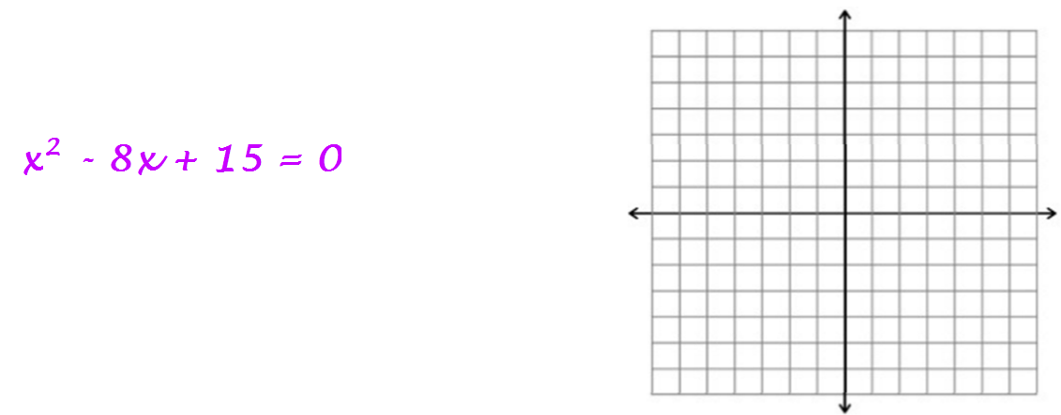

**Try this: Solve 3x² - 9x + 5 = 0 by graphing.**

