**Algebra 1 Semester 1 Study Guide Name ___________________________**

**Part 1 – This is part of your exam grade.**

* **I can simplify and evaluate expressions.**

**Simplify each expression.**

1. 2. |6 – 18| 3. -3(2x – 4) + 10x

**Evaluate each expression.**

4. 3a² + (b – c) for a = 2, b = 4, and c = 3 5.  for  and .

6. –a + 2b + c for a = 2, b = -3, and c = 4 7. x(-y + z) for x = 3, y = -3, and z = -1

* **I can write and solve equations.**

8. Solve  9. Solve 

10. Solve  11. Solve 

* **I can solve inequalities in one and two variables.**

12. Solve and graph the solution on a number line:

a)  b)  c) 

  

* **I can solve inequalities in one and two variables.**

13. Graph the solution set for the inequality 4x + 5y > 20.

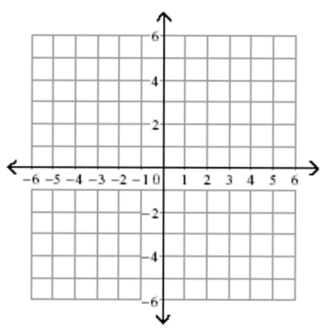

**Function Essentials - I can evaluate a function using function notation.**

14. If, then find . 15. If , then find 

* **I can determine the domain and range of a relation or a function.**

16. Given the following relation, what is the domain and range?

{(-2, 4), (-2, 0), (6, 5), (0, -2)}

17. Make a mapping diagram that represents the relation and determine whether the relation is   
 a function.



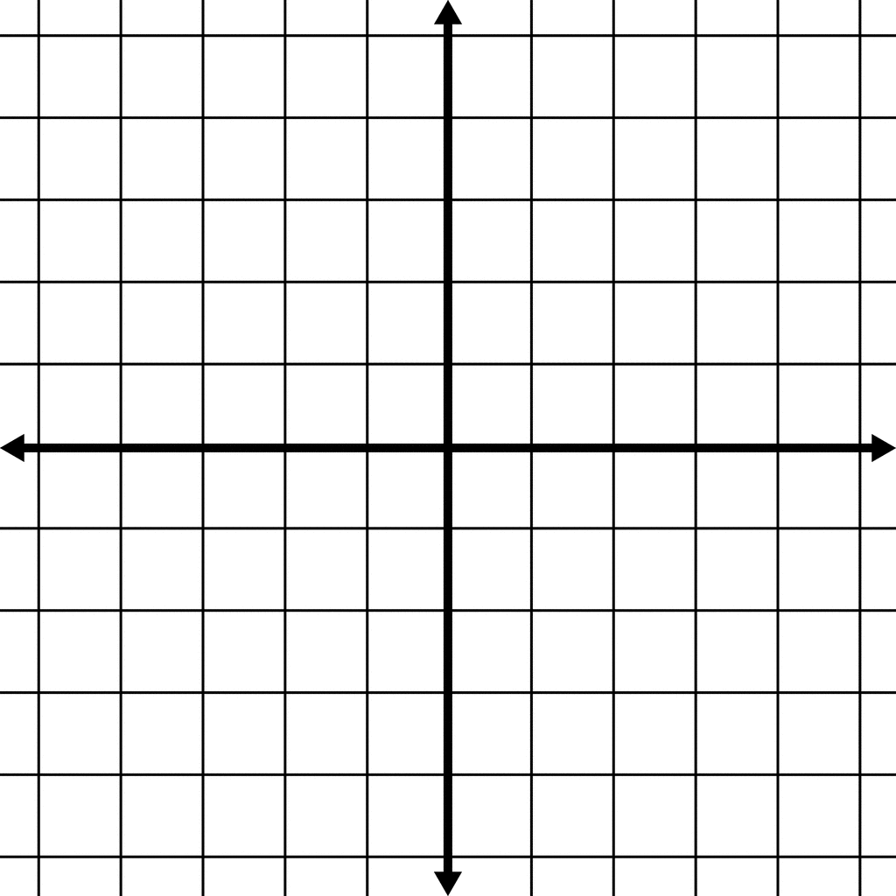18. What is the domain and range of the relation shown? Is the relation a function?

19. Find the domain and range of the relation. Is the relation a function? Explain.

|  |  |
| --- | --- |
| **Height of Person**  **(inches)** | **Shoe Size** |
| 29 | 2 |
| 36 | 3 |
| 54 | 3 |

20. Given the function, , where  is the time in minutes it takes to decorate the gym

for a dance and  is the number of students on the decorating committee, answer the following:

a) What is a reasonable domain for this function?

b) Find 

* **I can determine whether a relation is a function and identify the domain and range.**

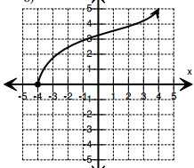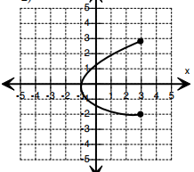21. Determine if the relation is a function. State the domain and range of each graph.

a) b)

[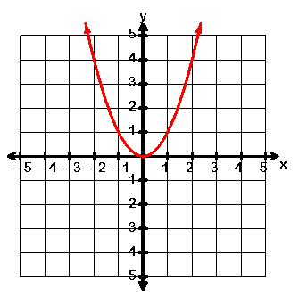](http://maths.nayland.school.nz/Year_12/AS_2.2_Graphs/1_parabolas.htm)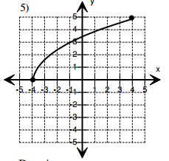

c) d)

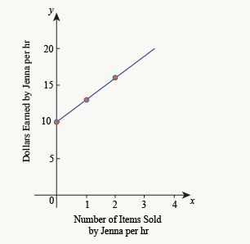22. Jenna works at a retail shop. She makes $10 per hour, plus $3 for each item she sells.   
 a) Explain why the graph represents this function.   
 b) Write an equation for this graph.

* **I can determine whether a number is rational or irrational.**

23. Decide whether the following are rational or irrational.

a) 2 b) 3 c)  d)  e)  f) 

**Algebra 1 Semester 1 Study Guide Name ___________________________**

**Part 2 – This is part of your exam grade.**

**Linear Function Essentials**

* **I can determine whether an ordered pair is a solution to the function.**

1. Which of the following is a solution to the function

a) (-2, -5) b) (0, 6) c) (6, -9) d) (10, -1)

2. For each graph, list 3 solutions. What is the slope of each line?

a) solutions b) solutions

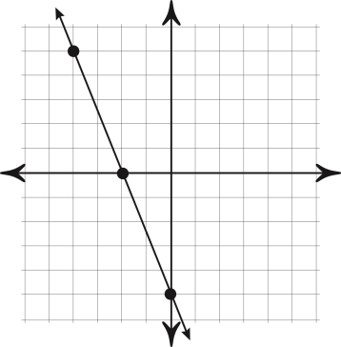 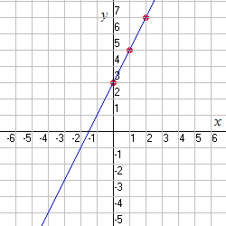

3. a) The rate of change is constant in the table. Find the rate of change. Explain what the rate of   
 change means for the situation.

b) Write a linear equation that models the table if *t* = time and *d* = distance.

c) What is the y-intercept for this data? Explain what the y-intercept means for this situation.

|  |  |
| --- | --- |
| **Time (in hours)** | **Distance (in miles)** |
| **4** | **168** |
| **6** | **252** |
| **8** | **336** |
| **10** | **420** |

* **I can find the slope and y-intercept of a linear equation.**

**Find the slope and *y*-intercept of each line.**

4. y = -3x + 7 5. y = -16 + 6x

* **I can write a linear equation.**

6. Write an equation for a line with slope –¾ and y-intercept 5.

7. Write an equation for a line with slope 4 and y-intercept -7.

* **I can graph a linear equation.**
* **I can determine characteristics of linear functions.**

**Use the slope and *y*-intercept to graph each equation.**

8. y = -3x + 3 9. y = -x – 4

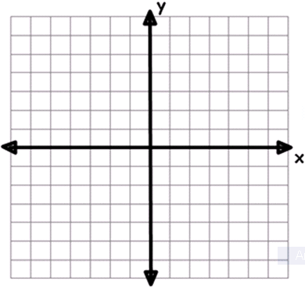 

Write an equation for each line below and state whether the slope is 0 or undefined.

10. slope = _____ 11. slope _____

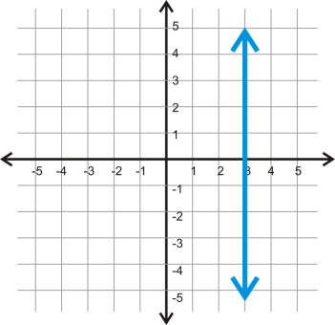 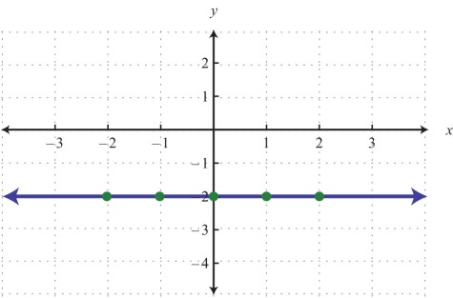

12. Find the x- and y- intercept for -3x – 4y = 12. Graph the equation.



13. A line passes through (2, -4) and (-2, 6). Write an equation for the line.

14. Write an equation for the line that is parallel to y = -5x + 3 and passes through (-4, 2).

**Algebra 1 Semester 1 Study Guide Name ___________________________**

**Part 3 – This is part of your exam grade.**

**Linear Function Applications**

**Correlation Unit - I can use deductive reasoning to determine the correlation between real-life data.**

* **I can determine whether a scatterplot shows a positive, negative, or no correlation for the given data.**

1. Draw a sketch of a scatter plot with the correlation described.

a) positive correlation b) negative correlation c) no correlation 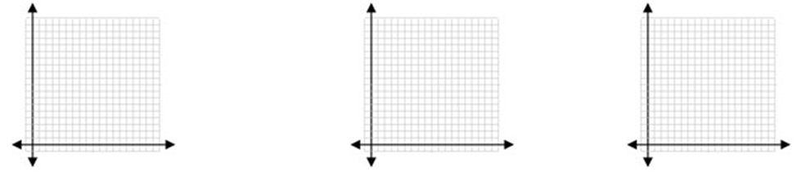

2. What type of correlation would you expect for each situation?

a) The distance that a person rides their bike and the amount of calories burned.   
b) The amount of free time a person has and the amount of time they spend working.

c) A person’s height (inches) and the number of pets they own.

3. Describe what a correlation coefficient tells about a set of data. (Include +/- as well as value)

* **I can use the given line of best fit to make prediction for new data.**

 Use the line of best fit to answer questions 4 and 5.

4. Based on the line of best fit, predict the daily sales if the temperature was 54 degrees.

5. Based on the line of best fit, predict the temperature if the daily sales was $100.

* **I can use residual plots to determine if a linear line is the best fit for the given data.**

6. Of the following, which residual plot shows a linear regression for a set of data. Explain.

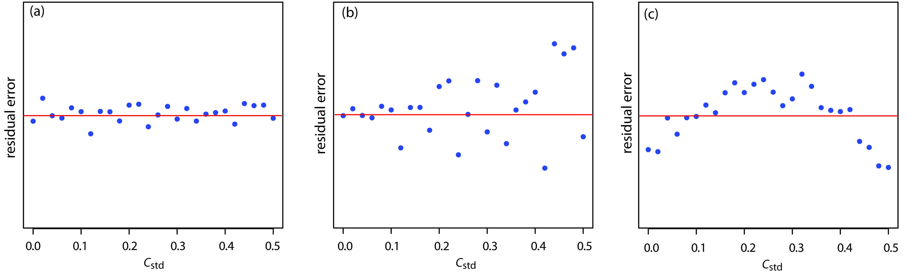

* **I can use the given data and scatterplot to make predictions.**
* **I can generate a correlation coefficient *(r)* using the calculator.**
* **I can create a *Linear Regression Equation* from a table of data.**

Use the table of values to answer questions 9 - 13.

|  |  |
| --- | --- |
| **Minutes using cell phone** | **Battery charge percentage** |
| 0 | 100 |
| 15 | 96 |
| 30 | 92 |
| 45 | 88 |
| 60 | 83 |
| 75 | 76 |
| 90 | 70 |

7. Enter this data into your calculator. What is the equation for the best fit line?

8. Use this data to determine the type of correlation.

9. What is the correlation coefficient for this data? (r)

10. Using your best fit line for this data, predict the battery charge percentage after 95 minutes?

11. Using your best fit line for this data, predict the number of minutes it would take for your phone to

run out of charge?

**Algebra 1 Semester 1 Study Guide Name ___________________________**

**Part 4 – This is part of your exam grade.**

**Systems of Linear Equations – I can write and solve systems of linear equations.**

1. Solve each system of equations:

a) 

b) 

c) 

**Write and solve a system of linear equations for each problem below.**

2. On Mr. Wood’s farm, he raises chickens and cows. There are 34 animals in all. Mr. Wood counts 110 legs on

these animals. Find the number of each type of animal.

3. A test has 24 questions worth 100 points.  The true/false questions are worth 4 points each and the multiple

choice questions are worth 5 points each.  How many of each type of question are on the test?

4. Emma is throwing a party! She buys 3 rolls of streamers and 15 party hats for $30. Later, she buys 2 more

rolls of streamers and 4 more party hats for $11. Find the cost of each roll of streamers and each party

hat.