7-1 Solving Systems of Linear Equations by Graphing

Learning Target: I can solve systems of linear equations by graphing.

Vocabulary System of linear Equations:

Solution of a system of linear equations:

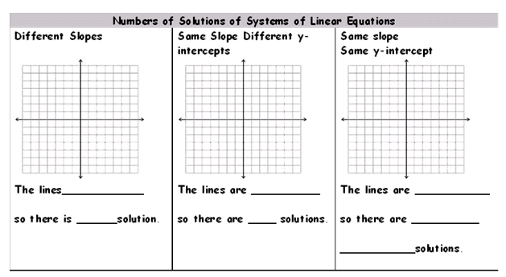

Use a graphing calculator to graph each system of equations.
Step 1) Enter each equation into the function.
y=

You must use slope-intercept form: y = mx + b

Step 2) Find the intersection of the lines, if there is one, by using the “intersect” function:
Use the following keys: .
2nd
trace
intersect
enter
enter
enter

Solve the system of linear equations by graphing  y = 2x – 3  y = x - 1 | 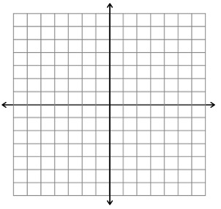

Solve by graphing

y= -2x + 1
y = -2x - 1
Solve by graphing

2x+ 4y = 8
y = -1/2x + 2

Solve by graphing
y = 3x-1
y = -2x + 4

Solve by graphing
x + y = 2
y = -2x - 1

Solve by graphing
y = 5/3x - 4
y = 2x - 6

Solve by graphing
y = x
y = 3x + 2

Solve by graphing
y = 3
y = 5

Solve by graphing
y = x -1
y = -x +7

Solve by graphing
x – y = 1
y = ¾x + 1

Solve by graphing
y = ¾x + 2
¾x –y = 4

Solve by graphing
y = 3x+2
-3x + y = 2

- What was the objective of today’s notes? (in your own words)

- How do you know when a system of linear equations has no solution?

- How do you know when a system of linear equations has infinitely many solutions?

- How do you know when a system of linear equations has one solution?

