1) Find the rate of change in the table. Explain

what the rate of change represents.

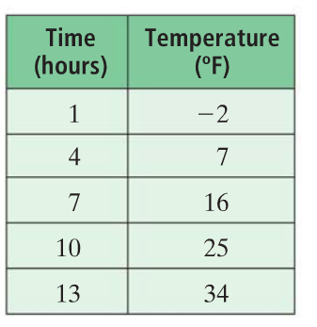

2) Find the slope of the line below. Explain your

method.

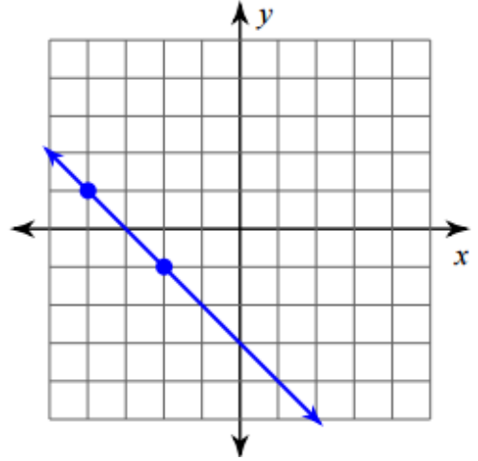

3) Find the slope of the line containing

(-5, 3) and (-2, -7).

4. Identify the slope and y-intercept for the

equation. Explain how you know which is the

slope and which is the y-intercept.

**y = -3x + 5**

5. Identify the slope and y-intercept for the

equation. Explain how you know which is the

slope and which is the y-intercept.

**y = -1 + 2/3 x**

6. Write the equation of the line with slope 1/2

and y-intercept -7.

7. Graph the equation **y = -2x + 4.**

Explain your steps.

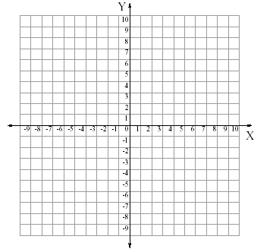

8. Graph y = 4. What is the slope?

Explain.



9. Graph x = -3. What is the slope?

Explain.



10. Identify the slope and a point on the line

for the equation. Explain how you know the

coordinates of the point and the slope.

y + 5 = 3/4(x - 4)

11. Graph the equation: **y - 3 = -1/2(x + 1)**.

Explain your steps.



12. Write an equation in point-slope form for the line

going through (-4, -2) with slope 3/4. Explain.

13. Find the x- and y-intercepts of this

equation in standard form.

**3x - 2y = -18**

14) Graph the equation **7x - 2y = -14**.

