Scatter Plots 1-3 Name ________________________________

**Learning Targets**

* **I can draw a line of best fit using the box method.**
* **I can write an equation of the line of best fit using slope and the y-intercept.**

**Remember:**

**y-intercept**

**slope-intercept form**

**slope formula**

**Examples**

Use the graph to find the y-intercept and the slope. Then write the equation in slope-intercept form.

1) 2)

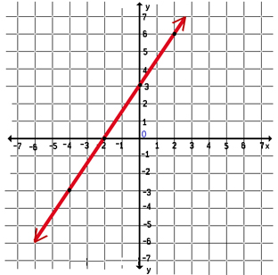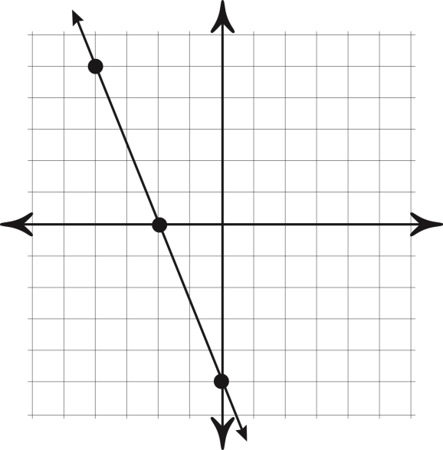

**y-intercept: ________ y-intercept: ________**

**slope: slope:**

**equation: __________________ equation: __________________**

**For each set of data, graph the points on the grid.**

1. **Draw a line of best fit using the box method.**
2. **Pick 2 points that the line goes through. They do not need to be one of the given points.**
3. **Find the slope using your 2 points and the slope formula.**
4. **Approximate the y-intercept.**
5. **Write the equation for your line of best fit in slope-intercept form.**

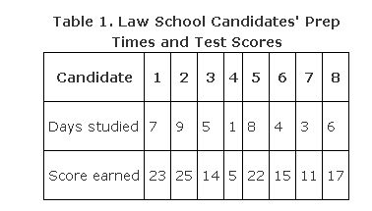 

Identify  ______ Identify  ______

Identify  ______ Identify  ______

Use the slope formula to find the slope:

m = ______

Approximate the y-intercept: _________________

Equation of the line in slope-intercept form: ____________________

**Table 2**

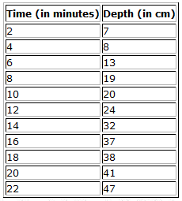

Identify  ______ Identify  ______

Identify  ______ Identify  ______

Use the slope formula to find the slope:

m = ______

Approximate the y-intercept: _________________

Equation of the line in slope-intercept form: ____________________

**Table 3**

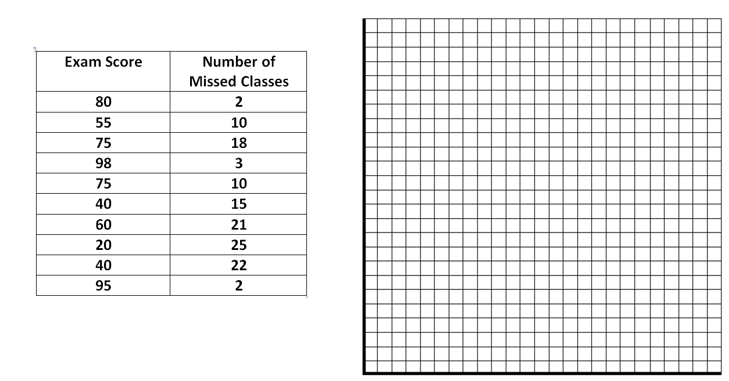

Identify  ______ Identify  ______

Identify  ______ Identify  ______

Use the slope formula to find the slope:

m = ______

Approximate the y-intercept: _________________

Equation of the line in slope-intercept form: ____________________

**Table 4**

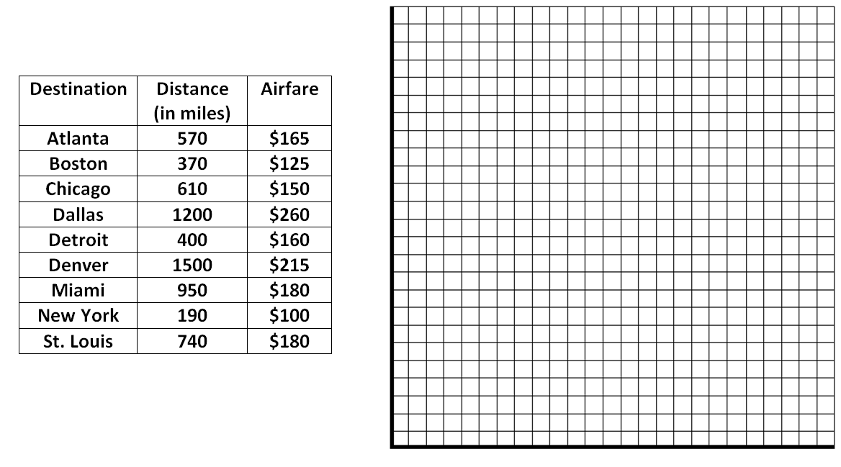

Identify  ______ Identify  ______

Identify  ______ Identify  ______

Use the slope formula to find the slope:

m = ______

Approximate the y-intercept: _________________

Equation of the line in slope-intercept form: ____________________