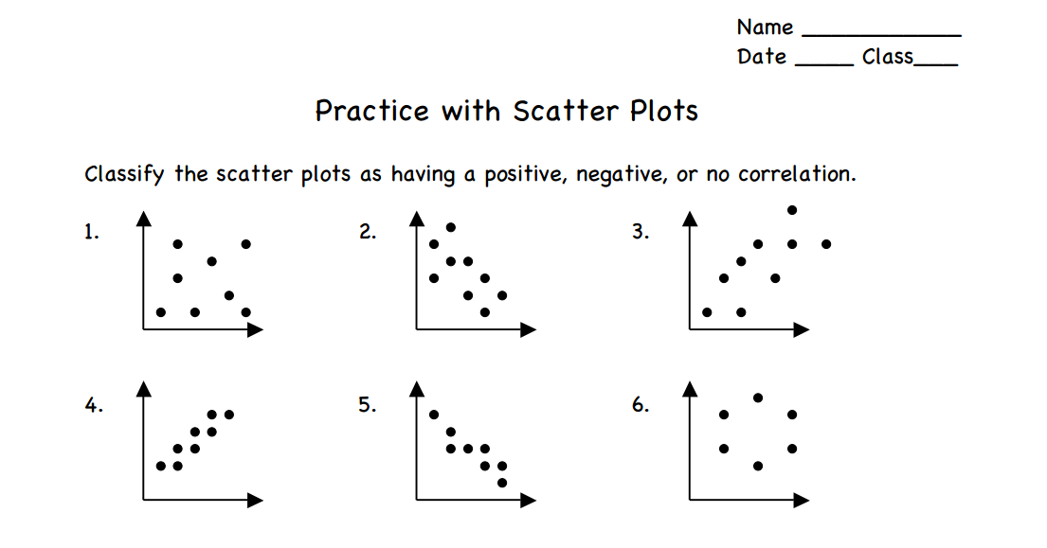

7. Mrs. Bridges asked her students how many hours of sleep they had the night before

the test. The data shows the number of hours the student slept and their score on the

exam.

* Plot the data on a scatter plot.
* Does the data show a positive corrlation, a negative correlation, or no correlation?
* Draw a line of best fit using the box method.

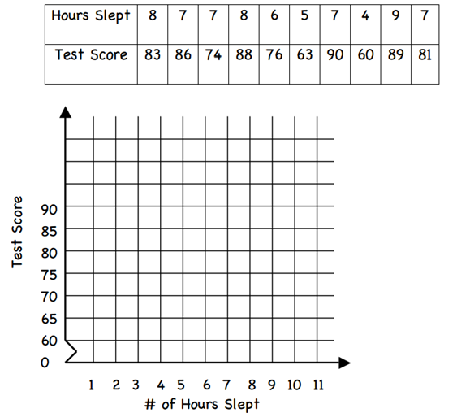

8. Deyana and Bayanne conducted an experiment. During a three-hour period outside,

Deyana recorded the temperature and Bayanne’s water consumption (how much water

she drank. The experiment was conducted on 7 randomly selected days during the summer.

The data is recorded in the table below.

