**Correlation Coefficient – Notes** Name __________________________

**Learning Target:**

**Correlation Coefficient -**

When we calculated the linear regression for a scatter plot, your calculator showed you the following values:

* **a – the slope**
* **b – the y-intercept**
* **r – the correlation coefficient**

Examples:

r = .999_____________________ r = -.925____________________

r = -.825____________________ r = - .09 ____________________

r = .363_____________________ r = .752_____________________

Write your own examples of a possible correlation coefficient:

strong positive ____ strong negative ____ weak positive ____

weak negative ____ no correlation ____ no correlation ____

(positive #) (negative #)

Use your calculator to make a scatter plot of the given data. Then answer the following questions.

|  |  |
| --- | --- |
| **x** | **y** |
| .9 | 3 |
| 2.5 | 2.2 |
| 2.9 | 2.8 |
| 4 | 4 |
| 5.1 | 5 |
| 6 | 6 |
| 7.2 | 7 |
| 7.9 | 5.9 |

A) 1. Create a scatterplot on your calculator.

2. Do you see a positive, negative or no correlation? _____________

3. What is the correlation coefficient? _______________

4. Does this indicate a strong correlation? ______ Explain your reasoning.

**Example** - Use your calculator to make a scatter plot of the given data. Then answer the following

questions.

The table below shows the predicted annual cost for a middle income family to raise a child from birth

until adulthood.

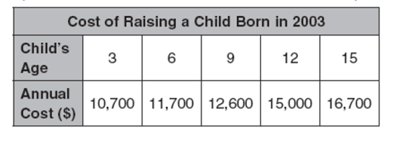

1. What is the independent variable? (x) ________________________
2. What is the dependent variable? (y) __________________________
3. Create a scatterplot on your calculator.
4. Do you see a positive, negative or no correlation? _____________
5. What is the correlation coefficient? _______________

6. Does this indicate a strong correlation? ______ Explain your reasoning.

_____________________________________________________

1. Use the calculator to find slope (a)_________________
2. Use the calculator to find the y-intercept (b):_________
3. Write the linear regression equation in slope intercept form.

10. Use your equation to determine when the annual cost if the child’s age is 10. Show your work

below. Does your answer seem reasonable? Explain.

11. Use your equation to determine the age of a child if the annual cost would is $17,930. Show your

work below. Does your answer seem reasonable? Explain.

Correlation Coefficient Practice Name _________________________

**Learning Target: I can generate a correlation coefficient (r) using the calculator.**

Use your calculator to make a scatter plot of the given data. Then answer the following questions.

The table below shows the attendance and revenue (money collected) at U.S. theme parks between

1991 and 1999.

|  |  |  |  |  |  |  |  |  |  |
| --- | --- | --- | --- | --- | --- | --- | --- | --- | --- |
| **Year** | **1991** | **1992** | **1993** | **1994** | **1995** | **1996** | **1997** | **1998** | **1999** |
| **Attendance**  **(millions)** | **260** | **267** | **275** | **267** | **280** | **290** | **300** | **300** | **309** |
| **Revenue**  **(billions of**  **dollars)** | **6.1** | **6.5** | **6.8** | **7.0** | **7.4** | **7.9** | **8.4** | **8.7** | **9.1** |

1. What is the independent variable? (x) ________________________
2. What is the dependent variable? (y) __________________________
3. Create a scatterplot on your calculator.
4. Do you see a positive, negative or no correlation? _____________
5. What is the correlation coefficient? _______________

6. Does this indicate a strong correlation? ______Explain your reasoning.

7. Use the calculator to find slope (m)_________________

8. Use the calculator to find the y-intercept (b):_________

9. Write the linear regression equation in slope intercept form.

10. Use your equation to predict the revenue for attendance of 325. Show your work below. Does your

answer seem reasonable? Explain.

A school collected data on math and science grades of nine randomly selected students.

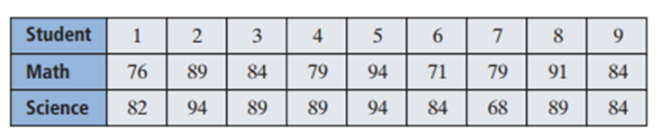

1. What is the independent variable? (x) ________________________
2. What is the dependent variable? (y) __________________________

3. Create a scatterplot on your calculator.

4. Do you see a positive, negative or no correlation? _____________

5. What is the correlation coefficient? _______________

6. Does this indicate a strong correlation? ______Explain your reasoning.

7. Use the calculator to find slope (m)_________________

8. Use the calculator to find the y-intercept (b):_________

9. Write the linear regression equation in slope intercept form.

10. Use your equation to predict the math score for a student with a science score of 75. Show your

work below.

11. Is this a reasonable prediction? Explain.