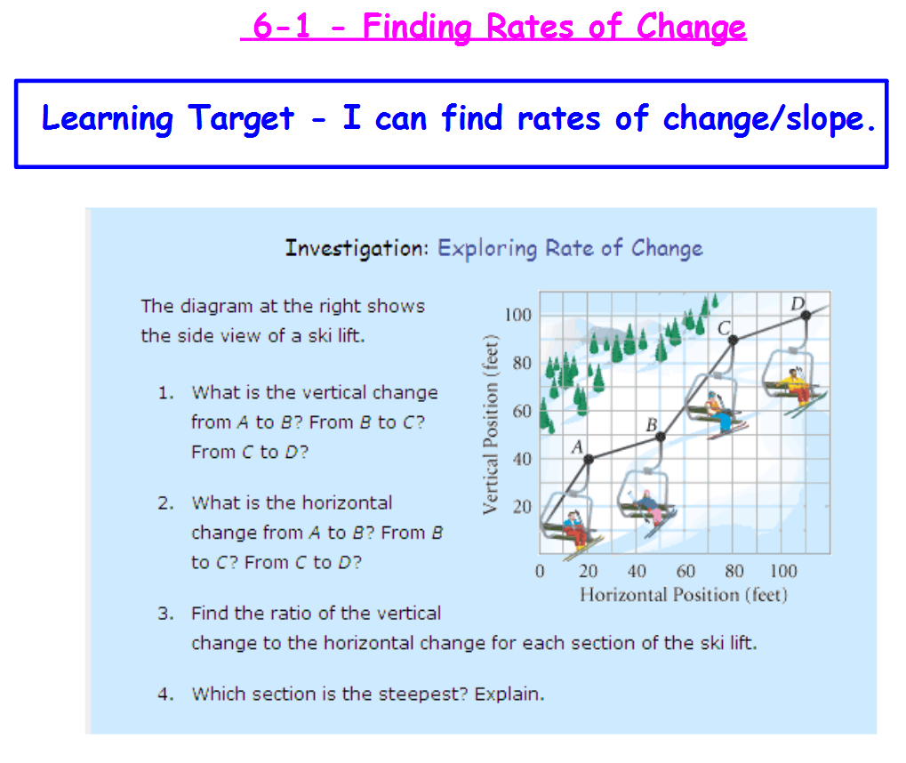

**Rate of Change**

**rate of change =**

**Example 1 - Finding Rate of Change Using a Table**

**The rate of change in the table is constant. Find the** **rate of change. What does the rate of change represent?**

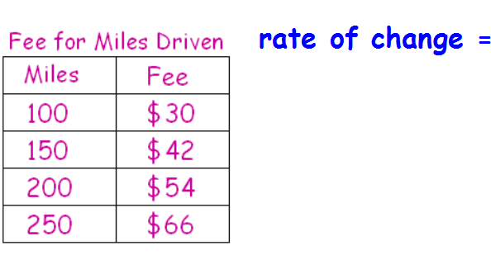

Check understanding.

Find the rate of change in the table below. What does the rate represent?

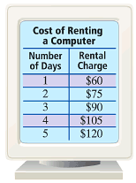

**You can also use a graph to find the rate of change.**

**Example 2 - Finding Rate of Change Using a Graph**

Find the rate of change of the data in the graph.

rate of change = change in **dependent** variable =

change in **independent** variable =

