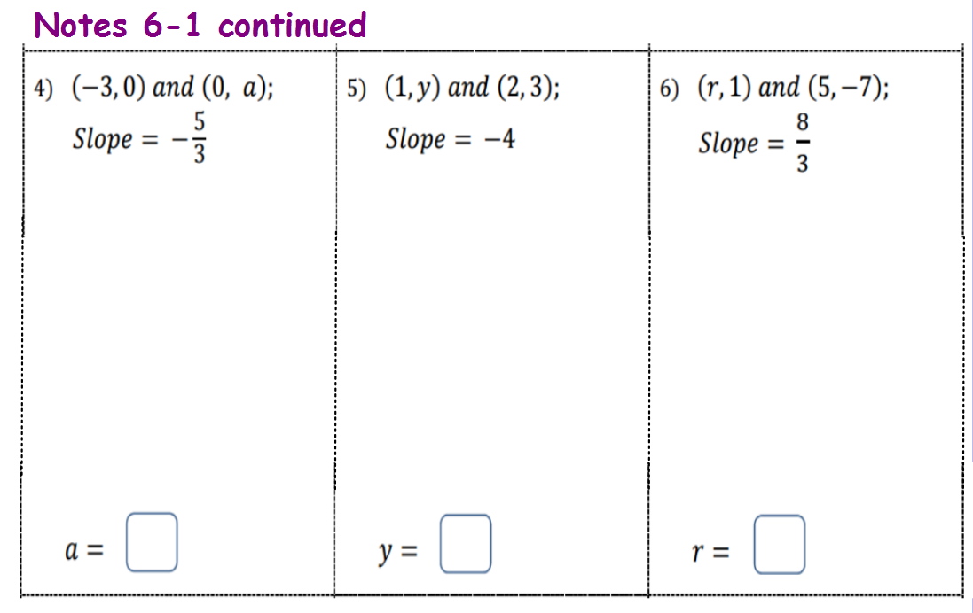

**Horizontal and Vertical Lines**

**Example 5 - Find the slope of each line.**

**Choose 2 points on each line and use the slope formula  to find the slope.**

**a. b.**

