**Finding Slope** Name ________________________

Date ____________ Hour ________

Find the slope for each line by counting . Label each graph to show whether the slope is positive, negative, zero or undefined. Write the number as a fraction. If the slope is zero or undefined, state whether the line is horizontal or vertical.

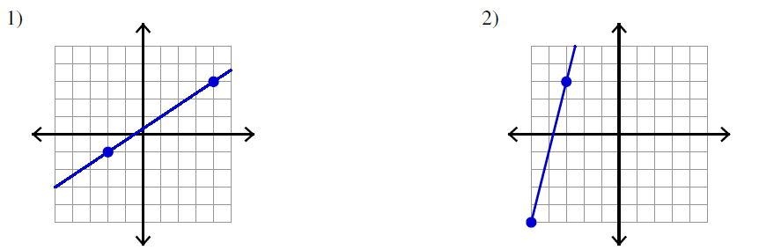

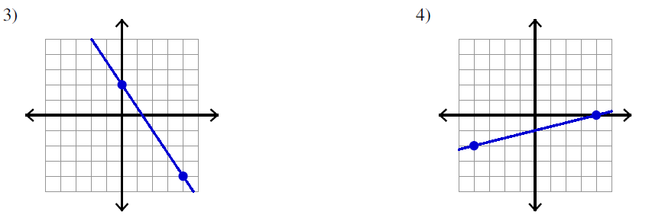

5) 6)

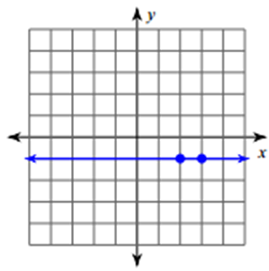 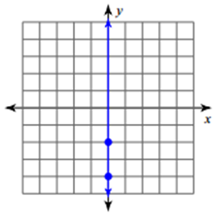

Use the slope formula  to find the slope of the line containing each pair of points.

9. (-4, 0) and (0, -4) 10. (-2, 3) and (4, -3) 11. (-4, 1) and (0, 3)

12. (5, -7) and (6, 3) 13. (1, 6) and (7, 5) 14. (-3, 4) and (3, -4)

