Investigation 5-3 Name ___________________
Date ___________ Hour ____

Section 5-3 – Investigation: Functions

1) Complete each table below for the perimeter and area of a square with the
given side lengths.
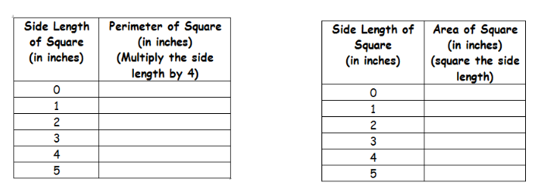

2. a) Make a graph to show the relationship between side length and perimeter.
(Graph the first column as the domain value (x) and the second column as
the range value (y). Label “Side Length” on the x-axis and “Perimeter”
on the y-axis.

b) Make a graph to show the relationship between side length and area. (Graph
the first column as the domain value (x) and the second column as the range
value (y). Label “Side Length” on the x-axis and “Area” on the y-axis.

3. a) For which of your graphs could you join the points to form a line?
b) For which of your graphs could you join the points to form a curve?

4. Write two rules (equations), one for finding the perimeter of a square
with side length l , and one for finding the area of a square.

