Introduction Section 5-3

Directions
- For each table, graph the set of ordered pairs. Label your graphs A, B, and C. Graph the points carefully and check your coordinates before step 2.
- Connect the points. a) What shape do you see on each graph?
b) Does your graph represent a function? Justify your answer.
- Do you see any kind of pattern on your graph or in the table? If so, describe the pattern on your
paper by the table or graph.

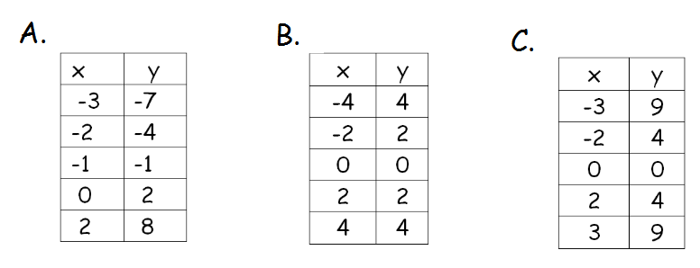
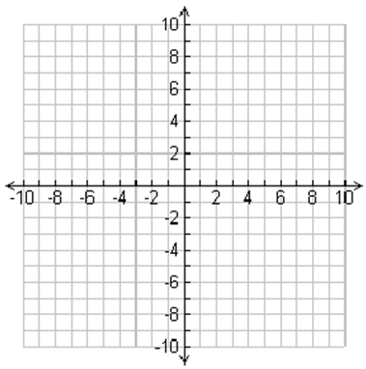

Use a graphing calculator to check your graphs. Follow the steps below carefully.
STAT
EDIT n
- Press

2. Enter the domain values (x-values) under L1 by putting in each value and pushing
ENTER
after every number.

3. Use the right arrow key to get over to L2 and enter the range values (y-values) by
ENTER
putting in each value and pushing after every number.
STAT PLOT
1
ENTER
ON
GRAPH
4. Press

5. Check to see if your graphs look the same as what you see on the calculator. If not,
go back and check your coordinates and re-graph.

