Reactants and Products Name _________________

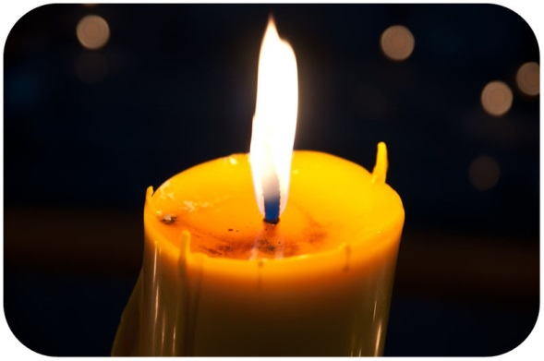

Did you ever wonder what happens to a candle when it burns? A candle burning is a [chemical change](http://www.ck12.org/physical-science/Chemical-Change-in-Physical-Science?referrer=crossref) in matter. In a chemical change, one type of matter changes into a different type of matter, with different chemical properties. Chemical changes occur because of [chemical reactions](http://www.ck12.org/chemistry/Chemical-Reactions?referrer=crossref). You can see more examples of chemical changes at this URL:<http://www.youtube.com/watch?v=66kuhJkQCVM>.

**From Reactants to Products**

All [chemical reactions](http://www.ck12.org/chemistry/Chemical-Reactions?referrer=crossref)—including a candle burning—involve reactants and products.

* **Reactants** are [substances](http://www.ck12.org/chemistry/Substances?referrer=crossref) that start a chemical reaction.
* **Products** are [substances](http://www.ck12.org/chemistry/Substances?referrer=crossref) that are produced in the reaction.

When a candle burns, the reactants are fuel (the candlewick and wax) and oxygen (in the air). The products are carbon dioxide gas and [water](http://www.ck12.org/biology/Water-Advanced?referrer=crossref) vapor.

**Relating Reactants and Products**

The relationship between reactants and products in a chemical reaction can be represented by a chemical equation that has this general form:

Reactants → Products

The arrow (→) shows the direction in which the reaction occurs. In many reactions, the reaction also occurs in the opposite direction. This is represented with another arrow pointing in the opposite direction (←).

**Q:** Write a general chemical equation for the reaction that occurs when a fuel such as candle wax burns.

**A:** The burning of fuel is a combustion reaction. The general equation for this type of reaction is:

Fuel + O2 → CO2 + H2O

**Q:** How do the reactants in a chemical reaction turn into the products?

**A:** Bonds break in the reactants, and new bonds form in the products.

**Breaking Bonds and Making Atoms**

The reactants and products in a chemical reaction contain the same [atoms](http://www.ck12.org/physical-science/Atoms-in-Physical-Science?referrer=crossref), but they are rearranged during the reaction. As a result, the atoms end up in different combinations in the products. This makes the products new [substances](http://www.ck12.org/chemistry/Substances?referrer=crossref) that are chemically different from the reactants.

Consider the example of [water](http://www.ck12.org/biology/Water-Advanced?referrer=crossref) forming from hydrogen and oxygen. Both hydrogen and oxygen [gases](http://www.ck12.org/physical-science/Gases-in-Physical-Science?referrer=crossref) exist as diatomic (“two-atom”) molecules. These molecules are the reactants in the reaction. The **Figure** [below](http://www.ck12.org/physical-science/Reactants-and-Products-in-Physical-Science/lesson/Reactants-and-Products/?referrer=featured_content#x-ck12-TVNfUFMtV2F0ZXJGb3JtaW5nLVJlYWN0YW50c1Byb2R1Y3Rz) shows that bonds must break to separate the [atoms](http://www.ck12.org/physical-science/Atoms-in-Physical-Science?referrer=crossref) in the hydrogen and oxygen molecules. Then new bonds must form between hydrogen and oxygen atoms to form [water](http://www.ck12.org/biology/Water-Advanced?referrer=crossref) molecules. The water molecules are the products of the reaction.

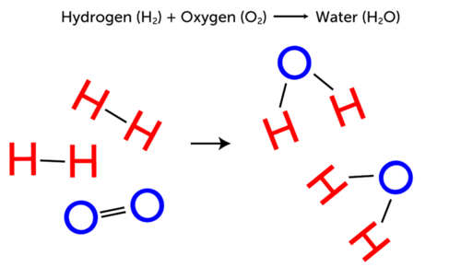

**Q:** Watch the animation of a similar chemical reaction at the following URL. Can you identify the reactants and the **product** in the reaction? <http://www.youtube.com/watch?v=SErRUqJ_x30>

**A:** The reactants are hydrogen (H2) and fluorine (F2), and the product is hydrogen fluoride (HF).

**Summary**

* All chemical reactions involve both reactants and products. Reactants are substances that start a chemical reaction, and products are substances that are produced in the reaction.
* A chemical reaction can be represented by the general [chemical formula](http://www.ck12.org/physical-science/Chemical-Formula-in-Physical-Science?referrer=crossref):

Reactants → Products

* Bonds break and reform during chemical reactions. Reactants and products contain the same [atoms](http://www.ck12.org/physical-science/Atoms-in-Physical-Science?referrer=crossref), but they are rearranged during the reaction, so reactants and products are different substances.

**Explore More**

Do the activities at the following URL for practice with reactants and products.

<http://phet.colorado.edu/en/simulation/reactants-products-and-leftovers>

**Review**

1. Identify the reactants and products in the following chemical reaction:

CH4+ 2O2 → CO2 + 2H2O

1. How do reactants change into products during a chemical reaction?