Chapter 3 Test
Study Guide

- Characteristic Properties – properties of elements that do not depend on the amount of the element. They can be physical or chemical properties.

  - Examples: color, odor. Density, conductivity, flammability and reactivity

- Physical Properties – properties of matter that can be observed or measured without changing the substance’s identity or composition

  - Examples: Density, State, Color, Odor, Volume, Conductivity, Solubility, Ductility, and Malleability

- Physical Change – change in matter that does not change the substance’s composition

  - Examples: cutting wood, melting a popsicle
  - Physical changes do NOT change the composition of the substance.

- Chemical Properties – properties of matter that describe the substance’s ability to participate in a chemical reaction

  - Examples:
    - Flammability – ability to burn
    - Reactivity – ability of 2 or more substances to combine to form other substances (ex. reactivity with acid, reactivity with water)
    - pH Scale – measures how acidic or basic a substance is (be able to use a pH scale to estimate the acid/basic level of substances.

- Chemical Change (reaction) – the process of changing a substance into an entirely new substance
  - In a chemical change, the substance’s composition changes.
  - Examples: fireworks exploding, iron rusting, milk souring
  - Chemical changes may cause bubbling or foaming or color change or produce heat, light or sound.

- Interpreting Graphs – Know how to interpret line graphs

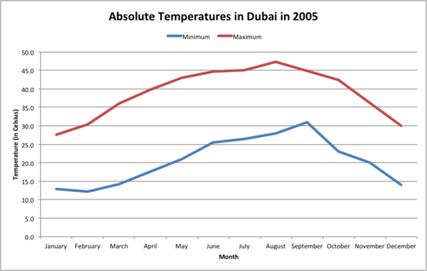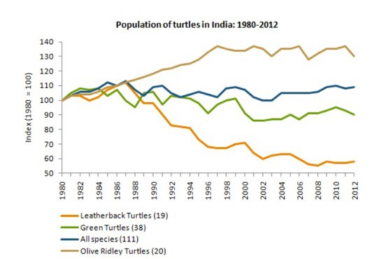

- Elements – a pure substance that cannot be separated into simpler substances by physical or chemical means
  - The smallest particle of an element that can still be classified as that element is an atom.
  - All particles of an element are identical.
  - Metals are shiny elements that conduct heat and electric current well. Iron is an example of a metal.
  - Nonmetals conduct heat and electricity poorly and can be a solid, liquid or gas. Sulfur is an example of a nonmetal.
  - Metalloids are elements that have properties of both metals and nonmetals. Silicon is an example of a metalloid.

- Compounds - pure substances composed of two or more elements that are chemically combined
  - The smallest particle of a compound that can still be classified as that compound is a molecule.
  - All particles of a compound are identical.
  - Compounds have different properties than the elements that form them, for example Sodium (Na) and Chlorine (Cl) are both poisonous elements but they chemically combine to form Sodium Chloride (NaCl) which is table salt that we eat.
  - Compounds can only be formed or broken down by chemical changes only (not by physical changes)
  - Compounds form in specific ratios and all particles are the same.
  - Carbon dioxide (CO₂) is an example of a compound. Animals breathe out carbon dioxide and plants take it in to use in photosynthesis.

- Mixtures – combinations of two or more substances that are not chemically combined
  - When elements form mixtures, the elements keep their original properties.
  - Mixtures are not pure substances.
  - Particles of mixtures are not all identical.
  - Mixtures can be separated physically.
  - Mixtures do not form in specific ratios and particles are not all the same.

- Pure Substances – Elements and Compounds are considered “pure substances” because all of their particles are identical. Mixtures are not considered pure substances because they are made up of different types of particles.

- Periodic Table - Elements are organized into groups or families according to similar properties of reactivity.

- Chemical Reactions – Reactants and Products
  - Reactants are the substances before they chemically react.
  - Products are the new substances formed by the chemical reaction.
  - Example:
    - Vinegar and baking soda are combined to give off carbon dioxide gas.
    - The reactants are vinegar and baking soda.
    - The product is the carbon dioxide gas.

