Get these apps!





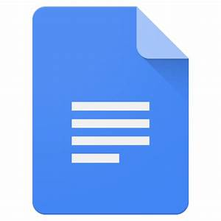





|  |  |  |
| --- | --- | --- |
| https://androidayuda.com/app/uploads/2017/04/Google-Classroom-630x330.jpg | https://tse1.mm.bing.net/th?id=OIP.BIelT2cV8vPhk1ufSaELdAHaD4&pid=15.1&P=0&w=320&h=169 | https://tse4.mm.bing.net/th?id=OIP.uQO-R8SBrbP46WEmr3WfaAHaHa&pid=15.1&P=0&w=300&h=300 |
| https://tse4.mm.bing.net/th?id=OIP.KKhJMbDNVcRw0GYppUXNRwHaC-&pid=15.1&P=0&w=423&h=171 | https://tse4.mm.bing.net/th?id=OIP.67nkfeA97REO5OAF85njUAHaDk&pid=15.1&P=0&w=358&h=173 | https://tse1.mm.bing.net/th?id=OIP.sENyd1PSiMeN40w7DB97VwHaBe&pid=15.1&P=0&w=506&h=102 |

Get these APPS!