**ESL Economics Final Study Guide**

Name: ________________________

Date: _________________ Hr: ____

**Vocab Final:** Monday, June 11 (regular class time)

**Questions Final:** Wednesday, June 13 9:30-10:30

**Practice all of these vocab! There are no retakes. Failure to take any test will result in a zero %. Translations will NOT be allowed on the exams, so be sure to practice and prepare as you need.**

1. economics: dealing with more wants and less resources

2. scarcity: little or few resources

3. need: required for basic survival

4. want: something we like but don’t need

5. land: natural places

6. capital: tools, equipment, and factories used to produce goods

7. labor: work/production

8. entrepreneur: someone who starts a business

9. economic growth: increase in a nation's total output of goods and services over time.

10. productivity: how well something does or sells

11. specialization: to focus and be good at one thing

12. human capital: the sum of people's skills, health, knowledge, and motivation

13. economic interdependence: when 2 or more businesses or countries need each other to make money

14. economy: the way money is made and used

15. employee: a person who works for money

16. employer: the business who hires workers

17. analysis: a deep study of something

18. explanation: to teach or make known

19. prediction: to think ahead

20. income: money that is made by a person

21. command: a want

22. good: a product that is useful, kind of scarce, and transferable to other

23. command: a want

24. good: a product that is useful, kind of scarce, and transferable to others

25. consumer good: goods intended for final use by people

26. consumers: people who use or consume goods to satisfy their wants and needs

27. durable good: lasts for at least 3 years

28. paradox of value: contradiction between essential items and nonessential items

29. utility: useful and provide satisfaction

30. exchange: a trade

31. wealth: having a lot of money

32. funds: money

33. Economic System النظام الاقتصادي: how a nation uses its resources to satisfy its people's needs and wants.

34. Society المجتمع: a group of people in an area

35. Traditional Economy الاقتصاد التقليدي: use of scarce resources are based on customs, ritual, or habits

36. Advantages المزايا: something good/positive/helpful

37. Disadvantage العيب: bad/negative/hurts

38. Market Economy اقتصاد السوق: the people make their own decisions for their best interests

39. Market - السوق: place where buyers and sellers exchange goods and services

40. Capitalism الرأسمالية: where citizens own the factors of production and decide their use (private businesses)

41. inability - عدم القدرة: not able to do something

42. competition - المنافسة: trying to make more money than others

43. Mixed Economy - الاقتصاد المختلط: economy with a combination of traditional, command, and market economies

44. minimum wage الحد الأدنى للأجور: the least money an employer can legally pay

45. protection الحماية: security

46. Social Security الضمان الاجتماعي: program that takes care of retired workers and people with disabilities

47. employment العمالة: jobs

48. inflation: rise in prices of goods

49. fixed income الإيرادات الثابتة: income that does not increase as prices go up

50. fluid: changing constantly

51. stability الاستقرار: not changing, normal

52. freedom الحرية: able to choose

53. equity حقوق الملكية: equality, fair

54. fixed income الإيرادات الثابتة: income that does not increase as prices go up

55. Fixed Costs (FC): prices that don’t ever change **الأسعار التي لا تتغير**

56. Variable Costs (VC): production costs that change when the level of production changes **يكلف هذا التغيير**

1. Total Costs (TC): FC + VC **إجمالي التكاليف**
2. Marginal Costs (MC): the EXTRA cost of producing one additional unit of output

**تكاليف إضافية**

1. Additional: more than before **إضافي**
2. E-commerce: online buying and selling **اعمال تجاريه عبر الانترنت**
3. Operate: how something runs/works
4. transactions: the action of buying and selling
5. equilibrium price: when the number of units produced equals the number of products sold
6. surplus: too much of an item (higher quantity than demand)
7. shortage: too little of an item (less quality than demand)
8. predict: to guess the future based on what you already know
9. increase: go up

Name: ________________________

Date: _________________ Hr: ____

**Chapter 1: What is Economics?**

1. List 3 examples of teach.

|  |  |  |
| --- | --- | --- |
| **Consumer Goods** | **Durable Goods** | **Nondurable Goods** |
|  |  |  |

1. What is an example of economic interdependence?
2. Fill in the bubble map for characteristics of economic growth.

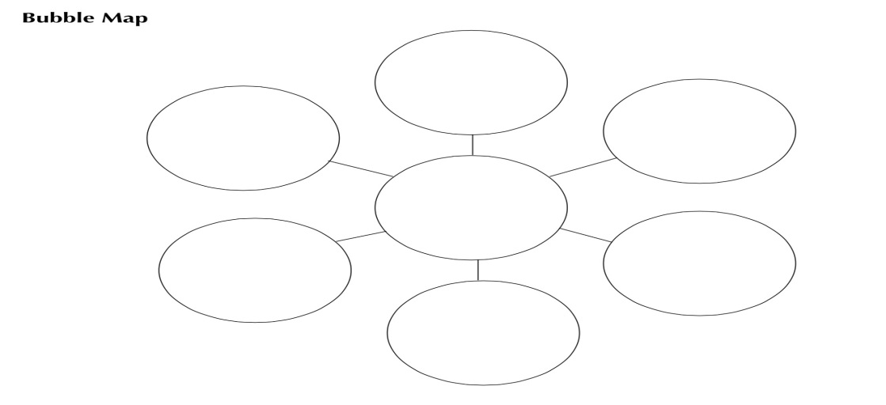

1. Write a sentence using the word funds in it.
2. A teacher, a surgeon, a mailman, and a dentist all walk into a restaurant together. Which of these has the highest standard of living (salary)? ______________________________

**Chapter 2: Economic Systems and Decision Making**

1. Define each economy and list an example for each.

|  |  |  |
| --- | --- | --- |
| **Economy Type** | **Definition** | **Example country** |
| Market |  |  |
| Command |  |  |
| Traditional |  |  |
| Mixed |  |  |

1. What is Michigan’s minimum wage in 2018? $_______ per hour
2. Free enterprise has 5 characteristics. Define each of them. The first is done for you.

|  |  |
| --- | --- |
| **Free Enterprise Characteristic** | **What it means** |
| Economic freedom | We are free to choose what to buy and how to earn money. |
| Voluntary exchange |  |
| Private property rights |  |
| Profit motive |  |
| Competition |  |

1. Read “The Role of the Entrepreneur” on workbook page 17. Write 2-3 sentences explaining what you read.
2. ---------------------------------------------------------------------------------------------------------------------------------------------------------------------------------------------------------------------------------------------------------------------------

**Chapter 4: Demand**

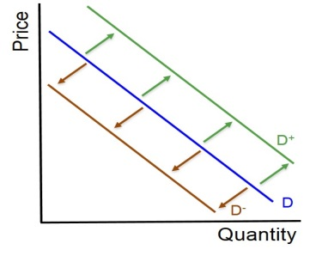

1. What kinds of “shifters” would cause the demand curve to shift left or right?
2. When demand increases, the curve shifts to the _____________. When it decreases, it shifts to the _______________.
3. What are some determinants of demand?
4. What is the substitution effect?
5. Elasticity: Write “E” for Elastic or “I” for Inelastic.

|  |  |
| --- | --- |
| * Gasoline _____ * Ice cream _____ * iPhone X _____ | * Care from doctors _____ * Medicine _____ * Internet ______ |

**Chapter 5: Supply**

1. What does the Law of Supply say?

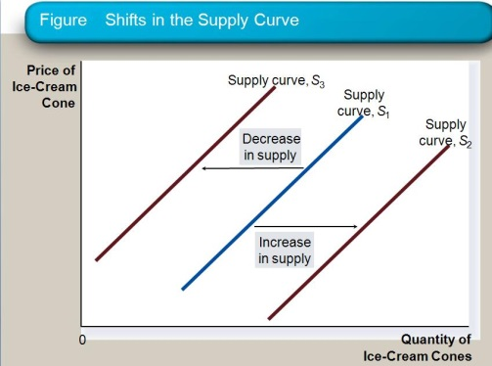

1. What are the 8 factors that can cause a shift in the supply curve (right or left)?
2. Match the stages of production.

|  |  |
| --- | --- |
| **Stage of Production** | **What it Says** |
| Stage I _______  Stage 2_______  Stage 3_______ | 1. Negative marginal returns 2. Increasing marginal returns 3. Decreasing marginal returns |

1. **Directions:** First, fill in the open boxes using Figure 5.5 A on TEXT pg. 128. Then color GREEN for Stage I, YELLOW for Stage II, and RED for Stage III of Production.

|  |  |  |  |
| --- | --- | --- | --- |
| **Number**  **Of Workers** | **Total Product** | **Marginal Product** | **Stages of Production** |
| 0 | 0 | 0 | Stage I |
| 1 | 7 | 7 |  |
| 2 |  | 13 |  |
| 3 |  | 18 |  |
| 5 |  |  |  |
| 6 | 110 |  | Stage II |
| 8 |  | 9 |  |
| 10 |  | 4 |  |
| 11 | 145 |  | Stage III |
| 12 |  | -10 |  |

1. Write an example of FIXED COST (FC).

**Chapter 6: Prices**

1. 4 reasons that prices are effective are:
2. Why would a store lower its prices from its competitors (Walmart)?

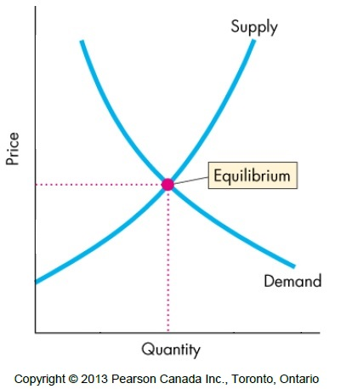

1. Use the chart above to describe what “equilibrium” means.