Ms. M. Beydoun
Honors Algebra II Classroom Syllabus

iBlog: http://iblog.dearbornschools.org/beydounsiblog/
Email: beydoum2@dearbornschools.org
Room #: A 124

School Phone #: (313) 827-1400

Grading Policy: STANDARDS-BASED GRADING
In order to shift our focus from letter grades to mastery of the content, standards based grading will be used in this class.
This system of achievement is focused on your demonstration of long-term mastery rather than short-term memorization.
More information on how we will use this scale can be found on my blog and will be discussed thoroughly in class.

Summative (Product)  - Unit Tests (4 point scale)  - Projects (4 point scale)  - Final Exam (4 point scale) | Formative (Practice)  - Homework  - Classwork  - Quizzes
Attendance:
Fordson’s attendance policy states that at 5 absences a student gets a letter sent home in warning as well as at 10 absences. When a student reaches 10 absences they will get reduced credit for the class unless they receive a 78% or higher on the end of term assessment or if they receive a 78% on the test out exam.
- A student who is over 15 minutes late to class is equal to 1 absence.
- Two late (5-15 minutes) in a class is equal to 1 absence.
- Four tardies in a class is equal to 1 absence.
- It is your responsibility to keep track of your attendance.
Homework:
- Homework is very important part of mathematics. Practice makes perfect. All students need to try each and every single problem to the best of their ability. Students must show all work to get full credit. Late work will NOT be accepted. Standards based grading eliminates the concept of late work. You may continue to work on a learning target until you meet or exceed the standard or until the term ends, whichever comes first. However, it is important to complete all work when it is due in order to keep up with activities in class. Assignments turned in late will be marked late in MiStar so that you and your parents can keep track of your work habits, but this will not directly impact your grade. You may redo any assignment to improve your final grade. Redoing an assessment will require extra work on your part; do your best the first time.
- Exit Tickets are given to assess understanding at the end of class. If you miss class for any reason (sickness, leaving school early, etc.) it is YOUR responsibility to check the absent work folder and meet all makeup work deadlines. All work must be done in PENCIL to get credit.
S.L.O.T. (bell-work)
Every day during class at the beginning of the hour you will be required to do S.L.O.T (bell-work). You will have S.L.O.T. quiz every Friday covering what we learned in class.
Required Supplies:
- Three-Ring Binder (1-inch binder recommended) OR a Two-Pocket Folder
- 1 Spiral Notebook and 1 Composition Notebook (One for Slots & the other for Guided Notes)
- Loose-leaf papers (Papers out of a notebook will NOT be accepted!!!)
- Graph Papers
- Pencils and Erasers (No PENS!!!)
- Highlighters
- Glue Sticks OR Scotch Tape

Test Standards:
- You are responsible for making up a test. Tests WILL NOT be excused for any reason.
- If you miss a test or quiz, it will have to be taken after school.
- You MAY NOT borrow or share a calculator during any test or quiz.
- During a test talking and cell phones are STRICTLY prohibited. Should you choose to talk or have a cell phone out during a test or quiz you will receive half of your grade earned. Should this occur a second time, you will receive a 0%.
- If you are caught cheating you may be disqualified from being a candidate for valedictorian or salutatorian.
Materials
Bring your math book, pencils, eraser, and calculator to class every single day.
You will be assigned a TI-Nspire graphing calculator and a Chromebook to use in class. You are responsible for the assigned item. You may not use any other calculator/ Chromebook other than the one that is assigned to you. Please report any damages immediately, so you will not be responsible for the damages. If you write on the calculator/ Chromebook you will lose privilege of using it for the week. If you repeat the same behavior, you will lose the privilege for the semester. If you damage the calculator or Chromebook it is your responsibility to replace it. I will not assign any calculators after class for you to finish your work.
Extra Help
PLEASE ASK FOR HELP if you are beginning to struggle. I am very flexible to help you become successful in mathematics. Tutoring for the Freshmen Academy will be offered after school. Day/Time will be determined.

Electronic Devices:
Phones, IPods, gaming devices, and other handheld devices will not be allowed during class time. Grades will be directly impacted by the inability to follow this rule. There is zero tolerance for electronics and cell phone use in class; the Fordson cell phone policy is strictly enforced in this classroom. Cell phones will be collected at the beginning of class daily, except days when we will use them in the lesson (you will be notified prior to us using them in class.)

Food/Drinks:
- No food allowed in my classroom.
- Water (with screw tops) will be permitted unless this creates a distraction in the classroom (Littering, spilling, messes, etc).
The same rules stated in your student handbook must be obeyed and followed in my classroom as well.
All freshmen will be given a daily planner. The planner is a tool to help you be successful in 9th grade. Please have your planner available every day at the beginning of each class period. PASSES will NOT be issued during class.
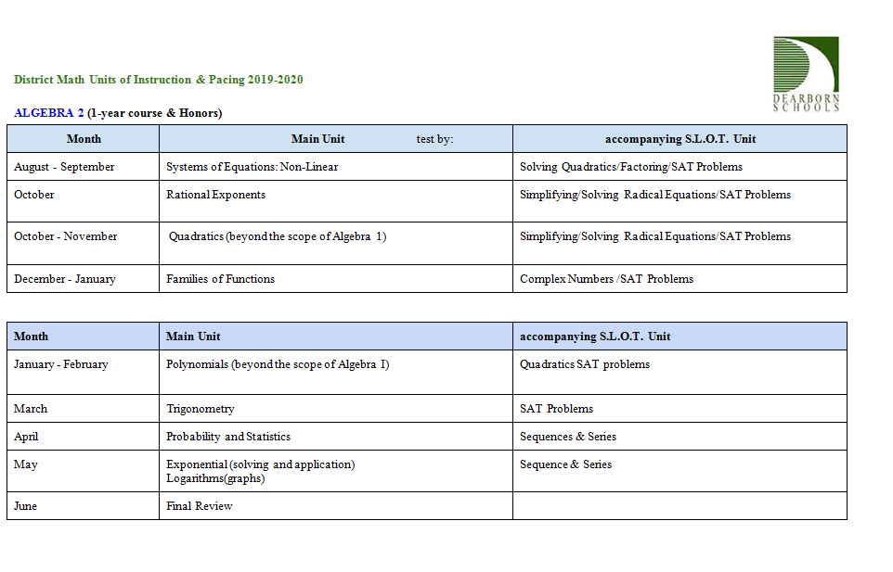

Algebra II units plan and Syllabus is subject to change at any time.
Technology to be in our classroom:

iBlog- Parents are highly advised to visit my blog to check for daily activities and assignments as well to contact me if needed.
- To checkout or contact me on my blog, visit the following website address: http://iblog.dearbornschools.org/beydounsiblog/

IXL (Algebra I)- will be used as a weekly homework assignment based on the unit you are being taught in class (must be completed and submitted within the given time).
- To login to IXL, visit the following website address: www.IXL.com/signin/fordson

Kaboot App- will be used to review for quizzes and tests.

Desmos Graphing Calculator- suggested to be downloaded.
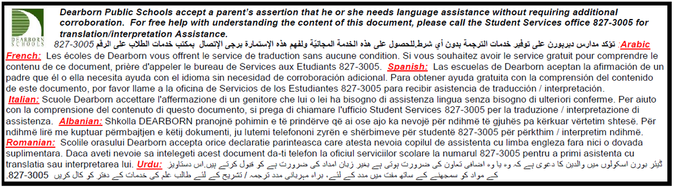
Cut ✂------------------------------------------------------------------------------------------Cut ✂
Dear Parent or Guardian,
I’m Ms. Beydoun. I am your son/daughter’s Honors Algebra II teacher. I am extremely excited to begin this school year. My goal is to help your son/daughter to be successful in Honors Algebra II. It is important that we all do our part to guarantee success in Honors Algebra II.
Please review the Syllabus and the Expectations in your son/daughter’s planner. I reviewed the course syllabus and PBIS with each student. A copy of the course syllabus may be found on my website. I would appreciate you and your student reviewing the syllabus and planner together then sign below to indicate that you have read and agree to comply with these policies. If you have any further questions regarding the course or the district policies, please feel free to contact me. My contact information is above. Please cut the bottom portion of this page and keep the top.
Thank you in advance for your concern and interest in your child’s education.

I have read and understand Ms. Beydoun’s Honors Algebra II Syllabus

_________________________________
Student Name (Printed)

_________________________________ __________________ ___________
Student Signature Date Hour

_________________________________
Parent/Guardian Name (Printed)

_________________________________ _______________________
Parent/Guardian Signature Date

_____( )_______________________
Parent/Guardian Phone Number

Math Department Final Exam Policy
It is the policy of the Mathematics Department at Fordson High School that no student will be permitted to take his or her final exam early. In addition, all missing assignments incurred as a result of leaving school before the official end of the semester will be marked as zeroes in the grade book. Lastly, the Dearborn Public Schools audit policy will be applied to all absences that occur prior to the official end of the school year.
*Due to district policy if anyone is found cheating he/she may be prohibited to be the valedictorian or the salutatorian.
Parents please leave me any information you would like me to have regarding communications of your student’s achievement in our class.

