|  |  |  |  |  |
| --- | --- | --- | --- | --- |
| Important information from Unit 3 | | | | |
| Combining Like terms | Finding Equivalent expressions | Using the Distributive  Property | Writing and using expressions | Solving equations |

8.) Thomas is bringing in his dog to the veterinary hospital. It will cost $120 for the dog’s shots plus $20 per appointment.

***Part A***

Write an equation showing the total cost, t, for the amount he will owe.

t = 120 + 20x

***Part B***

The veterinary hospital decides to give Thomas a 10% discount for his total cost. Write a new equation showing this updated cost.

t = 0.10(120 + 20x)

***Part C***

How much will it cost if Thomas’ dog needs 3 appointments?

t = 120 + 20x

120 + 20(3)

120 + 60

$180.00

9.) Write an equivalent expression for **2 + 18x** hint: use the distributive property

2(1 + 9x)

10.) Which of the following are equivalent to **5x(x – 3)** Choose all that apply

1. 5 $x^{2}$– 15x
2. 5( $x^{2}$– 3x)
3. -15x + 5 $x^{2}$
4. (x + 3)5x
5. 6x – 8

11.) Find an equivalent expression for the following expression: **2y(1 – 2y) – (2y + 7)**

2y – 4y – 2y + 7

-4y + 7

12.) Solve the equation $\frac{1}{4}$**(x + 8) + $\frac{3}{4}$ x = 10**

$\frac{1}{4}$ x + 2 + $\frac{3}{4}$ x = 10

x + 2 = 10

x = 8

13.)

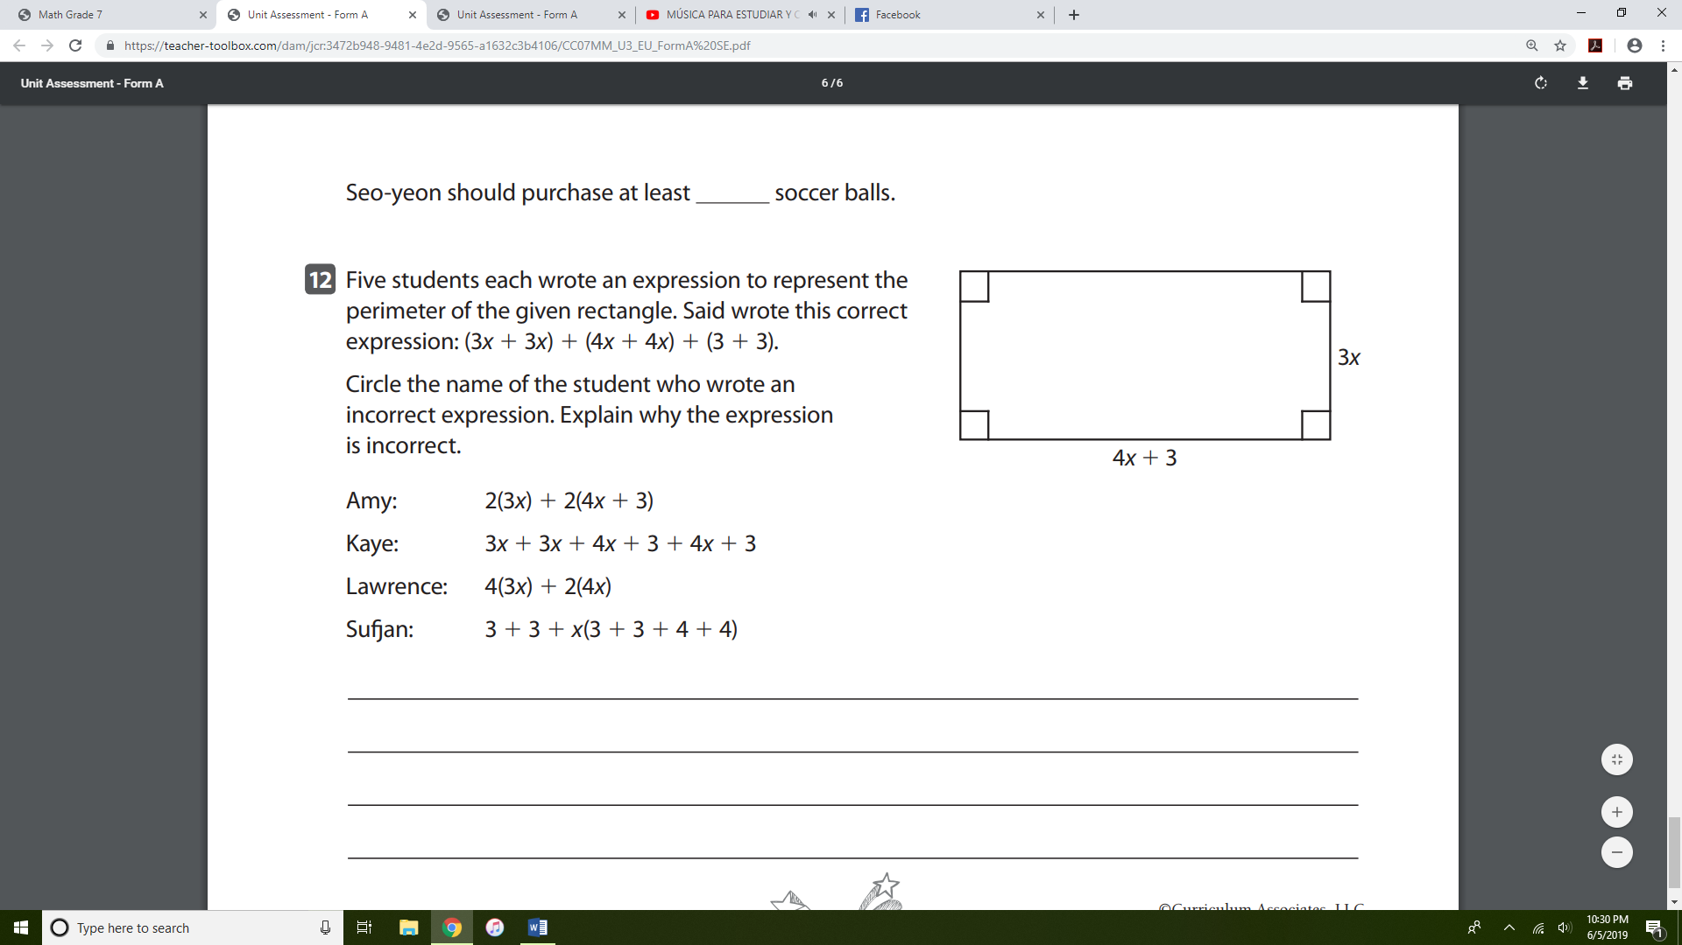

Which expression showing the perimeter of the rectangle is incorrect? Explain why

2(3x) + 2(4x + 3) 4(3x) + 2(4x) 3 + 3 + x(3 + 3 + 4 + 4)

6x + 8x + 3 12x + 8x 6 + 3x + 3x + 4x + 4x

14x + 3 20x 6 + 14x