C:\Program Files (x86)\Microsoft Office\MEDIA\CAGCAT10\j0305493.wmf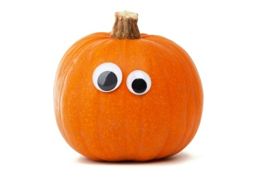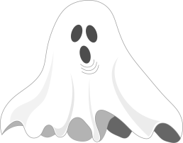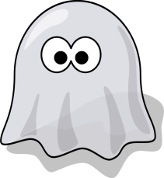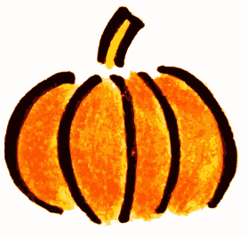

Hello Woodworth Community!

Students will have an opportunity to purchase a costume pass on Halloween for $1.00. The pass will be a Pumpkin sticker and it will be available for purchase during A2 on Halloween (October 31). Students will need to wear the sticker showing that they paid to wear the costume for the entire day. All money raised will go towards PBIS rewards.

In an effort to enjoy and celebrate Halloween at Woodworth Middle School appropriately, respectfully, and in accordance with school rules, we ask that students use the following guidelines when selecting a costume:

1. NO head coverings, NO masks or FULL face paint. Staff members must be able to identify students.
2. Costumes that are provocative, revealing, sexual in nature, or employ questionable props are not permitted.
3. Costumes that depict violence, alcohol, or drugs are not permitted. Fake weapons are not allowed.
4. Costumes that could be offensive or perpetuate a stereotype of someone’s culture, gender, heritage, or religion are not permitted.
5. Costumes should not hinder your ability to participate in your classes, including P.E. Costumes may not disrupt or impede traffic, or present issues of safety in the hallway.

Students wearing questionable costumes will be asked to change into normal school attire. If students have any questions regarding the appropriateness of their costume idea, we encourage them to speak with school administers.

Here are some talking points for you to assist in this teachable moment…

* Remind students of their audience in the building (students, teachers, parents, community members,).
* This is a school—what may be appropriate in pop culture or the media may not be appropriate for a place of learning.
* We are a community, and we want students to think about how their costume choice may impact others within this community. Thank you for taking the time to help our students understand these guidelines!

PBIS Committee