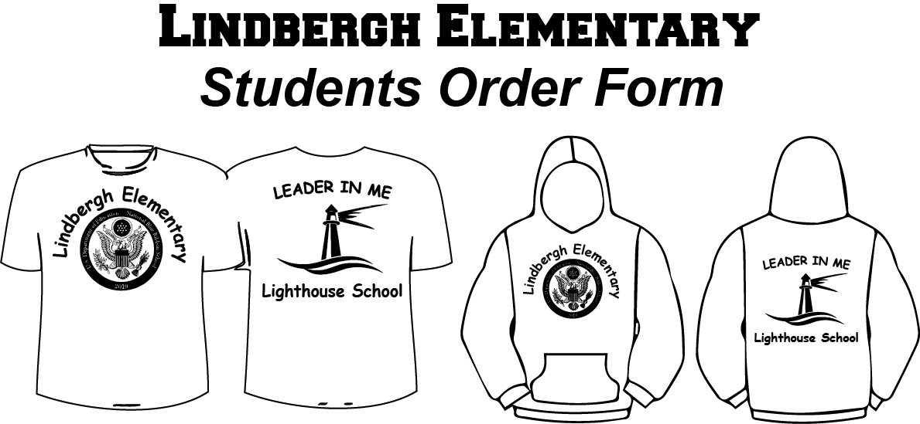

STUDENT NAME:____________________________________

Teacher Name:________________________________________

Grade: _______________________________________________

**METHOD OF PAYMENT: Cash only. No checks**

|  |  |  |  |  |  |  |  |  |
| --- | --- | --- | --- | --- | --- | --- | --- | --- |
| **Item** | **Quantity** | **Size** | **Color** | | | **Price** | **NOTES** | **Total** |
| **ROYAL** |  |  |
| **Short Sleeve T-Shirt** |  |  |  |  |  | 9.00 |  |  |
| **Long Sleeve T-Shirt** |  |  |  |  |  | 11.00 |  |  |
| **Hooded Sweatshirt** |  |  |  |  |  | 22.00 |  |  |
|  |  |  |  |  |  |  |  |  |
|  |  |  |  |  |  |  |  |  |
|  |  |  |  |  |  |  |  |  |
|  |  |  |  |  |  |  |  |  |
|  |  |  |  | | |  |  |  |

**Sizes:**

**Youth XSmall_____ Youth Small _____ Youth Medium _____ Youth Large_____ Youth XL________**

**Adult Small _____ Adult Medium _____ Adult Large _____ Adult XLarge _____**

**+$ 3.00 for: XXL, XXXL**

**ALL ORDERS ARE DUE TO CLASSROOM TEACHERS WITH CASH ONLY BY _____________________________**