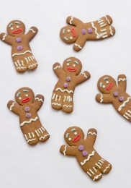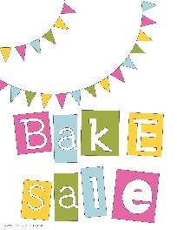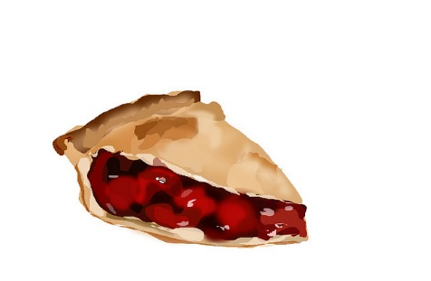

**CALLING ALL BAKERS!**

It’s that time of year again!!!

The Lindbergh **Holiday Boutique** and **Bake Sale** is November 12th.

Our sale last year was a tremendous success **thanks to all the wonderful families that**

**donated their time, energy and delicious baked goods and candy.**

We need your help again this year:

Donate your Cakes, Cookies, Rice Krispie Treats!

Donate Quick Breads, Pies, Cupcakes, Brownies!

Donate Gluten Free Goodies, Candy -Fudge, pretzels!

Have a favorite baked good or candy? Please donate it!!!!

Not a baker or candy maker? No problem!

Store bought and bakery goods are welcome too.

We would also be happy to have donations of clear basket wrap, clear cellophane treat bas and colorful ribbon too. Once again, we are offering incentives to the classes that donates the most baked goods by Friday, November 11, 2016:

First Prize: Ice Cream Sandwich party

Second Runner Up: Doughnuts for the class.

**With your help we can make it another RECORD BREAKING YEAR!**