March is Reading Month!

Monday | Tuesday | Wednesday | Thursday | Friday
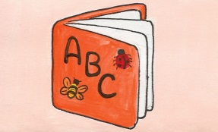 |  |  |  | 
7 | 7 | 9 | 10 | 11
Doorway decorating week!  *Spring Picture Day! | *Read a biography today.  Start bookmarks for contest.  Secret reader. | *Bring $1 and wear your pajamas to school!  (Leader In Me Fundraiser) | *Make a poster telling about your favorite book. | *Wear a hat with words!  Guess the Book.
14 | 15 | 16 | 17 | 18
*Don’t forget to work on your bookmarks for the contest!  *Secret reader.  Mrs. DeNeen-Special read aloud. | *Put a poem in your pocket. Read it to five people today. | Late Start…  *Bookmarks are due!  *Wear a shirt that has your favorite team’s name on it. | *Read about your favorite animal. Share some facts you learned with a friend. | *Read In 1:30 - 2:30  Bring in a pillow and a stuffed animal.  Guess the Book.
21 | 22 | 23 | 24 | 25
*Wear pin or button with words!  *Read a magazine.  Secret reader. | *Read a joke or  riddle book. Practice a joke and tell it to a friend. | Teacher Shuffle 9:00  *Wacky Sock Wednesday! | *Dress as your favorite book character!  Guess the book. | SPRING BREAK BEGINS…  
28 | 29 | 30 | 31

“The more that you read, the more things you will know. The more that you learn, the more places you’ll go.” ~Dr. Seuss

