March is Reading Month!

Monday | Tuesday | Wednesday | Thursday | Friday
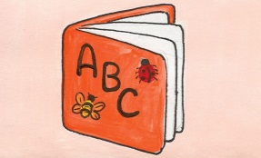  2 | 3 | 4 | 5 | 6
 | PBiS Assembly |  | Read a fantasy book.  *Wear a shirt with words on it! | Read a picture book with a friend.  *Spring Picture Day!  Guess the Book.
9 | 10 | 11 | 12 | 13
Doorway decorating week!  Dearborn High Football Team-Guest readers.  Secret reader. | Read a biography today.  Start bookmarks for contest. | Late Start  *Wacky Sock Day! | Make a poster telling about your favorite book. | *Wear a hat with words!  Guess the Book.
16 | 17 | 18 | 19 | 20
Don’t forget to work on your bookmarks for the contest!  Secret reader.  Mrs. DeNeen-Special read aloud. | Read a poem to a friend. | Bookmarks are due!  *Wear a shirt that has your favorite team’s name on it. | Read about your favorite animal. Share some facts you learned with a friend.  Author Visit. | *Wear a pin or button with words!  **Book swap today!!!!  Guess the Book.
23 | 24 | 25 | 26 | 27
Read a magazine.  Secret reader. | Read a joke or  riddle book. Practice a joke and tell it to a friend. | Teacher Shuffle 9:00  *Show your Lindbergh spirit! Wear your Lindbergh shirt today! | Put a poem in your pocket. Read it to five people today. | *Dress as your favorite book character!  Guess the book.
30 | 31 |  |  | 
Read a realistic fiction book.  Secret reader. | Read-In 1:30 – 2:30  *Bring in a pillow and stuffed animal.

“The more that you read, the more things you will know. The more that you learn, the more places you’ll go.” ~Dr. Seuss

