Cream Puffs

½ cup water Toppings
¼ cup or ½ stick butter
¼ t. salt 2 T. Confectioner’s sugar (optional)
½ cup sifted flour 1 Scoop ice cream (optional)
2 Eggs 1-2 T. hot fudge (optional)
1-2 T. Fruit mixture (optional)

Preheat oven to 425˚. In a medium saucepan melt butter. Add water; bring to a rolling boil. Add sifted flour and salt all at once; stir vigorously. Cook and stir till mixture forms a ball that doesn’t separate. Remove from heat; cool slightly, about 3-5 minutes.
Add eggs, one at a time, beating with a wooden spoon after each addition for 1 to 2 minutes or till smooth.
Drop batter by heaping tablespoon 3 inches apart onto a greased baking sheet. Bake in a 425 oven about 20 minutes reduce heat to 400 until till golden brown and puffy.

Remove from oven. Cool on a wire rack. Split; remove any soft dough inside. Fill with your choice of topping: hot fudge, whipped cream, pudding, ice cream, or fruit mixture.

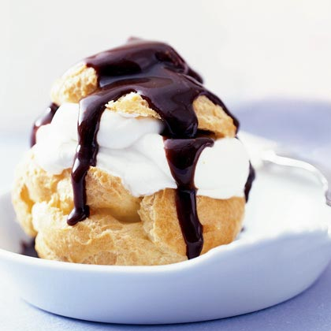I love mrs anderson!!!!!

Heat oven to 400. Heat water and butter to rolling boil. Reduce heat to low. Measure flour by dip/level/pour/sift. Add sifted flour mixture all at once. Stir vigorously with a wooden spoon. Cook and stir until mixture forms a ball that doesn’t separate. Remove from heat. Beat in eggs separately until smooth before adding the next egg. Drop dough by heaping tablespoons 3 inches apart onto an ungreased baking sheet. Bake 35 to 40 minutes or until puffed and golden. Cool away from draft. When cream, puffs are cooled, put them in a bag, label with kitchen unit # and section #. Store in refrigerator until serving. Wash dishes. Dry dishes. Finish clean-up

Day 2 –Set table. To prepare dessert: cut off tops, (optional: pull out and filaments of soft dough). Carefully fill puffs with ice cream and or hot fudge and replace tops. Wash dishes. Dry dishes. Finish clean-up

