Functions Essentials STUDY GUIDE NAME:______________________________

DATE:___________ PERIOD:_________

1. Evaluate the following expressions given the functions below:

g(x) = -3x + 1 f(x) = x² + 7

a. g(10) = b. f(3) = c. h(–2) =

d. j(7) = e. h(a) f. g(b+c)

h. Find x if g(x) = 16 i. Find x if h(x) = –2 j. Find x if f(x) = 23

2. Given $f(x)=3−4x$. Fill in the table and then sketch a graph.

x | f(x)
-2
-1
0
1
 | -9

3. Translate the following statements into coordinate points, then plot them!

a. f(–1) = 1

b. f(2) = 7

c. f(1) = –1

d. f(3) = 0

f(x)
y
x
5
5
-5
-5
4. Given this graph of the function f(x):

Find:

a. f(–4) = b. f(0) = c. f(3) =

d. f(-5) = e. x when f(x) = 2 f. x when f(x) = 0

5.
Function? (yes or no)

Domain

Range

6.
Function? Yes No  Domain : Range : | Function? Yes No  Domain : Range :

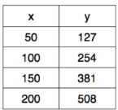  Domain:  Range: | 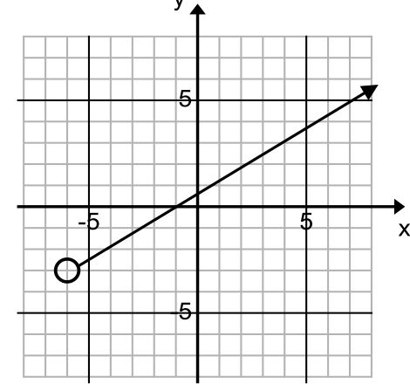  Domain:  Range: | 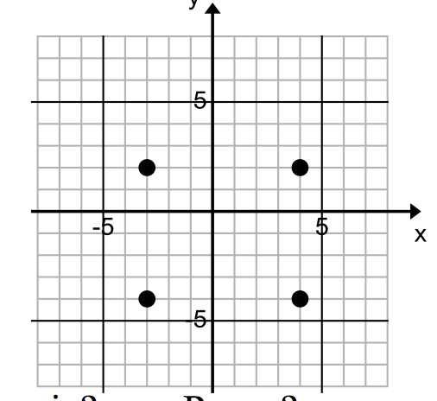  Domain:  Range:
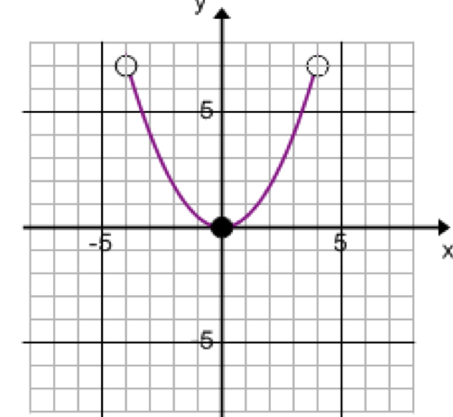  Domain:  Range: | 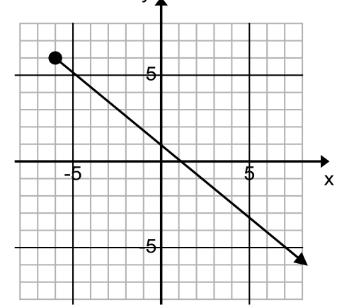  Domain:  Range: | 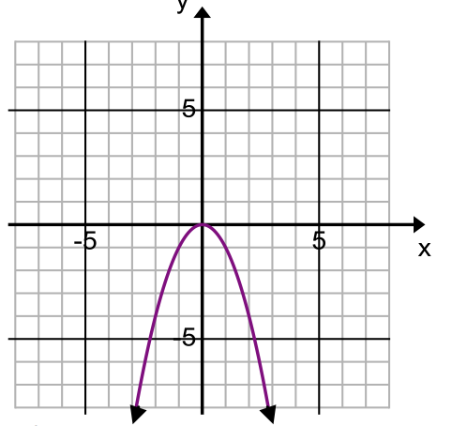  Domain:  Range:
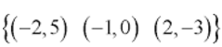  Domain:  Range: | 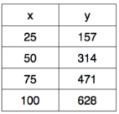  Domain:  Range: | 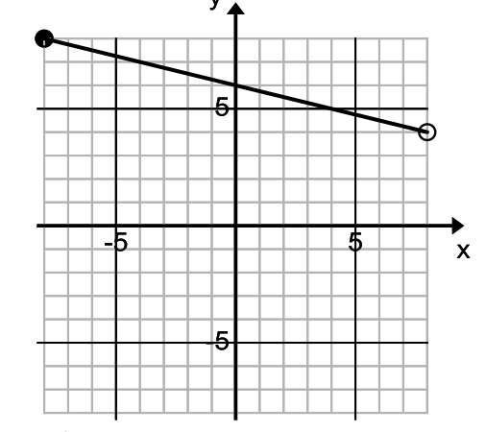  Domain:  Range:

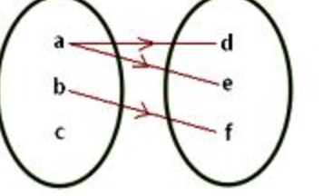  Domain:  Range: | 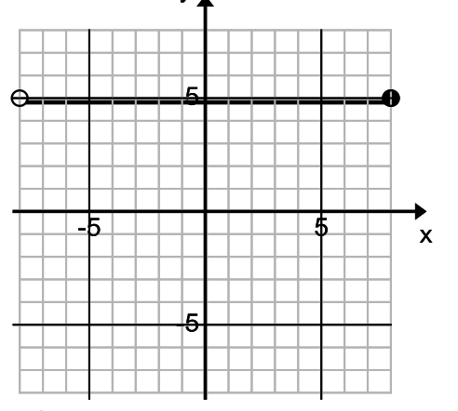  Domain:  Range: | 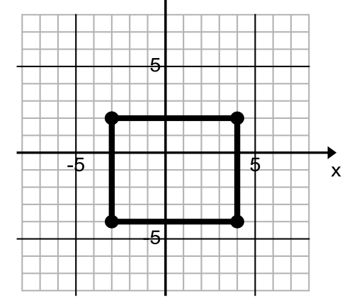  Domain:  Range:
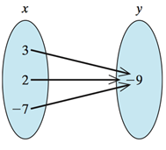  Domain:  Range: | 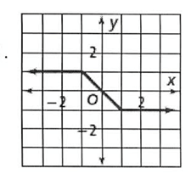  Domain:  Range: | 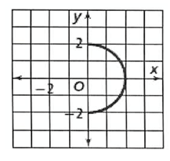  Domain:  Range:
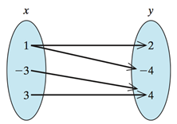  Domain:  Range: | 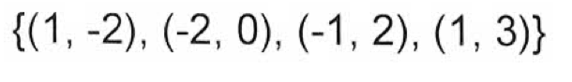  Domain:  Range: | 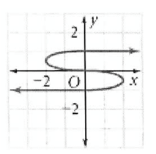  Domain:  Range:

