Name:_________________________________Date:______________1st 2nd 3rd 4th 5th 6th

Coordinate Plane

1 | - Label the x- axis  - Label the y-axis  - Label each Quadrant  - I, II, III, IV  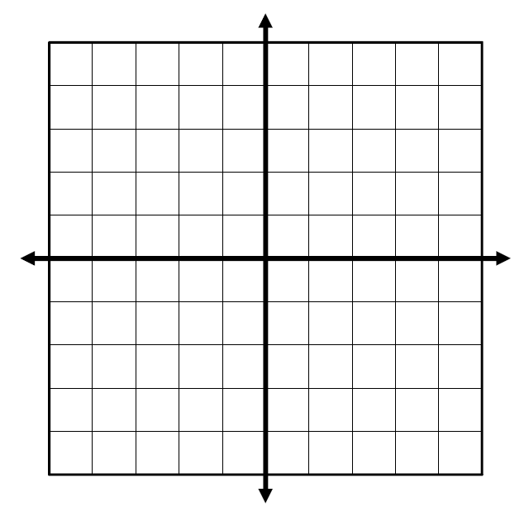 | 2 | - Give an example of an ordered pair  - Label the x-coordinate  - Label the y-coordinate  Ordered Pair  ↗ ↖
3 | - Label the x- axis  - Label the y-axis  - Plot the point (2,-4)  - Label the point  - The point (2,-4) is in Quadrant____ | 4 | - Label the x- axis  - Label the y-axis  - Plot the point (4,3)  - Label the point  - The point (4,3) is in Quadrant_____
5 | - Label the x- axis  - Label the y-axis  - Plot the point (-2,-5)  - Label the point  - The point (-2,-5) is in Quadrant____ | 6 | - Label the x- axis  - Label the y-axis  - Plot the point (-3,1)  - Label the point  - The point (-3,1) is in Quadrant_____
7 | - Label the x- axis  - Label the y-axis  - Plot a point in Quadrant III  - Label the point  - Is x>0 or is x<0?  - X is ______________  - Is y>0 or is y<0?  - y is ______________ | 8 | - Label the x- axis  - Label the y-axis  - Plot a point in Quadrant I  - Label the point  - Is x>0 or is x<0?  - X is ______________  - Is y>0 or is y<0?  - y is ______________
9 | - Label the x- axis  - Label the y-axis  - Plot a point in Quadrant IV  - Label the point _________  - Is x>0 or is x<0?  - X is ______________  - Is y>0 or is y<0?  - y is ______________ | 10 | - Label the x- axis  - Label the y-axis  - Plot a point in Quadrant II  - Label the point  - Is x>0 or is x<0?  - X is ______________  - Is y>0 or is y<0?  - y is ______________
11 | If a point is in Quadrant I, which of the following is true?  - ax<0, y >0  - x>0, y <0  - x>0, y >0  - x <0,y <0  - Choose a point in Quadrant I ______  - Justify your answer. | 12 | If a point is in Quadrant IV, which of the following is true?  - ax<0, y >0  - x>0, y <0  - x>0, y >0  - x <0,y <0  - Choose a point in Quadrant IV ______  - Justify your answer.
13 | If a point is in Quadrant III, which of the following is true?  - x<0, y >0  - x>0, y <0  - x>0, y >0  - x <0,y <0  - Choose a point in Quadrant IV______  - Justify your answer. | 14 | If a point is in Quadrant II, which of the following is true?  - x<0, y >0  - x>0, y <0  - x>0, y >0  - x <0,y <0  - Choose a point in Quadrant IV ______  - Justify your answer.
15 | Is the point on the x-axis or the y-axis?  - The point is on the _______-axis  - Label the point ___________  - Label the x-axis  - Label the y-axis  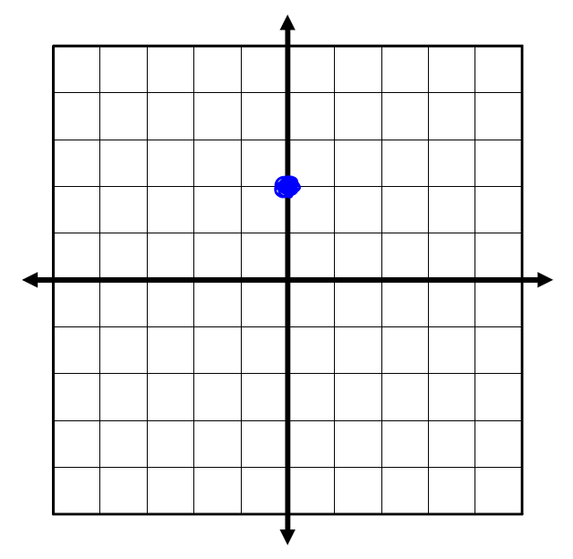 | 16 | Is the point on the x-axis or the y-axis?  - The point is on the _______-axis  - Label the point ___________  - Label the x-axis  - Label the y-axis  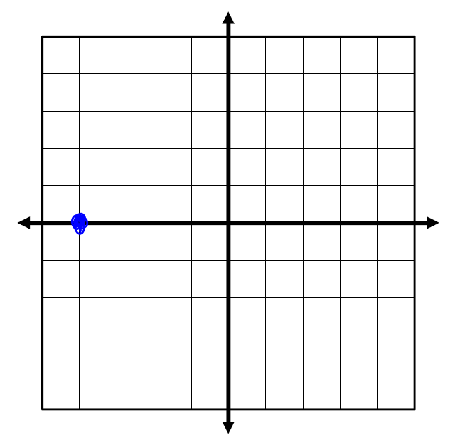
17 | If x <0 and y>0, which Quadrant is your point in?  - Plot and label your point  My point, __________, is in Quadrant ____ | 18 | If x <0 and y <0, which Quadrant is your point in?  - Plot and label your point  My point, __________, is in Quadrant ____
19 | If x>0 and y >0, which Quadrant is your point in?  - Plot and label your point  My point, __________, is in Quadrant ____ | 20 | If x>0 and y <0, which Quadrant is your point in?  - Plot and label your point  My point, __________, is in Quadrant ____
21 | If (x,y) is on the x-axis, what is true?  x=0 or y=0? Why? Justify your answer by plotting the point.  If (x,y) is on the x-axis, then ______=0. | 22 | If (x,y) is on the y-axis, what is true?  x=0 or y=0? Why? Justify your answer by plotting the point.  If (x,y) is on the y-axis, then ______=0.

