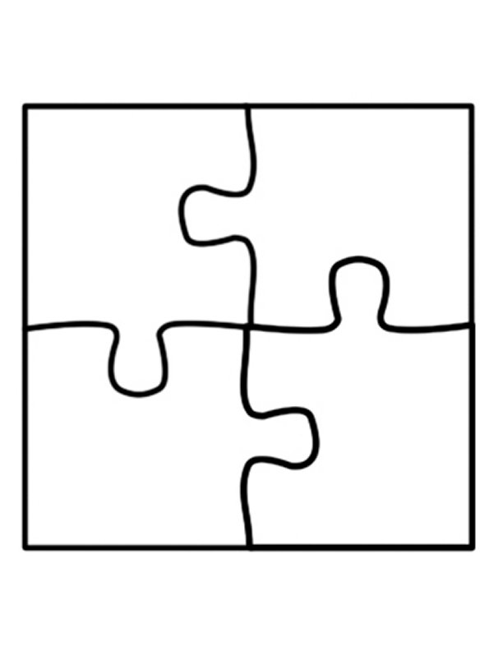 ***The sum of 5x***

***and 2x is 5x+2x ≥ 70***

***at least 70***

[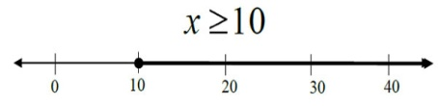](https://www.google.com/url?sa=i&rct=j&q=&esrc=s&source=images&cd=&cad=rja&uact=8&ved=0ahUKEwiym4H06-_QAhUHi1QKHVgSBBUQjRwIBw&url=http://ontrack-media.net/gateway/algebra1/g_a1m1l7s1.html&psig=AFQjCNEmILreVilYH1ZwJI7QPAQikDgPwQ&ust=1481672918435579)

**x≥10**



**Twice a number**

**Increased by 6**

**is at most 12**

**[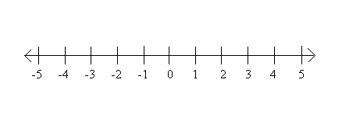](https://www.google.com/url?sa=i&rct=j&q=&esrc=s&source=images&cd=&ved=0ahUKEwjTgI6s7u_QAhWIwVQKHR4DChUQjRwIBw&url=http://www.sparknotes.com/math/algebra1/inequalities/section4.rhtml&bvm=bv.141320020,d.cGw&psig=AFQjCNEidT2GuE04SQdgiU3QF1haAQjYjQ&ust=1481673491254472&cad=rjt)**

** The product of negative**

**five and x increased**

**by 6 is less**

**than 11**

**[](https://www.google.com/url?sa=i&rct=j&q=&esrc=s&source=images&cd=&ved=0ahUKEwjTgI6s7u_QAhWIwVQKHR4DChUQjRwIBw&url=http://www.sparknotes.com/math/algebra1/inequalities/section4.rhtml&bvm=bv.141320020,d.cGw&psig=AFQjCNEidT2GuE04SQdgiU3QF1haAQjYjQ&ust=1481673491254472&cad=rjt)**



**The product of a number**

**and 7 decreased by 3**

**is greater than**

**18**

**[](https://www.google.com/url?sa=i&rct=j&q=&esrc=s&source=images&cd=&ved=0ahUKEwjTgI6s7u_QAhWIwVQKHR4DChUQjRwIBw&url=http://www.sparknotes.com/math/algebra1/inequalities/section4.rhtml&bvm=bv.141320020,d.cGw&psig=AFQjCNEidT2GuE04SQdgiU3QF1haAQjYjQ&ust=1481673491254472&cad=rjt)**

** -3 times a number**

**increased by 8 is**

**no more than**

**14**

**[](https://www.google.com/url?sa=i&rct=j&q=&esrc=s&source=images&cd=&ved=0ahUKEwjTgI6s7u_QAhWIwVQKHR4DChUQjRwIBw&url=http://www.sparknotes.com/math/algebra1/inequalities/section4.rhtml&bvm=bv.141320020,d.cGw&psig=AFQjCNEidT2GuE04SQdgiU3QF1haAQjYjQ&ust=1481673491254472&cad=rjt)**



**The quotient of a number**

**and 5 is no greater**

**than 12**

**[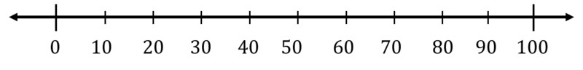](https://www.google.com/url?sa=i&rct=j&q=&esrc=s&source=images&cd=&cad=rja&uact=8&ved=0ahUKEwjEmZ-TwvLQAhUG6CYKHcXAAKkQjRwIBw&url=https://www.illustrativemathematics.org/content-standards/tasks/1805&bvm=bv.141536425,d.eWE&psig=AFQjCNE81Y_bphbwodl3HFeoZeoNAbQTGQ&ust=1481764730543098)**



**A gallon of orange juice costs**

**$2.50. What is the**

**maximum number of**

**gallons you can buy**

**for $15?**

**[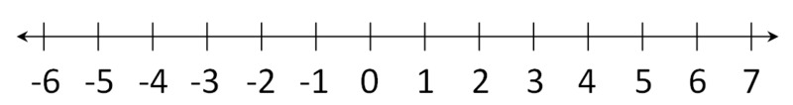](https://www.google.com/url?sa=i&rct=j&q=&esrc=s&source=images&cd=&cad=rja&uact=8&ved=0ahUKEwj4g6ehwfLQAhWLJiYKHV-0AEQQjRwIBw&url=https://www.illustrativemathematics.org/content-standards/tasks/337&psig=AFQjCNE1sOsGtL6iChwrH53V0tgfTdjOhA&ust=1481764520635297)**

** Eman bought t-shirts for**

**$2 each. What is the**

**minimum number of**

**t-shirts she can buy**

**for $60?**

**[](https://www.google.com/url?sa=i&rct=j&q=&esrc=s&source=images&cd=&cad=rja&uact=8&ved=0ahUKEwjEmZ-TwvLQAhUG6CYKHcXAAKkQjRwIBw&url=https://www.illustrativemathematics.org/content-standards/tasks/1805&bvm=bv.141536425,d.eWE&psig=AFQjCNE81Y_bphbwodl3HFeoZeoNAbQTGQ&ust=1481764730543098)**