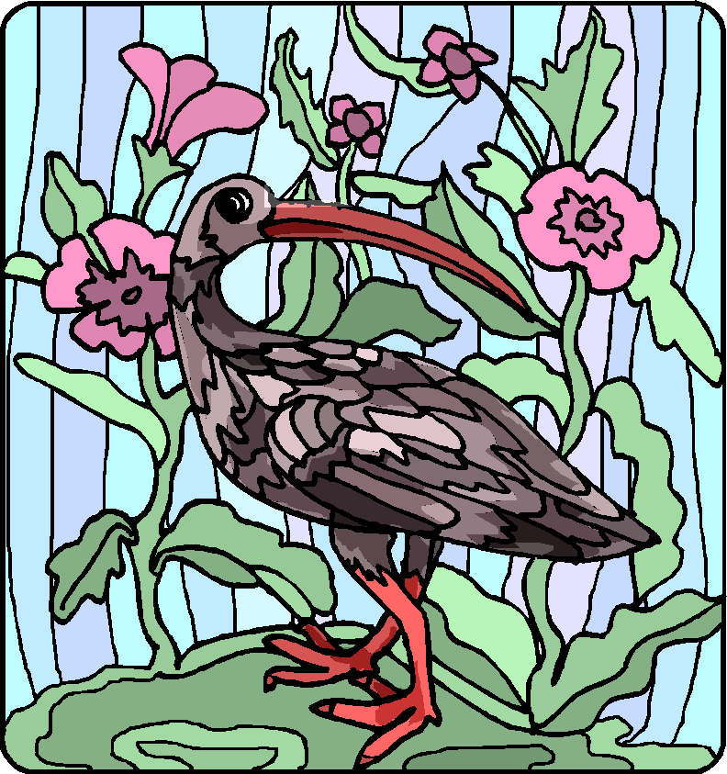**The Scarlet Ibis**

by James Hurst

Summer was dead, but autumn had not yet been born when the ibis came to the bleeding tree. It's strange that all this is so clear to me, now that time has had its way. But sometimes (like right now) I sit in the cool green parlor, and I remember Doodle.

Doodle was about the craziest brother a boy ever had. Doodle was born when I was seven and was, from the start, a disappointment. He seemed all head, with a tiny body that was red and shriveled like an old man's. Everybody thought he was going to die.

Daddy had the carpenter build a little coffin, and when he was three months old, Mama and Daddy named him William Armstrong. Such a name sounds good only on a tombstone.

When he crawled on the rug, he crawled backward, as if he were in reverse and couldn't change gears. This made him look like a doodlebug, so I began calling him 'Doodle.' Renaming my brother was probably the kindest thing I ever did for him, because nobody expects much from someone called Doodle.

Daddy built him a cart and I had to pull him around. If I so much as picked up my hat, he'd start crying to go with me; and Mama would call from wherever she was, "Take Doodle with you."

So I dragged him across the cotton field to share the beauty of Old Woman Swamp. I lifted him out and sat him down in the soft grass. He began to cry.

"What's the matter?"

"It's so pretty, Brother, so pretty."

After that, Doodle and I often went down to Old Woman Swamp.

There is inside me (and with sadness I have seen it in others) a knot of cruelty borne by the stream of love. And at times I was mean to Doodle. One time I showed him his casket, telling him how we all believed he would die. When I made him touch the casket, he screamed. And even when we were outside in the bright sunshine he clung to me, crying, "Don't leave me, Brother! Don't leave me!"

Doodle was five years old when I turned 13. I was embarrassed at having a brother of that age who couldn't walk, so I set out to teach him. We were down in Old Woman Swamp. "I'm going to teach you to walk, Doodle," I said.

"Why?"

"So I won't have to haul you around all the time."

"I can't walk, Brother."

"Who says so?"

"Mama, the doctor–everybody."

"Oh, you can walk." I took him by the arms and stood him up. He collapsed on to the grass like a half-empty flour sack. It was as if his little legs had no bones.

"Don't hurt me, Brother."

"Shut up. I'm not going to hurt you. I'm going to teach you to walk." I heaved him up again, and he collapsed.

"I just can't do it."

"Oh, yes, you can, Doodle. All you got to do is try. Now come on," and I hauled him up once more.

It seemed so hopeless that it's a miracle I didn't give up. But all of us must have something to be proud of, and Doodle had become my something.

Finally one day he stood alone for a few seconds. When he fell, I grabbed him in my arms and hugged him, our laughter ringing through the swamp like a bell. Now we knew it could be done.

We decided not to tell anyone until he was actually walking. At breakfast on our chosen day I brought Doodle to the door in the cart. I helped Doodle up; and when he was standing alone, I let them look. There wasn't a sound as Doodle walked slowly across the room and sat down at the table. Then Mama began to cry and ran over to him, hugging him and kissing him. Daddy hugged him, too. Doodle told them it was I who had taught him to walk, so they wanted to hug me, and I began to cry.

"What are you crying for?" asked Daddy, but I couldn't answer. They didn't know that I did it just for myself, that Doodle walked only because I was ashamed of having a crippled brother.

Within a few months, Doodle had learned to walk well. Since I had succeeded in teaching Doodle to walk, I began to believe in my own infallibility. I decided to teach him to run, to row, to swim, to climb trees, and to fight. Now he, too, believed in me; so, we set a deadline when Doodle could start school.

But Doodle couldn't keep up with the plan. Once, he collapsed on the ground and began to cry.

"Aw, come on, Doodle. You can do it. Do you want to be different from everybody else when you start school?"

"Does that make any difference?"

"It certainly does. Now, come on."

And so we came to those days when summer was dead but autumn had not yet been born. It was Saturday noon, just a few days before the start of school. Daddy, Mama, Doodle, and I were seated at the dining room table, having lunch. Suddenly from out in the yard came a strange croaking noise. Doodle stopped eating. "What's that?" He slipped out into the yard, and looked up into the bleeding tree. "It's a big red bird!"

Mama and Daddy came out. On the topmost branch perched a bird the size of a chicken, with scarlet feathers and long legs.

At that moment, the bird began to flutter. It tumbled down through the bleeding tree and landed at our feet with a thud. Its graceful neck jerked twice and then straightened out, and the bird was still. It lay on the earth like a broken vase of red flowers, and even death could not mar its beauty.

"What is it?" Doodle asked.

"It's a scarlet ibis," Daddy said.

Sadly, we all looked at the bird. How many miles had it traveled to die like this, in our yard, beneath the bleeding tree?

Doodle knelt beside the ibis. "I'm going to bury him."

As soon as I had finished eating, Doodle and I hurried off to Horsehead Landing. It was time for a swimming lesson, but Doodle said he was too tired. When we reached Horsehead landing, lightning was flashing across half the sky, and thunder was drowning out the sound of the sea.

Doodle was both tired and frightened. He slipped on the mud and fell. I helped him up, and he smiled at me ashamedly. He had failed and we both knew it. He would never be like the other boys at school.

We started home, trying to beat the storm. The lightning was near now. The faster I walked, the faster he walked, so I began to run.

The rain came, roaring through the pines. And then, like a bursting Roman candle, a gum tree ahead of us was shattered by a bolt of lightning. When the deafening thunder had died, I heard Doodle cry out, "Brother, Brother, don't leave me! Don't leave me!"

The knowledge that our plans had come to nothing was bitter, and that streak of cruelty within me awakened. I ran as fast as I could, leaving him far behind with a wall of rain dividing us. Soon I could hear his voice no more.

I stopped and waited for Doodle. The sound of rain was everywhere, but the wind had died and it fell straight down like ropes hanging from the sky.

I peered through the downpour, but no one came. Finally I went back and found him huddled beneath a red nightshade bush beside the road. He was sitting on the ground, his face buried in his arms, which were resting on drawn-up knees. "Let's go, Doodle."

He didn't answer so I gently lifted his head. He toppled backward onto the earth. He had been bleeding from the mouth, and his neck and the front of his shirt were stained a brilliant red.

"Doodle, Doodle." There was no answer but the ropy rain. I began to weep, and the tear-blurred vision in red before me looked very familiar. "Doodle!" I screamed above the pounding storm and threw my body to the earth above his. For a long time, it seemed forever, I lay there crying, sheltering my fallen scarlet ibis