FORDSON HIGH SCHOOL

Ms. Alhashemi’s Language Arts Class (2017-18)

**Room Number: G122**

**Contact Information:** [alhashn@dearbornschools.org](mailto:alhashn@dearbornschools.org)

I welcome and encourage student and parent contact. If you have any questions, concerns, or would like to schedule to meet before or after school please contact me.

**Student Expectations / Classroom Norms:**

* Students are expected to come to class prepared to learn with all classroom supplies
* Students are expected to arrive on time to class and are in their seats when the bell rings
* No cell phone - school policy
* Raise your hand for permission to speak or leave your seat
* Be respectful to self and others
* Students are to remain in their seats until teacher dismisses class.

**Supplies:**

* Binder with 5 Dividers
* Loose-leaf Paper
* Blue or black pens
* Notebook
* Highlighter

**Planners:**

All students are expected to bring their planners to class every day. Students will write homework and other necessary notes daily. If the student’s grade is affected by missing assignments, teacher and parents should be signing planner every day to ensure student homework is complete.

**Food/Drinks:**

Food and drinks are not allowed in the classroom. Water bottles are permitted and encouraged.

**Passes:**

Planners will be used as a pass for students to use the restroom in case of an urgency. It is required that students bring their planner every day to class. If a student forgets their planner on a particular day, they will not be allowed a pass for that day. Students are granted 3 passes a semester in case of an urgent need to use the restroom. Students should use the restroom between classes-during passing time.

**Late/ Absent work:**

Late assignments will not be allowed unless permitted otherwise.

If you are absent it is your responsibility to ask for your missing work for that day. You can also check iBlog or Remind for homework postings and weekly announcements. Parents are highly encouraged to subscribe to our classroom iBlog.

iBlog:  <http://iblog.dearbornschools.org/alhashemin>

**Silent Sustained Reading:**

Students are encouraged to read every day to help increase reading proficiency. In Language Arts, students will be given reading texts/ books to read for the last 10 minutes of class before eventually choosing a novel. Students will be required to bring their reading novel every day to class. Teacher will confer with students throughout the week for reading improvement and comprehension.

**Grading system:**

**A 100-93% C 76-73%**

**A- 92-90% C- 72-70%**

**B+ 89-87% D+ 69-67%**

**B 86-83% D 66-63%**

**B- 82-80% D- 62-60%**

**C+ 79-77% E 59%**

*Formative Assignments***-** (Classwork, Participation, Homework, Bell work, Assignments) - **(20%)**

*Summative Assignments-*(Exams, Quizzes, Projects, Essays, Assignments) - **(80%)**

Attendance/Audit

Students are required to attend classes and keep absences to a minimum. Audit is in place and the following is district policy:

* A student who is over fifteen minutes late to class is considered to be absent.
* Two lates (5 to 15 minutes) in a class is considered to be an absence.
* Four tardies in a class is considered to be an absence.
* When a student has ten (10) or more absences, excused or unexcused in one semester (based on above) they may receive reduced credit.
  + A student who receives reduced credit will receive their full credit and their letter grade if they earn a 78% or higher on the end of term common/comprehensive assessment (final).

**Cell Phone Policy:**



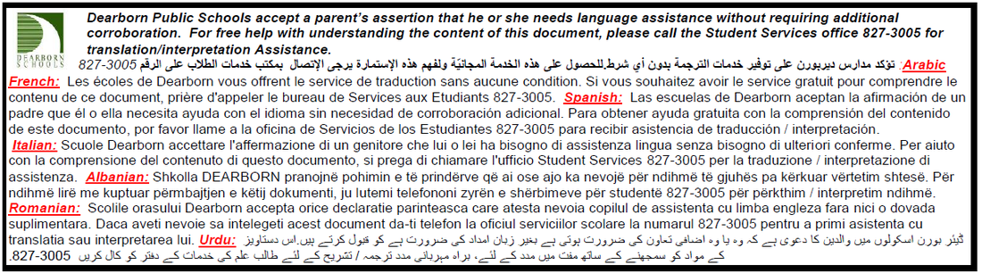

**-------------------------------------------------------------------------------------------------------------------------------**

**Please sign and return this sheet to Ms. Alhashemi by September 12, 2017**

Date: ___________

Hour: ___________

I have read, understand, and agree to the classroom rules, expectations, and procedures.

_________________________ ________________________

Printed Student Name Student Signature

______________________ ________________________

Parent/Guardian Name Parent/Guardian Signature

**Due date: 09/12/17**