Polyhedra | Triangular Prism | Pyramid
Rectangular Prism | Net | Edge
Vertex | Base | Polygon
Lateral face | Surface Area | Volume
Cubic unit

Solid 3D figure with several faces. | A many-sided 2D shape. | The line where 2 faces or surfaces meet.
A point where 3 or more edges meet. | The face or surface a solid object stands on. | The face or surface of the solid on its sides.
The measure of the space a 3D shape can hold. | The measure of the area of all of the faces of a 3D shape. | A pattern that can be assembled into a 3D shape.
A polyhedron with triangular lateral faces. | A polyhedron with 2 triangular bases and 3 rectangular lateral faces. | A polyhedron with 2 rectangular bases and 4 rectangular lateral faces.
The unit of measure for volume.

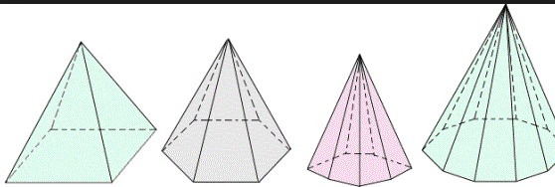 | 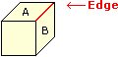 | 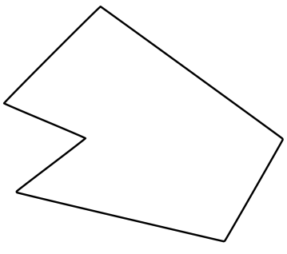
 | 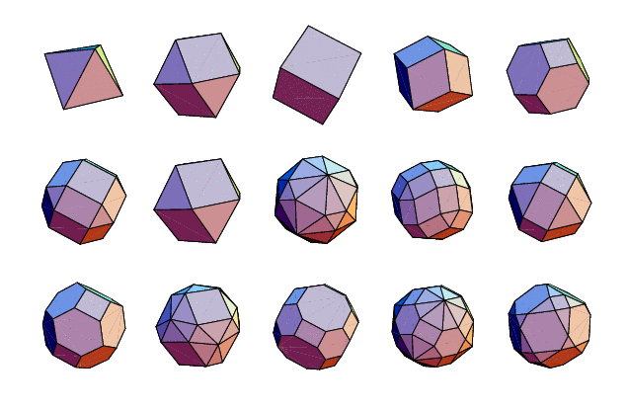
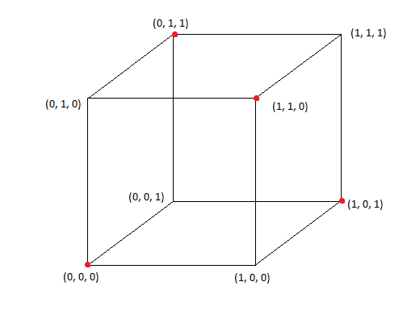 | 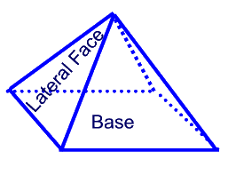 | 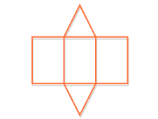
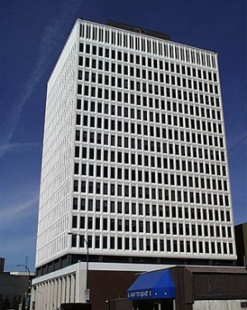 |  | 