**Rational Number Adventure**

Write a story that includes rational numbers. In your story, there should be increasing and decreasing of rational numbers, Then, illustrate your story on a number line and with a drawing. Fractions and decimals are awesome numbers to use! You may do this on a large sized paper, poster, or white copy paper.

Example: **Once upon a time, a jelly fish learned to fly. He was known as the "teenage mutant ninja jelly fish." He started his journey at 600 feet below sea level. He then swam and swam until he reached sea level and then he shook his tentacles and began to rise! He rose far above the Burj Khalifa, which is the tallest sky scraper in the world at 2717.54 feet above sea level and then floated back down into the ocean. He rested at the Midnight Zone of the ocean, which begins at 3281 feet below sea level.**





*Drawing*

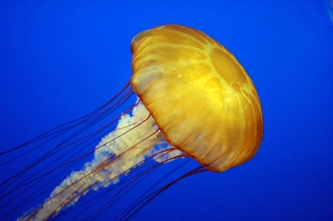

|  |  |  |
| --- | --- | --- |
|  | **Points Possible** | **Points Received** |
| **The story includes 3 or more rational numbers.** | **5** |  |
| **The story represents an increase and decrease in numbers.** | **5** |  |
| **The number line is made correctly with correct intervals.** | **5** |  |
| **The story is correctly represented on the number line.** | **5** |  |
| **The story and drawing are creative and were made with effort. They have color and appear neat.** | **5** |  |
| **Total** | **25** |  |