NAME: _______________________________

**PRATICE ASSESSMENT FOR COMMON CORE STANDARDS 6.G.A.1, 6.G.A.3, and 6.NS.C.8**

 **Which of the figures have an area of 16 units2? Show your work to prove your answer.**

1)



 yes no

2)



 yes no

3)



 yes no

4)



yes no

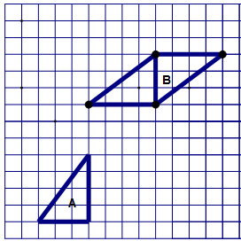Asma used copies of right triangle A to compose each of the quadrilaterals. Use the diagram to answer questions 5 – 7.

5) Find the area of triangle A

6) Find the area of quadrilateral B

7) The area of triangle A is ____________ the area of quadrilateral B.

a) equal to b) twice c) half

8) A parking lot is in the shape of a trapezoid. Enter the area of the parking lot found by   
 composing or decomposing into triangles and rectangles. Show work to support your answer.

 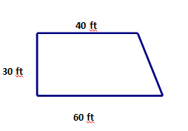

9) Consider this figure.

Enter the total area of figure ABCD in square centimeters. Show work to support your answer.





Use the triangle at the right for questions 10 and 11.

10) What is the length of AB?

11) What is the length of BC?

**Use the coordinate plane shown below for 12 - 16. Select True or False for each statement.**



12) Point K is at the origin True False

13) The ordered pair for M is (4, -4) True False

14) Point P has coordinates (-6, 0) True False

15) Point L names the ordered pair (6, 6) True False

16) Point N is in Quadrant II True False

17) Does the set of ordered pairs make a rectangle?

 A (4, -1) B (6, 1) C (-4, 1) D (-6, -1)



yes no

18) Does the set of ordered pairs make a rectangle?

W (0, 1) X (5, -1) Y (5, -5) Z (0, -5)



yes no

19) Find the area of quadrilateral WXYZ above. Show work above.

20) The vertex of a polygon is located at *A* (4, 1). The length of side *AB* is 5 units. Determine   
 whether each ordered pair could be the coordinate for point B. Select all that apply.

 a) (9, 1) b) (4, -6) c) (4, 6) d) (-2, 1) e) (-4, 4) f) (-1, 1) g) (4, -4)

**To find the area of a triangle, the formula A =  • 5 • 3 is used. Tell if the set of ordered pairs is represented by this formula.**

****21.) (4, 1) (7, 6) (7, 1)

yes no

22.) (3, -1) (8, -1) (8, 3)

 yes no

23.) Casey lives at point G. She is going to walk to Marwa’s house, which is located at point E. She is then going to walk to Tim Horton’s, which is located at point F. What is the total distance that Casey will walk?



a) 6 blocks b) 8 blocks c) 10 blocks d) 14 blocks