Narrative of the Life of Frederick Douglass (Ch. 6 & Ch. 7)

Directions “Text: Narrative of the Life of Frederick Douglass (Ch. 6 & Ch. 7)”: As we read this text and reflect on our notes, answer all questions completely in the document attached to this assignment on Google Classroom. A correct response fully answers the question IN COMPLETE SENTENCES and WITH DETAILS from the text. Cite quotes and specific examples to defend your answer and explain your reasoning. Keep in mind our Essential Question (EQ): To what extent does education set us free and simultaneously expose us to the harsh realities of life? Are we better off not knowing everything?

*REMEMBER MISTRESS REFERS TO THE LADY OF THE HOUSEHOLD (SLAVE OWNER’S WIFE).

1. Douglass’ new mistress (Mrs. Auld) taught him the ABC’s, however as soon as her husband, the slavemaster Mr. Auld, discovered this, he, “at once forbade Mrs. Auld to instruct [him] further.” Why? Provide a complete explanation.

ANSWER:

2. What effect did Mr. Auld’s warning to Mrs. Auld have on Douglass?

ANSWER:

3. How did Mrs. Auld, Douglass’ mistress, attempt to stop his efforts at learning to read and write? Provide at least one specific example.

ANSWER:

4. Describe how, despite these efforts, Douglass succeeded in learning to read and write. Provide a complete explanation.
.
ANSWER:

5. What did Douglass discover from reading, “The Columbian Orator”? How did his new knowledge affect Douglass?

ANSWER:

6. Douglass discovered through his reading the word, “abolition.” What did this mean? How did the knowledge of the word affect Douglass?

ANSWER:

7. What did learning to read and write finally inspire Douglass to do, especially after his conversation with the two Irishmen on the wharf?

ANSWER:

Vocabulary
- orator: (n) a public speaker, especially one who is eloquent or skilled
- wharf: (n) a structure built on the shore of a harbor that allows ships to be docked and for goods to be taken off and put on ships
Narrative of the Life of Frederick Douglass
Written by Himself | Published 1845
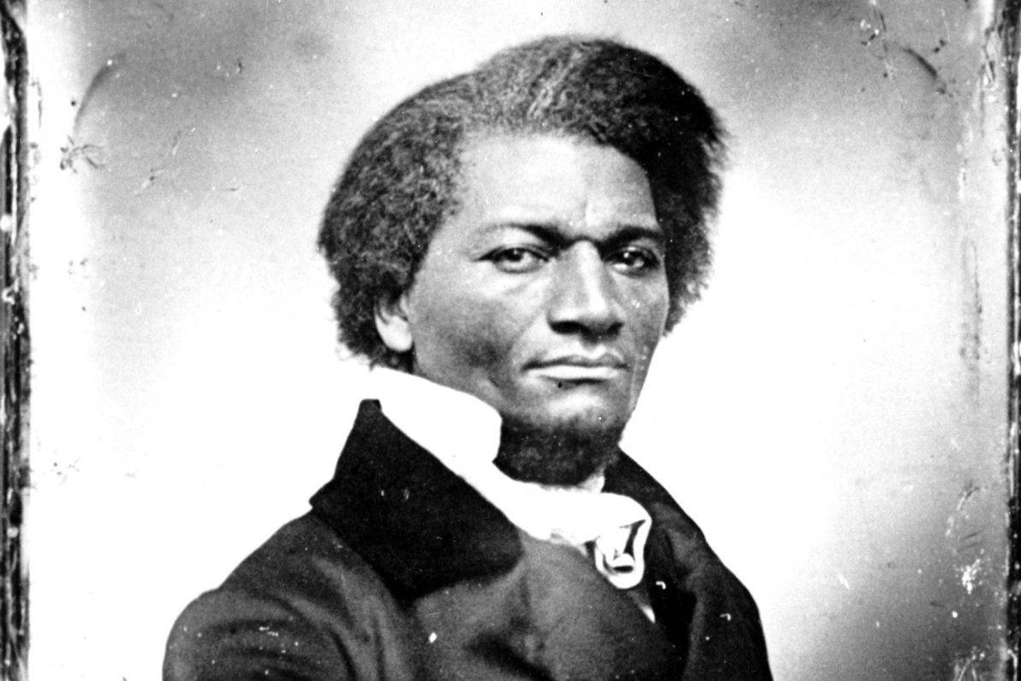
LINK TO CHAPTER VI AUDIOBOOK
LINK TO CHAPTER VII AUDIOBOOK

Page 32

CHAPTER VI.
My new mistress. proved to be all she appeared when I first met her at the door,--a woman of the kindest heart and finest feelings. She had never had a slave under her control previously to myself, and prior to her marriage she had been dependent upon her own industry for a living. She was by trade a weaver; and by constant application to her business, she had been in a good degree preserved from the blighting and dehumanizing effects of slavery. I was utterly astonished at her goodness. I scarcely knew how to behave towards her. She was entirely unlike any other white woman I had ever seen. I could not approach her as I was accustomed to approach other white ladies. My early instruction was all out of place. The crouching servility, usually so acceptable a quality in a slave, did not answer when manifested toward her. Her favor was not gained by it; she seemed to be disturbed by it. She did not deem it impudent or unmannerly for a slave to look her in the face. The meanest slave was put fully at ease in her presence, and none left without feeling better for having seen her. Her face was made of heavenly smiles, and her voice of tranquil music.
But, alas! this kind heart had but a short time to remain such. The fatal poison of irresponsible power was already in her hands, and soon commenced its infernal work. That cheerful eye, under the influence of slavery, soon became red with rage; that voice,

Page 33
made all of sweet accord, changed to one of harsh and horrid discord; and that angelic face gave place to that of a demon.
Very soon after I went to live with Mr. and Mrs. Auld, she very kindly commenced to teach me the A, B, C. After I had learned this, she assisted me in learning to spell words of three or four letters. Just at this point of my progress, Mr. Auld found out what was going on, and at once forbade Mrs. Auld to instruct me further, telling her, among other things, that it was unlawful, as well as unsafe, to teach a slave to read. To use his own words, further, he said, "If you give a nigger an inch, he will take an ell. A nigger should know nothing but to obey his master--to do as he is told to do. Learning would spoil the best nigger in the world. Now," said he, "if you teach that nigger (speaking of myself) how to read, there would be no keeping him. It would forever unfit him to be a slave. He would at once become unmanageable, and of no value to his master. As to himself, it could do him no good, but a great deal of harm. It would make him discontented and unhappy." These words sank deep into my heart, stirred up sentiments within that lay slumbering, and called into existence an entirely new train of thought. It was a new and special revelation, explaining dark and mysterious things, with which my youthful understanding had struggled, but struggled in vain. I now understood what had been to me a most perplexing difficulty--to wit, the white man's power to enslave the black man. It was a grand achievement, and I prized it highly. From that moment, I understood the pathway from slavery to freedom. It was

Page 34
just what I wanted, and I got it at a time when I the least expected it. Whilst I was saddened by the thought of losing the aid of my kind mistress, I was gladdened by the invaluable instruction which, by the merest accident, I had gained from my master. Though conscious of the difficulty of learning without a teacher, I set out with high hope, and a fixed purpose, at whatever cost of trouble, to learn how to read. The very decided manner with which he spoke, and strove to impress his wife with the evil consequences of giving me instruction, served to convince me that he was deeply sensible of the truths he was uttering. It gave me the best assurance that I might rely with the utmost confidence on the results which, he said, would flow from teaching me to read. What he most dreaded, that I most desired. What he most loved, that I most hated. That which to him was a great evil, to be carefully shunned, was to me a great good, to be diligently sought; and the argument which he so warmly urged, against my learning to read, only served to inspire me with a desire and determination to learn. In learning to read, I owe almost as much to the bitter opposition of my master, as to the kindly aid of my mistress. I acknowledge the benefit of both.
I had resided but a short time in Baltimore before I observed a marked difference, in the treatment of slaves, from that which I had witnessed in the country. A city slave is almost a freeman, compared with a slave on the plantation. He is much better fed and clothed, and enjoys privileges altogether unknown to the slave on the plantation. There is a vestige of decency, a sense of shame, that does much to curb and

Page 35
check those outbreaks of atrocious cruelty so commonly enacted upon the plantation. He is a desperate slaveholder, who will shock the humanity of his non-slaveholding neighbors with the cries of his lacerated slave. Few are willing to incur the odium attaching to the reputation of being a cruel master; and above all things, they would not be known as not giving a slave enough to eat. Every city slaveholder is anxious to have it known of him, that he feeds his slaves well; and it is due to them to say, that most of them do give their slaves enough to eat. There are, however, some painful exceptions to this rule. Directly opposite to us, on Philpot Street, lived Mr. Thomas Hamilton. He owned two slaves. Their names were Henrietta and Mary. Henrietta was about twenty-two years of age, Mary was about fourteen; and of all the mangled and emaciated creatures I ever looked upon, these two were the most so. His heart must be harder than stone, that could look upon these unmoved. The head, neck, and shoulders of Mary were literally cut to pieces. I have frequently felt her head, and found it nearly covered with festering sores, caused by the lash of her cruel mistress. I do not know that her master ever whipped her, but I have been an eye-witness to the cruelty of Mrs. Hamilton. I used to be in Mr. Hamilton's house nearly every day. Mrs. Hamilton used to sit in a large chair in the middle of the room, with a heavy cowskin always by her side, and scarce an hour passed during the day but was marked by the blood of one of these slaves. The girls seldom passed her without her saying, "Move faster, you black gip!" at the same time giving them a blow with the cowskin

Page 36
over the head or shoulders, often drawing the blood. She would then say, "Take that, you black gip!"-- continuing, "If you don't move faster, I'll move you!" Added to the cruel lashings to which these slaves were subjected, they were kept nearly half-starved. They seldom knew what it was to eat a full meal. I have seen Mary contending with the pigs for the offal thrown into the street. So much was Mary kicked and cut to pieces, that she was oftener called "pecked" than by her name.

CHAPTER VII.
I LIVED in Master Hugh's family about seven years. During this time, I succeeded in learning to read and write. In accomplishing this, I was compelled to resort to various stratagems. I had no regular teacher. My mistress, who had kindly commenced to instruct me, had, in compliance with the advice and direction of her husband, not only ceased to instruct, but had set her face against my being instructed by any one else. It is due, however, to my mistress to say of her, that she did not adopt this course of treatment immediately. She at first lacked the depravity indispensable to shutting me up in mental darkness. It was at least necessary for her to have some training in the exercise of irresponsible power, to make her equal to the task of treating me as though I were a brute.

Page 37
My mistress was, as I have said, a kind and tender-hearted woman; and in the simplicity of her soul she commenced, when I first went to live with her, to treat me as she supposed one human being ought to treat another. In entering upon the duties of a slaveholder, she did not seem to perceive that I sustained to her the relation of a mere chattel, and that for her to treat me as a human being was not only wrong, but dangerously so. Slavery proved as injurious to her as it did to me. When I went there, she was a pious, warm, and tender-hearted woman. There was no sorrow or suffering for which she had not a tear. She had bread for the hungry, clothes for the naked, and comfort for every mourner that came within her reach. Slavery soon proved its ability to divest her of these heavenly qualities. Under its influence, the tender heart became stone, and the lamblike disposition gave way to one of tiger-like fierceness. The first step in her downward course was in her ceasing to instruct me. She now commenced to practise her husband's precepts. She finally became even more violent in her opposition than her husband himself. She was not satisfied with simply doing as well as he had commanded; she seemed anxious to do better. Nothing seemed to make her more angry than to see me with a newspaper. She seemed to think that here lay the danger. I have had her rush at me with a face made all up of fury, and snatch from me a newspaper, in a manner that fully revealed her apprehension. She was an apt woman; and a little experience soon demonstrated, to her satisfaction, that education and slavery were incompatible with each other.

Page 38
From this time I was most narrowly watched. If I was in a separate room any considerable length of time, I was sure to be suspected of having a book, and was at once called to give an account of myself. All this, however, was too late. The first step had been taken. Mistress, in teaching me the alphabet, had given me the inch, and no precaution could prevent me from taking the ell.
The plan which I adopted, and the one by which I was most successful, was that of making friends of all the little white boys whom I met in the street. As many of these as I could, I converted into teachers. With their kindly aid, obtained at different times and in different places, I finally succeeded in learning to read. When I was sent of errands, I always took my book with me, and by going one part of my errand quickly, I found time to get a lesson before my return. I used also to carry bread with me, enough of which was always in the house, and to which I was always welcome; for I was much better off in this regard than many of the poor white children in our neighborhood. This bread I used to bestow upon the hungry little urchins, who, in return, would give me that more valuable bread of knowledge. I am strongly tempted to give the names of two or three of those little boys, as a testimonial of the gratitude and affection I bear them; but prudence forbids;--not that it would injure me, but it might embarrass them; for it is almost an unpardonable offence to teach slaves to read in this Christian country. It is enough to say of the dear little fellows, that they lived on Philpot Street, very near Durgin and Bailey's ship-yard. I used to talk this matter of slavery

Page 39
over with them. I would sometimes say to them, I wished I could be as free as they would be when they got to be men. "You will be free as soon as you are twenty-one, but I am a slave for life! Have not I as good a right to be free as you have?" These words used to trouble them; they would express for me the liveliest sympathy, and console me with the hope that something would occur by which I might be free.
I was now about twelve years old, and the thought of being a slave for life began to bear heavily upon my heart. Just about this time, I got hold of a book entitled "The Columbian Orator." Every opportunity I got, I used to read this book. Among much of other interesting matter, I found in it a dialogue between a master and his slave. The slave was represented as having run away from his master three times. The dialogue represented the conversation which took place between them, when the slave was retaken the third time. In this dialogue, the whole argument in behalf of slavery was brought forward by the master, all of which was disposed of by the slave. The slave was made to say some very smart as well as impressive things in reply to his master--things which had the desired though unexpected effect; for the conversation resulted in the voluntary emancipation of the slave on the part of the master.
In the same book, I met with one of Sheridan's mighty speeches on and in behalf of Catholic emancipation. These were choice documents to me. I read them over and over again with unabated interest. They gave tongue to interesting thoughts of my own soul, which had frequently flashed through my mind,

Page 40
and died away for want of utterance. The moral which I gained from the dialogue was the power of truth over the conscience of even a slaveholder. What I got from Sheridan was a bold denunciation of slavery, and a powerful vindication of human rights. The reading of these documents enabled me to utter my thoughts, and to meet the arguments brought forward to sustain slavery; but while they relieved me of one difficulty, they brought on another even more painful than the one of which I was relieved. The more I read, the more I was led to abhor and detest my enslavers. I could regard them in no other light than a band of successful robbers, who had left their homes, and gone to Africa, and stolen us from our homes, and in a strange land reduced us to slavery. I loathed them as being the meanest as well as the most wicked of men. As I read and contemplated the subject, behold! that very discontentment which Master Hugh had predicted would follow my learning to read had already come, to torment and sting my soul to unutterable anguish. As I writhed under it, I would at times feel that learning to read had been a curse rather than a blessing. It had given me a view of my wretched condition, without the remedy. It opened my eyes to the horrible pit, but to no ladder upon which to get out. In moments of agony, I envied my fellow-slaves for their stupidity. I have often wished myself a beast. I preferred the condition of the meanest reptile to my own. Any thing, no matter what, to get rid of thinking! It was this everlasting thinking of my condition that tormented me. There was no getting rid of it. It was pressed upon me by every object within sight or

Page 41
hearing, animate or inanimate. The silver trump of freedom had roused my soul to eternal wakefulness. Freedom now appeared, to disappear no more forever. It was heard in every sound, and seen in every thing. It was ever present to torment me with a sense of my wretched condition. I saw nothing without seeing it, I heard nothing without hearing it, and felt nothing without feeling it. It looked from every star, it smiled in every calm, breathed in every wind, and moved in every storm.
I often found myself regretting my own existence, and wishing myself dead; and but for the hope of being free, I have no doubt but that I should have killed myself, or done something for which I should have been killed. While in this state of mind, I was eager to hear any one speak of slavery. I was a ready listener. Every little while, I could hear something about the abolitionists. It was some time before I found what the word meant. It was always used in such connections as to make it an interesting word to me. If a slave ran away and succeeded in getting clear, or if a slave killed his master, set fire to a barn, or did any thing very wrong in the mind of a slaveholder, it was spoken of as the fruit of abolition. Hearing the word in this connection very often, I set about learning what it meant. The dictionary afforded me little or no help. I found it was "the act of abolishing;" but then I did not know what was to be abolished. Here I was perplexed. I did not dare to ask any one about its meaning, for I was satisfied that it was something they wanted me to know very little about. After a patient waiting, I got one of our city papers, containing

Page 42
an account of the number of petitions from the north, praying for the abolition of slavery in the District of Columbia, and of the slave trade between the States. From this time I understood the words abolition and abolitionist, and always drew near when that word was spoken, expecting to bear something of importance to myself and fellow-slaves. The light broke in upon me by degrees. I went one day down on the wharf of Mr. Waters; and seeing two Irishmen unloading a scow of stone, I went, unasked, and helped them. When we had finished, one of them came to me and asked me if I were a slave. I told him I was. He asked, "Are ye a slave for life?" I told him that I was. The good Irishman seemed to be deeply affected by the statement. He said to the other that it was a pity so fine a little fellow as myself should be a slave for life. He said it was a shame to hold me. They both advised me to run away to the north; that I should find friends there, and that I should be free. I pretended not to be interested in what they said, and treated them as if I did not understand them; for I feared they might be treacherous. White men have been known to encourage slaves to escape, and then, to get the reward, catch them and return them to their masters. I was afraid that these seemingly good men might use me so; but I nevertheless remembered their advice, and from that time I resolved to run away. I looked forward to a time at which it would be safe for me to escape. I was too young to think of doing so immediately; besides, I wished to learn how to write, as I might have occasion to write my own pass. I consoled myself with the hope that I should

Page 43
one day find a good chance. Meanwhile, I would learn to write.
The idea as to how I might learn to write was suggested to me by being in Durgin and Bailey's ship-yard, and frequently seeing the ship carpenters, after hewing, and getting a piece of timber ready for use, write on the timber the name of that part of the ship for which it was intended. When a piece of timber was intended for the larboard side, it would be marked thus--"L." When a piece was for the starboard side, it would be marked thus-- "S." A piece for the larboard side forward, would be marked thus--"L. F." When a piece was for starboard side forward, it would be marked thus--"S. F." For larboard aft, it would be marked thus--"L. A." For starboard aft, it would be marked thus--"S. A." I soon learned the names of these letters, and for what they were intended when placed upon a piece of timber in the ship-yard. I immediately commenced copying them, and in a short time was able to make the four letters named. After that, when I met with any boy who I knew could write, I would tell him I could write as well as he. The next word would be, "I don't believe you. Let me see you try it." I would then make the letters which I had been so fortunate as to learn, and ask him to beat that. In this way I got a good many lessons in writing, which it is quite possible I should never have gotten in any other way. During this time, my copy-book was the board fence, brick wall, and pavement; my pen and ink was a lump of chalk. With these, I learned mainly how to write. I then commenced and continued copying the Italics in

Page 44
Webster's Spelling Book, until I could make them all without looking on the book. By this time, my little Master Thomas had gone to school, and learned how to write, and had written over a number of copy-books. These had been brought home, and shown to some of our near neighbors, and then laid aside. My mistress used to go to class meeting at the Wilk Street meeting house every Monday afternoon, and leave me to take care of the house. When left thus, I used to spend the time in writing in the spaces left in Master Thomas's copy-book, copying what he had written. I continued to do this until I could write a hand very similar to that of Master Thomas. Thus, after a long, tedious effort for years, I finally succeeded in learning how to write.

