**Directions:** The following prompt is based on the accompanying ten sources.

This question requires you to integrate a variety of sources into a coherent, well-written essay. Refer to the sources to support your position; avoid mere paraphrase or summary. Your argument should be central; the sources should support this argument.

Remember to attribute both direct and indirect citations.

**Introduction**

College football players are known for their grit, long hours spent practicing, and the stadiums they fill on Saturdays in the Fall. Colleges are authorized to profit off of player jersey sales and tickets, along with other bonuses that the team earns. This has fueled a growing debate on whether colleges should compensate students with the money they earn from their likenesses.

**Assignment**

Read the following sources (including any introductory information) carefully. **Then, in an essay that synthesizes at least six of the sources for support, take a position that defends, challenges, or qualifies the claim that colleges should pay their football players like professionals (on top of their scholarship, if applicable).**

Refer to the sources as Source A, Source B, etc.; titles are included for your convenience.

Source A (Beamon)

Source B (Rothstein)

Source C (Lemmons)

Source D (Mclaughlin)

Source E (Debate.org)

Source F (Photo)

Source G (Hruby)

Source H (Graph)

Source I (Kerkhoff)

Source J (Gregory)

|  |
| --- |
| **Source A**  Beamon, Krystal A. “‘Used Goods.’” *Jstor*, 16 Feb. 2018, [www.jstor.org/stable/25608704?seq=1#page_scan_tab_contents](http://www.jstor.org/stable/25608704?seq=1#page_scan_tab_contents). |

*The following passage is excerpted from an article about the emotional impact of college football on African American athletes.*

Collegiate student-athletes, particularly, African American male student-athletes, often have lower career maturity, an impaired aptitude to devise educational and career plans, with self-esteem and an identity based on athletics. African American male student-athletes in football and basketball also have lower academic achievement, stronger expectations for a professional sports career, and are socialized more intensely toward sports than their White counterparts.

|  |
| --- |
| **Source B**  Rothstein, Michael. “Heading to the NFL, Michigan's Jake Butt Says College Players Should Be Paid.” *ESPN*, ESPN Internet Ventures, 24 Mar. 2017, [www.espn.com/college-football/story/_/id/18995190/michigan-standout-jake-butt-says-college-football-players-paid](http://www.espn.com/college-football/story/_/id/18995190/michigan-standout-jake-butt-says-college-football-players-paid). |

*The following passage is excerpted from an interview with one of college football’s best players.*

Butt said he first started recognizing this during his sophomore year at Michigan, when he moved into an apartment and received $900 a month to pay for housing and other incidentals, including bills, food and gas. Problem was, rent was $700 and that meant he had $200 to pay for the rest of his bills. He called his father, Rob, and asked for money. Rob asked about the scholarship. Butt explained the situation, which affects many college athletes who don't have time for a part-time job on top of classes and their sport.

Butt said he's thankful for the education he got at Michigan and the connections he made. But he sees salaries of others who work in NCAA sports and what the NCAA men's basketball tournament brings in and it makes him wonder.

"I'm looking at what this March Madness is bringing in," Butt said. "How much money do they bring in? Oh, but the basketball players are getting an education. How are they getting an education when they are missing the whole entire month of March?"

|  |
| --- |
| **Source C**  Lemmons, Malcolm. “College Athletes Getting Paid? Here Are Some Pros And Cons.” *The Huffington Post*, TheHuffingtonPost.com, 29 Mar. 2017, [www.huffingtonpost.com/entry/college-athletes-getting-paid-here-are-some-pros-cons_us_58cfcee0e4b07112b6472f9a](http://www.huffingtonpost.com/entry/college-athletes-getting-paid-here-are-some-pros-cons_us_58cfcee0e4b07112b6472f9a). |

*The following passage is excerpted from an article explaining the positives and negatives of college athletes getting paid.*

Pros

Support their families ― Players would be able to actually afford a decent meal and possibly send some money back home. Many of these athletes come from urban, low-class families and often leave school early because of the unimaginable pressure to be the main provider for their family at a young age.

Players may stay longer ― To backup the last point, players wouldn’t have to leave school early and would still be able to pursue an education while taking care of their family back home. This would possibly increase graduation rates, allow fans to see their favorite players mature through college, and ensure coaches are preparing athletes as much as possible for the next level.

Cons Financial irresponsibility ― Amateur players receiving compensation just seems like a complete disaster. They don’t know how to manage their money, and there wouldn’t be anyone their to guide their financial decisions. Colin Cowherd states, “I don’t think paying all college athletes is great; not every college is loaded, and most 19-year-olds (are) gonna spend it—and let’s be honest, they’re gonna spend it on weed and kicks!” Unfair compensation between players ― How will players be compensated? Will each player receive the same amount? What about the top level talent? Should they receive more because they were All-Americans? In theory, wouldn’t it bring problems between players, due to one teammate potentially receiving more money?

|  |
| --- |
| **Source D**  McLaughlin, Patrick. “College Football Players, Not Coaches, Deserve to Be Paid.” *Mercatus Center*, Mercatus Enterprises, 14 Sept. 2016, [www.mercatus.org/expert_commentary/college-football-players-not-coaches-deserve-be-paid](http://www.mercatus.org/expert_commentary/college-football-players-not-coaches-deserve-be-paid). |

*The following passage is excerpted from an opinion piece on why college football coaches, not players should be paid..*

When direct payments to the players cannot be made, indirect payments are. Because the schools aren’t allowed to make monetary payment, they pay in other ways. It’s amazing how much money is available when you don’t pay labor.

With the funds that would have gone to athlete salaries, for example, schools spend additional funds on locker rooms, weight rooms, training facilities, and spend more money on tutors, advisers, trainers and coaches. Because the coaches influence an athlete’s odds of going pro, a large part of these funds get placed in the coach’s contract. Thus college coaches aren’t receiving a market wage; it’s artificially inflated.

This is an inefficient use of resources. The resources that go to upgrading facilities and bidding wars for popular coaches should be paid directly to the players. It’s reminiscent of the 1970s, when passenger airlines couldn’t change their fares; prices were set by the Civil Aeronautics Board. So airlines competed in other dimensions — for example, by finding better flight attendants or offering fancier, “free” in-flight dining.

|  |
| --- |
| **Source E**  “Should College Football Players Get Paid?” *Debate.org*, 16 Feb. 2018, [www.debate.org/opinions/should-college-football-players-get-paid](http://www.debate.org/opinions/should-college-football-players-get-paid). |

*The following passage is excerpted from an argumentative website that lays out the arguments for and against the payment of college players.*

Pay the men!

Of course college football players should receive compensation for their work. A "scholarship" is not enough. For starters these "full ride" scholarships are actually one year scholarships that the school can choose to renew or not. So for example if a player is great his first two seasons and helps the school profit but then is injured and unable to complete a career at the school the next two years if his schooling are gone as the school fails to renew the next year. Why should the universities profit millions off great college players while they get nothing.

No they shouldn't

Paying college athletes destroys the love of the game. It also gives unfair advantages to wealthier colleges who can offer more to 18 year olds for their college to have the most successful team. All college athletes sacrifice so much so they can play because they love the game and unfortunately pros lose some of that drive for their paychecks.

|  |
| --- |
| **Source F**  Holder, Chris. “Welcome to College Athletics: A Letter From Your Strength Coach.” *Breaking Muscle*, 13 Sept. 2017, breakingmuscle.com/fitness/welcome-to-college-athletics-a-letter-from-your-strength-coach. |

*The following photo symbolizes the work college football players put in during workouts.*

Image result for cal poly football workout

|  |
| --- |
| **Source G**  Hruby, Patrick. “Opinion | College Football Could Pay Its Players. The Sugar Bowl Proves It.”*NBCNews.com*, NBCUniversal News Group, 19 Feb. 2018, [www.nbcnews.com/think/opinion/college-football-has-money-pay-players-college-football-playoff-proves-ncna833486](http://www.nbcnews.com/think/opinion/college-football-has-money-pay-players-college-football-playoff-proves-ncna833486). |

*The following passage is excerpted from an article that details how much money the NCAA makes from college football and provides an argument for paying players.*

When top-ranked Clemson takes on Alabama in the hotly contested Sugar Bowl this New Year's Day, Tigers coach Dabo Swinney will pocket a $150,000 bonus. His counterpart at Georgia, Kirby Smart, will earn a $425,000 bonus for appearing in the other College Football Playoffs semifinal, the Rose Bowl. And if Swinney or Smart leads their team to a national championship, they stand to collect an additional $450,000 and $1.45 million, respectively — all in addition to their respective $6.75 million and $3.75 million annual average base salaries. But sure, schools can’t afford to pay their players.

|  |
| --- |
| **Source H**  Gaines, Cork. “The average college football team makes more money than the next 25 college sports combined.” *Business Insider*, Business Insider, 20 Oct. 2016, www.businessinsider.com/college-sports-revenue-2016-10. |

*The following chart demonstrates how much more college football makes than other sports.*

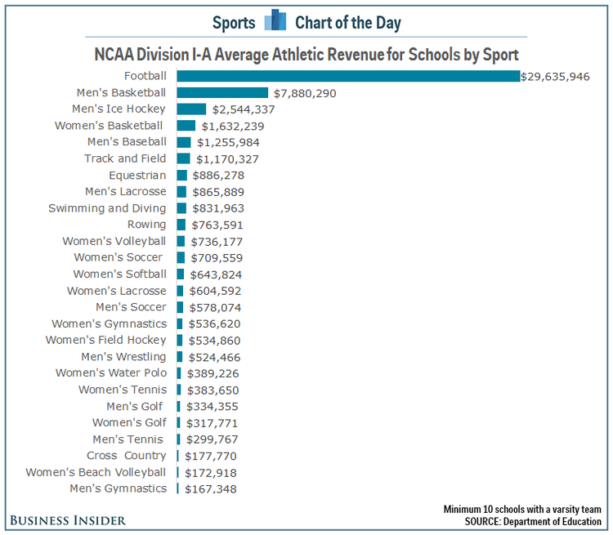

|  |
| --- |
| **Source I**  Kerkhoff, Blair. “They're Not Paychecks, but Major College Athletes Got Extra Scholarship Stipends for First Time This School Year.” *Kansascity*, The Kansas City Star, 30 June 2016, [www.kansascity.com/sports/college/article86062792.html](http://www.kansascity.com/sports/college/article86062792.html). |

*The following article explains a recent advancement towards paying major college athletes.*

The kids got paid, cash money, simply for being scholarship student-athletes. A new era in college sports arrived for the 2015-16 school year in the form of full “cost of attendance,” a stipend paid over and above the benefits of a scholarship. The amount of the stipend varies by school, ranging from about $2,000 to $5,000 extra going to each full-scholarship athlete.

|  |
| --- |
| **Source J**  Gregory, Sean. “College Football Championship 2018: Paying College Athletes.” *Time*, Time, 8 Jan. 2018, time.com/5088736/college-football-championship-2018-pay/. |

*The following article takes a look at a court case that may allow college football players to start making money from their likenesses.*

The *Jenkins* case, however, makes a broader claim than *O’Bannon.* Whereas *O’Bannon* concerned a college athlete’s ability to profit from the use of his or her likeness, *Jenkins* focuses on the market for signing college athletes to schools. It seeks to ends the NCAA’s blanket wage restrictions, and allow individual athletic conferences to determine the levels at which players should be paid. Kessler, who has represented the players’ unions of all four major U.S. professional sports leagues and helped NFL players win the right to become free agents in the early 1990s, is representing the *Jenkins* plaintiffs.