**Content Objective**

**Students will demonstrate evaluation of “Allegory of the Cave” and the *Autobiography of Malcolm X* by citing evidence to support metaphoric connections using centers.**

**Language Objective**

**Students will draw, write and orally justify the metaphoric connections made between “Allegory of the Cave” and “…Malcolm X” by completing a chart focusing on the metaphors: cave, sun, upper world, and liberator.**

**Center 1**

**Visualize**

In the "Allegory of the Cave", Plato writes a dialog between the main character, Socrates, and his older brother, Glaucon.

**Allegory:** Allegory is a [figure of speech](http://literarydevices.net/figure-of-speech/) in which abstract ideas and principles are described in terms of characters, figures and events. Heavy on symbolism.

1. **Draw the cave that is described by Socrates in Plato’s “Allegory of the Cave”**
2. **Select one person from the group to be the drawer, and as a group, discuss and label all the features and images described in the cave and outside the cave.**
3. **Label the two worlds: what do they represent?**
4. **Discuss the differences in both worlds illustrated.**
5. **Draw the cave in your chart**
6. **Call me when you finish so I can snap a photo of your drawing.**
7. **Please erase the drawings and notes when finished.**

**Center 2**

**THEME**

**What is a theme?** Th[eme](http://literarydevices.net/tag/theme/) is defined as a main idea or an underlying meaning of a literary work that may be stated directly or indirectly. There may be several themes and major and minor themes.

**Major Themes in “Allegory of the Cave”**

**Identity**

**Enlightenment**

**Education  
 Religion**

**Transformation**

**Discussion Questions: Write your responses in your chart after discussion**

* **Compare to the themes in Malcolm X** 
  + **Name the themes in Malcolm X**
  + **Are there similar themes?**
  + **Are there different themes?**

**Center 3**

**Metaphor:** a figure of speech in which a word or phrase is applied to an object or action to which it is not literally applicable.

**Metaphor: The Cave**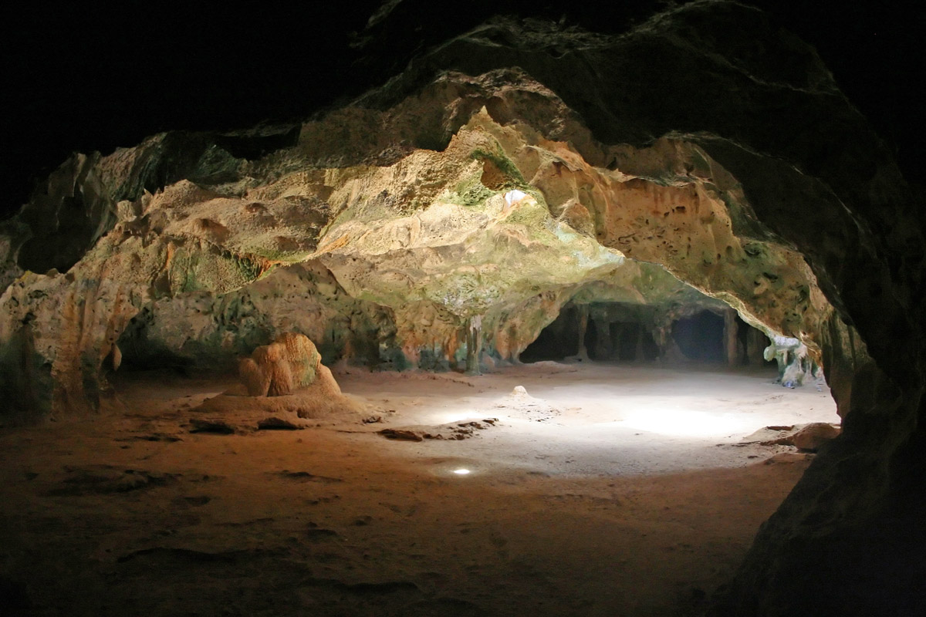

***The Autobiography of Malcolm X***

**Discussion Questions: Write your responses in your chart after discussion**

* **Who was Malcolm before prison?**
* **What was his “cave”?**
* ***Cite Textual evidence to justify your claim ( At least one example)***

**Center 4**

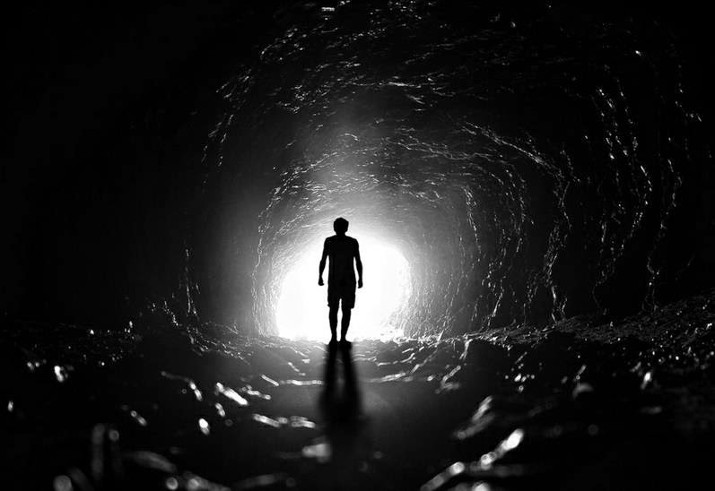**Metaphor: "The Liberator"/Instructor**

**Discussion Questions: Write your responses in the chart after discussion**

* How was Malcolm educated?
* Who was Malcolm's "liberator"/instructor? Perhaps more than one?
* ***Cite Textual evidence to justify your claim ( At least one example)***

**Center 5**

**Metaphors: Ascent into Sunlight  
Sun**

**Discussion Question: Write your responses in the chart after discussion**

* How was religion influential to Malcolm's education? His enlightenment?
* How did Malcolm transform?
* ***Cite Textual evidence to justify your claim ( At least one example)***

**Center 6**

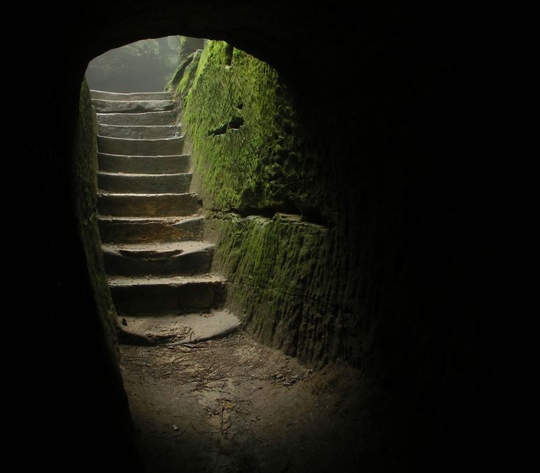**Metaphor: Upper World**

**Discussion Questions-Write your responses in the chart after discussion**

* What “upper world” was revealed to Malcolm?
* What type of individual did he become?
* What was his new awareness of society? Of himself?
* ***Cite Textual evidence to justify your claim ( At least one example)***

**Center 7**

**Make your own connections!**

1. What are some other metaphors and/or symbols in the “Allegory of the Cave” that connect to Malcolm X’s story?

He went through different stages in his life, and so he perhaps went through more than one transformation. Explain and connect the “Allegory in the Cave” story to events, people and ideas presented in the *Autobiography of Malcolm X.*

**Center Title Record Responses**

|  |  |  |
| --- | --- | --- |
| **1 Visualize** | **Draw cave here:** | |
| **2 Theme** | **Malcolm X Themes** | **Textual Evidence (pgs #’s)** |
| **3 Metaphor: Cave** | **Malcolm X’s “Cave “** | **Textual Evidence (pgs #’s)** |
| **4 Metaphor: Liberator** | **Malcolm X’s Liberator** | **Textual Evidence (pgs #’s)** |
| **5 Metaphor: Sunlight/sun** | **Malcolm X’s Liberator(s)** | **Textual Evidence (pgs #’s)** |
| **6 Metaphor: Upper World** | **Malcolm X’s Upper World** | **Textual Evidence (pgs #’s)** |
| **7 List your own metaphors/symbols from “Allegory of the Cave”** | **Malcolm X’s Connections** | **Textual Evidence (pgs #’s)** |