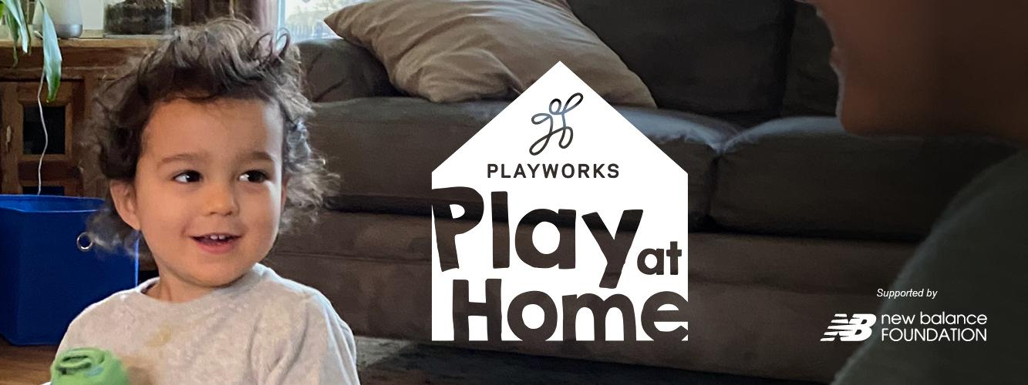

**Boppity Bop Bop Bop**

|  |  |
| --- | --- |
| **# of people to play:** 3-10 | **Best for ages:**  6+ |
| **Equipment needed:** None **Social and Emotional (SEL) Competencies:** Responsible Decision-making, Self-management  **SEL Skills Practiced:** Conflict resolution, Resilience | **Setup/Teaching Time:**  5 minutes |

### **Set Up**

* The group should be standing in a circle, at least arm-distance apart.
* Go over instructions from below. Provide examples of each sequence and use call and response to make sure players know how to play the game.
* All ties are resolved with Roshambo (aka Rock, Paper, Scissors) therefore make sure everyone knows how to play.

### 

### **Review SEL Skills Practiced:**

* **Conflict Resolution:** figuring out a fair and respectful solution when there is a problem or argument between people. Today, we will use Roshambo as a way to help us make decisions and resolve conflicts respectfully.
* **Resilience:** Shake off your mistake/loss, and get ready to try again!

### 

### **How to Play**

* The group gathers in a circle, with one person in the middle (selected by the game leader).
* The player in the middle walks up to/points to a player in the circle and says “Boppity Bop Bop Bop.” If the player in the middle completes the phrase before the other player says “Bop,” the two switch places. If the player on the outside says “Bop” before the middle player finishes the phrase, the game continues with the same player in the middle.
* The player in the middle can fake out players on the outside by simply pointing and saying “Bop” to a player in the circle. If the outside player says “Bop,” the two players switch places.

**SEL Game Debriefs**

* When you were unsuccessful in a round, how did you “shake it off” and get yourself ready to try again?
* How did we solve a disagreement respectfully in this game? When else could we use Roshambo at home?

### **Academic Applications**

* The player on the outside of the circle must say the correct word before the player in the middle finishes spelling it.

### **At-Home Accommodations**

* Ball up a sock to use as a soft throwable object versus pointing at players. The person in the middle can throw the ball to the person before they say the phrase.

### **Modifications for Social Distancing**

* Instead of standing in a circle, you spread out the group throughout the room.

### **Challenge ideas**

* Make up a different phrase or add rules!