Dear Families,

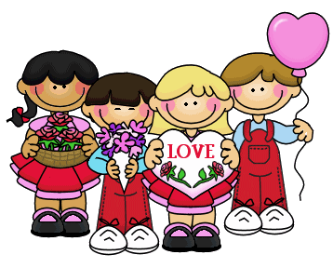Some children like to bring candy and small cards to school on Valentine’s Day. If your child would like to bring something in to share, please make sure that they bring enough for our class before or on February 14, 2019. Also, your child may write his/her name on their treat, but please **do not** write the names of their friends. It makes it difficult for them to pass out their treats when they are looking for everyone’s name.

Thank you,

Ms. Abulhassan

Dear Families,

Some children like to bring candy and small cards to school on Valentine’s Day. If your child would like to bring something in to share, please make sure that they bring enough for our class before or on February 14, 2019. Also, your child may write his/her name on their treat, but please **do not** write the names of their friends. It makes it difficult for them to pass out their treats when they are looking for everyone’s name.

Thank you,

Ms. Abulhassan