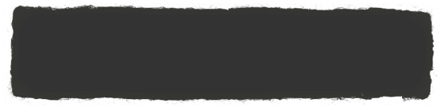

February 4, 2019

**ELA/Reading:**

* This week’s spelling pattern: et
* Next week’s spelling pattern: ig
* Nouns and proper nouns
* This week’s sight word: said
* Retelling stories in sequence using picture cards and transition words like first, next, then, last

**Writing:**

* Narrative Writing- telling a story about a personal experience and providing a reaction
* Writing sentences that match illustration
* Listening for sounds when writing words
* Starting with a capital letter and ending with a period when writing a sentence
* Separating written words with finger spaces
* Using and spelling sight words correctly when writing

**Math:**

* Measurement: Volume
  + Compare volume using *more than, less than*, and *the same as* by pouring
  + Explore the conservation of volume by pouring
  + Compare using the *same as* with units

**Social Studies:**

* Who am I?
  + Past, present, and future
  + Understanding our past and present by using timelines

**Science:**

* Weather
  + How the sun warms the Earth
* 100th Day of School Celebration. February 11, 2018. More details to come.
* Valentines Day exchange- February 14, 2019. More details to come.

* Thank you all for your patience and support. January has been a long month of mid-year assessments. The great news is that your children have made a great deal of progress. We are excited to get back to our normal routine and start the second half of the school year with a positive mindset for new learning experiences.
* 2/6/19- Late Start. School Starts @ 9:35
* 2/14/19- Half-Day. Dismissal at 11:45
* 2/15/19-2/18/19 No school. Students will return on 2/19/18

**Reminders**

**Upcoming Events**

**Curriculum**

Ms. Abulhassan’s Class

Newsletter