Dear families,

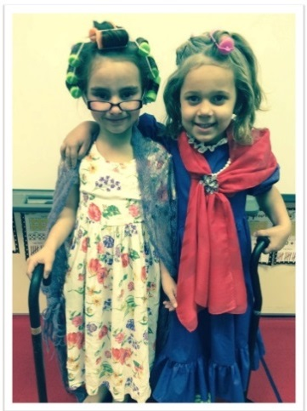We are celebrating the 100th day of school on Monday, February 12, 2019. We have lots of engaging activities planned for the day. We would like to invite the students to dress up like they are **100 years old**! Get creative with glasses, hair, and outfits! We cannot wait to celebrate 100 days of learning!

Thank you,

Ms. Abulhassan

Dear families,

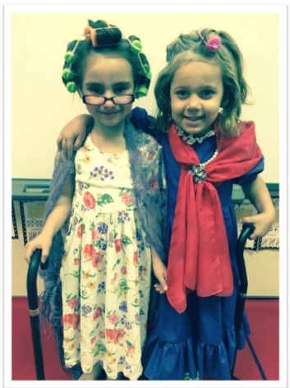We are celebrating the 100th day of school on Monday, February 12, 2019. We have lots of engaging activities planned for the day. We would like to invite the students to dress up like they are **100 years old**! Get creative with glasses, hair, and outfits! We cannot wait to celebrate 100 days of learning!

Thank you,

Ms. Abulhassan