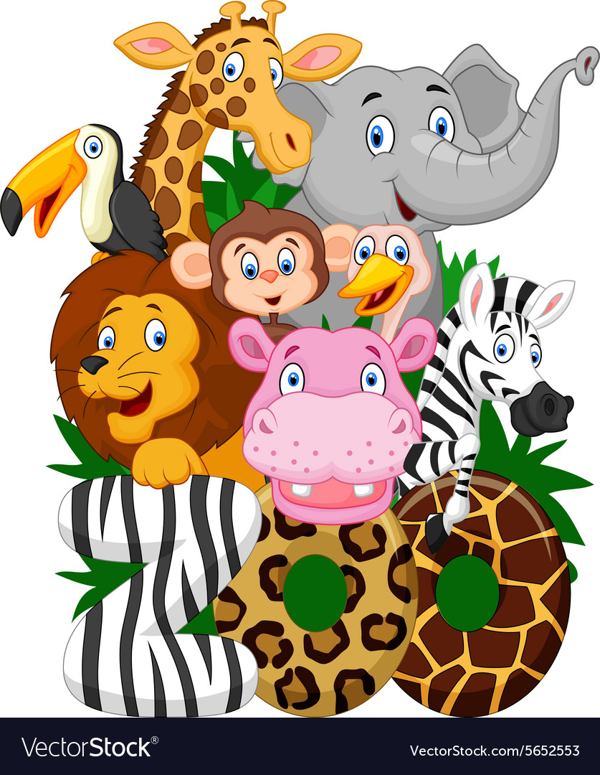

**ELA/Reading:**

* Vowels: Long vs. Short
* This week’s vowel: A
* Blending sounds to read unknown words
* This week’s sight word: my
* Compare and Contrast characters and events in text and between texts
* What is the main idea of an informational-nonfiction text

**Writing:**

* Opinion Writing- stating opinion and giving reasons why to support opinion
* Writing a simple sentence that matches illustration
* Listening for sounds when writing words
* Starting with a capital letter and ending with a period when writing a sentence
* Separating written words with finger spaces
* Using taught sight words correctly when writing

**Math:**

* Identifying the number that is one less, one more, ten less and ten more than a given number using a number grid
* Counting practice: Counting by ones, twos, tens and backwards
* 2-D flat shapes and 3-D solid shapes
  + identifying and classifying shapes based on attributes

**Social Studies:**

* Needs and Wants
  + Sorting needs and wants
  + Identifying needs and wants

**Science:**

* Weather
  + Weather watching
    - Observing different types of weather
    - Preparing for a storm
* We will be having a holiday celebration that includes a PJ day with gingerbread decorating. More details to come soon.



* As discussed during conferences, please have your child practice writing a simple sentence about a topic using proper capitalization and ending marks. If your child needs to be challenged, have him/her add details to their writing.
* READ, READ, READ every night with your child. A key factor in student success is parent involvement. Reading is essential in building your child’s early reading skills, and it provides a great opportunity to bond with your child. Discuss the books you read, take turns reading, and select books that your child is interested in. All this will help your child develop a love of reading.
* NO SCHOOL for kindergarten on Friday, December 14, 2018

**Reminders**

**Upcoming Events**

**Curriculum**

December 3, 2018

Ms. Abulhassan’s Class

Newsletter