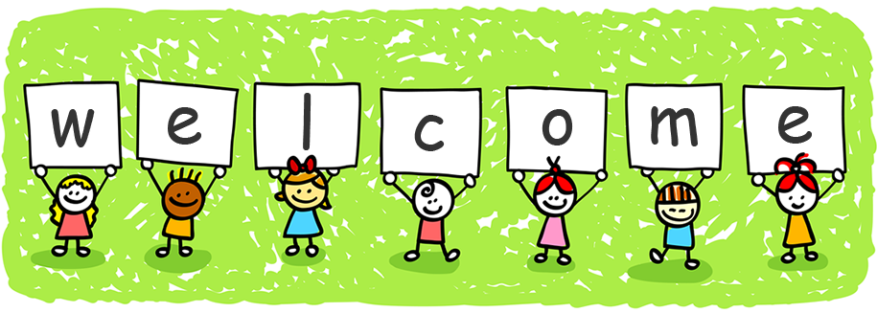

Dear families,

Welcome! My name is Ms. Abulhassan and I look forward to having a very successful school year with your children. Since we are just getting started with the school year, I thought you might like to know a little about me. I have been teaching for 5 years now. I taught both kindergarten and first grade. Teaching is a huge part of my life, and I truly enjoy having a job that is incredibly rewarding. I have always had a passion for helping young minds grow and instilling a love for learning early on.

On my free time, I enjoy traveling to new places and meeting all kinds of wonderful people. I also enjoy spending time with my family. I come from a very close-knit family, and I grew up with so much love and support from them. I am forever thankful. In addition to traveling and spending time with my family, I love reading inspirational books. Books have a way of helping me expand my thinking and maintain a positive outlook on life. Hopefully, my love of reading nurtures a love of reading in your children.

Kindergarten is definitely a year of tremendous growth and learning as your child gains independence in everyday learning tasks. I will do our best to ensure that your child is provided with a supportive and engaging environment that challenges and inspires him/her to become an active participant in the learning process. In addition, I will make every effort to create an educational partnership with you. You are the most important person in your child’s life, and I strongly believe that your support will help your child reach his/her full potential. Together, we can help your child build a strong foundation for a lifetime of learning.

Soon, the kindergarten teaching team will be holding a parent meeting. Please check your child’s folder for the upcoming date and time. For now, here is some information pertaining to my classroom procedures and policies.

**Absences** – Please make sure your child is in school every day unless he/she is sick. If your child is sick, it is necessary to call the office and inform them that he/she will be absent. The number is 313-827-2300. Please send a note or call if your child will need to be dismissed early for appointments. Kindergarten is a continuous experience with each lesson building on the lessons the day before. Attendance and punctuality are the keys to success. School starts at 8:35 and ends at 3:35 every day. You must pick your child up promptly because children tend to get emotional when they do not see you after school.

**Drop-Off and Pick-Up** – When you drop off your child in the morning, they are expected to line-up next to our designated cone on the playground blacktop during the warmer months or in the gym during the cooler months. I will pick them up when the bell rings at 8:35. Please note that if you drop off your child before 8:25, there will be no adult supervision. At dismissal, 3:35, students are to be picked up from the classroom for the month of September only. For the remainder of the year, they are to be picked up from the front of the building. Please let the office or I know if someone else will be picking up your child. I will not send your child home unless I know who he/she is going home with.

**Homework** - Students will regularly receive homework. A packet will be sent home every Monday and will need to be returned on Friday. We recommend that your child does one page a day (front and back side). A weekly reading log will be also sent home to ensure that your child is reading at least 15 minutes a day. The reading log will have to be signed daily. Expectations and more information will be discussed further at our parent meeting. PLEASE encourage your child to be responsible about doing his/her homework. It teaches responsibility and independence.

**Communication Folders** – Your child has been provided with a Communication Folder. It is your child’s responsibility to bring this to class daily, since they will be turning in homework, and collecting new assignments in this folder. Here you will find any unfinished class work, homework, teacher notes, handouts and spelling lists.

**Supplies**- I recommend that your child has a backpack to carry things from school. Other school supplies will be provided by us. However, any donations are greatly appreciated. Things we may need include:

* Kleenex
* Hand Sanitizer
* Clorox Wipes
* White copy paper
* 24 Crayola pack of Crayons
* Glue Sticks
* EXPO Dry Erase Markers
* Lunch Box (if packing a lunch)

**Classroom Policies and Rules-** We here at Geer Park have a color-coded behavior system. The three colors are green, yellow, and red. Everybody starts on green. If your child flips his/her card to yellow, that means they have a warning. If they flip to red, you will receive a call or note home and you child will lose a classroom privilege.The following is a list of rules I create with the kids on the first day**:**

1. I will follow directions.
2. I will respect myself, respect others, and respect my school.
3. I will listen with the teacher is talking.
4. I will use nice hands and feet.
5. I will always try my best.

**Snack**- Every month, a snack calendar will go home informing you of when your child is to bring snack for our class. Please send enough snacks for the whole class.

An important goal in my classroom is to reinforce healthy eating habits. With this goal in mind, the following is a list of acceptable snacks:  
  
• Crackers   
• Pretzels  
• Fruit and/or vegetables  
• Yogurt or pudding  
• Granola bars  
• Fruit snacks  
• Rice Cakes  
• Applesauce  
• 100 calorie packs  
• String cheese  
• Mini-muffins

Students may bring milk, water, or juice with their provided snack for the class. If a drink is provided, boxed drinks are recommended.

**Birthdays** – You are welcome to bring in a treat to celebrate your child’s birthday. Please provide the necessary paper products as well. PLEASE do not bring sheet cakes. Cupcakes are much easier to work with. Healthy snacks are always recommended and suggested.

**Questions and Concerns**- Please do not hesitate to contact me with any questions or concerns you may have regarding your child. If you call during school hours, it will go directly to voicemail since I am teaching. I will return your call as soon as possible. You may also contact me via email at [abulhah@dearbornschools.org](mailto:abulhah@dearbornschools.org). In addition, you may send a note with your child. Please do not wait until a scheduled conference to contact me regarding concerns.

I would like to thank you in advance for both your support and partnership for the upcoming school year. I look forward to meeting you soon! ☺

Sincerely,

Ms. Abulhassan