AoW #2 Scientists Reveal Three Keys to Happiness

By ABC News October 2, 2003

*(Several studies have worked towards revealing the key to happiness, however, a new study by Stephen and Rachel Kaplan reveals that there might actually be three keys to happiness. As you read, take notes on how nature affects people. )*

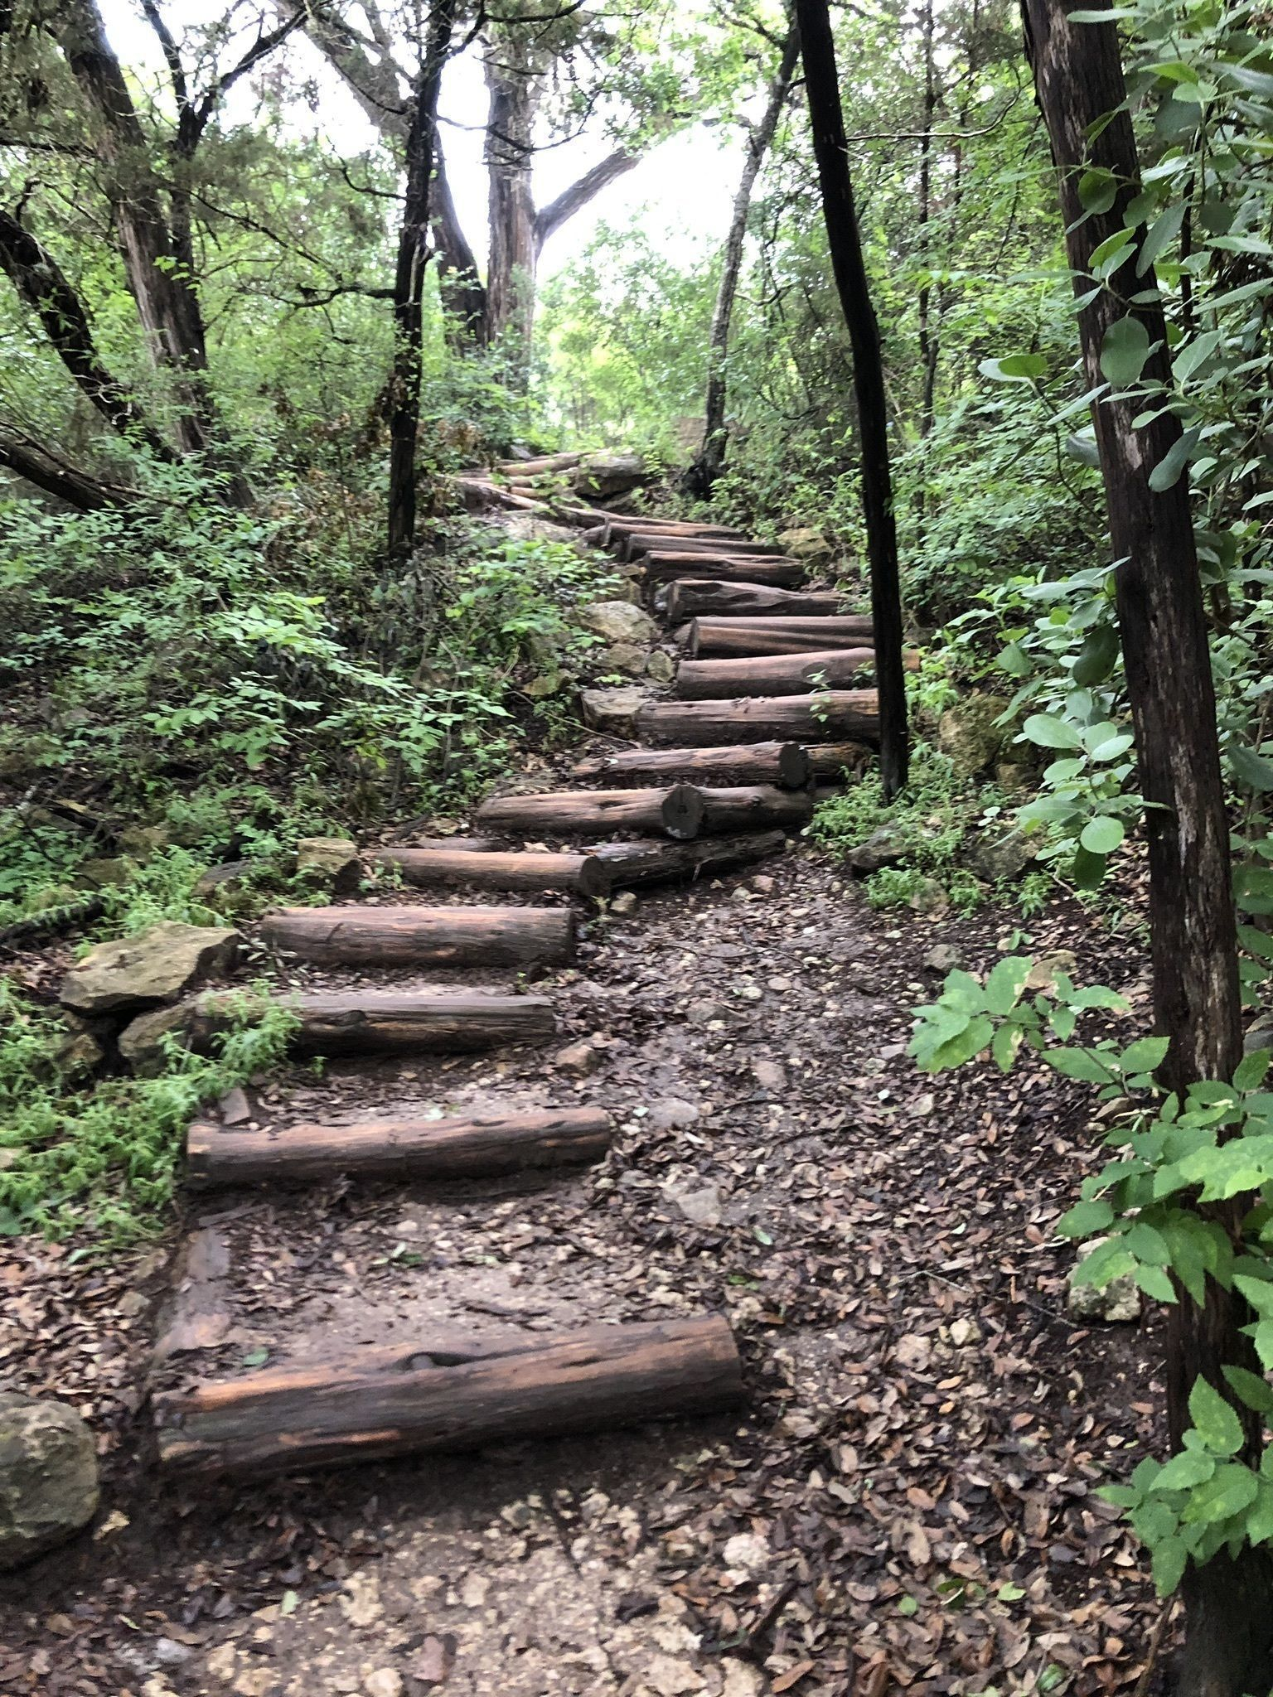 [1] What would it take to make you really satisfied with your life? According to decades of research by a husband and wife team of psychologists at the University of Michigan, you need to put yourself in an environment that meets three basic human needs.

To make your way down the road to happiness you need to feel competent and believe that you can make a difference. You also need to understand what the heck is going on around you and have the opportunity to choose your own options.

Before you start firing off all those e-mails about money, love, health and so on, give these folks a chance to explain. They arrived at their conclusions partly by showing people pictures of nature.

**Picturing a Perfect Life**

Stephen Kaplan, who is also a professor of electrical engineering and computer science in addition to being a psychologist, and his wife, Rachel Kaplan, professor of environment and behavior, started down this road decades ago during the horror that followed the assassination of President John F. Kennedy. What could have precipitated1 such an unreasonable act of violence?

Could it be, they wondered, that violence could stem at least partly from an unhealthy environment? "Some environments bring out the best in people," Stephen Kaplan says. "Others do exactly the opposite. How can you describe an environment that brings out the best in people?" At that time there was no general consensus among psychologists as to what constituted a healthy environment. But the Kaplans were intrigued by one study that came out about that time suggesting that what people really liked in their lives was a "medium level of complexity."

"We thought that was very odd," Kaplan says, because both he and his wife believed that what people really needed in their lives was exposure to nature. So they set out to find if they were right. They collected a bunch of photos showing urban scenes in Detroit and scenes of nature. Strangely enough, the urban scenes were shot by an expert photographer and were much better in quality than the scenes of nature, which were shot by a mediocre2 photographer after a dry, dull summer.] Participants in the study were asked to indicate how much they liked each photo. "With a single exception, every single nature picture was preferred over every single urban picture,"

Kaplan says. "The one exception was an urban park."

**Yearning for Mystery**

In the years since, they have repeated that study dozens of times, all over the world, with the same results. One exception is among teenagers who prefer the urban scenes with city lights and things to do over scenes of nature, but Kaplan says they grow out of that stage.

So, why does that tell us anything about what we need for satisfying lives? The answer lies not just in the photos, but in some of the details.

"One of the first things we realized is that even among nature pictures, there's some that people prefer very much to others," says Kaplan, who spoke for both he and his wife during the interview. "It turned out that those were the photos where you could learn more if you walked into the scene."

[15] A trail leading around a tree and disappearing in the distance beckons to the viewer to come in, look around, and learn something. That makes it a much more enticing photo.

"We hadn't realized that landscape architects had figured that out 50 years earlier," Kaplan says.

A picture with a little mystery is preferable because "people want to explore, and they want to find things out," he says. Conversely, if they can't understand what's going on, they become very angry. So the pictures told the story of a very basic need among all persons — the need to understand their world and pick their own options as they head on down that trail and around the tree.

**Is Taking Control a Mistake?**

But for that little adventure to be helpful, Kaplan says, a person needs to believe that his or her life can make a difference. Nothing is more irritating, or frustrating, than the feeling of helplessness, so if you want to make a difference you've got to take control, right? Not necessarily, the Kaplans believe. Taking control sometimes can be a bad mistake.

"There's a tremendous number of times when people want things to be under control, but they don't want to control them. That's a tremendous responsibility," Kaplan says. "So gradually we came to the realization that what people want to do is participate. The opposite of helplessness is being heard. It's playing a part. It's being engaged in the action. Not being ignored." Only then will it be possible for your life to make a difference.

But chances are you're going to be ignored anyway unless others see you as competent and effective, the third step on the Kaplan's road to self fulfillment. And once again, they concluded, nature can play a part.

In a series of studies, the couple demonstrated that an office window that overlooks a natural scene helps people relax, thus fighting off one of the primary threats to competence, mental fatigue. Both energy and job enthusiasm rose among people who had a chance to glance out the window occasionally and see something, even if it was only a single tree. Nature, the Kaplans suggest, is competency's greatest ally.

**Natural Healing**

It even helps when trying to deal with a potentially fatal illness. One of their studies involved cancer patients.

"The first thing they wanted to do when they got their diagnosis was take a ride in the country," Kaplan says.

The study found that spending 20 minutes outdoors each day helped the patients cope with the "mental fatigue" of dealing with all the issues that come along with the cancer.

But wouldn't a debilitating disease like cancer be so overwhelming that it would wipe out the three conditions the Kaplans feel are so important? Aren't things like health, love, and even an adequate income also extremely important?

[30] Of course, Kaplan says, but their findings lay the foundation for dealing with all those other issues. You've got to feel competent, think you can make a difference, and understand what's going on to handle any crisis. And for starters, take a look out the window occasionally.