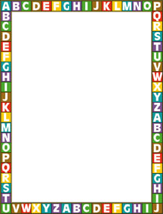

Our Third Grade Suggested Supply List

We are so excited and looking forward to working with you and your child next school year! Third grade is such a fun year where your child will be learning and growing so much! In order for them to succeed and thrive there are some things they will need. With your support and help, we can make it a wonderful and successful year! Here is what they will need:

- Backpack
- Loose leaf lined paper
- 3 Spiral Notebooks
(not perforated)
- 2 folders (with prongs/fasteners)
- Pencil sharpener with
Shaving holder
- Box of markers
- Dry erase marker
- Ruler
- Lined Paper
- Pencil Box or Pouch
- Box of crayons
- Box of colored pencils
- Box of #2 pencils
- Glue sticks
- Highlighters
- Scissors (pointy tips are better)
- Small Post-its
- Kleenex
- Erasers
- Multiplication flash cards (dollar store usually carries them)
- Markers

Our Class Wish List
Items donated to our classroom, at any time, are GREATLY appreciated!

- White Copy Paper
- Clorox wipes
- Hand Sanitizer

Thank you so much for your cooperation in setting your student up for success! We appreciate and encourage your involvement in your child’s education and we will do all we can to help your student reach their full potential. We know this is going to be a wonderful year!

Ready, Set, Here We Go!

